Hello
Xen Project

Author:
Mohsen Mostafa Jokar

Editor:
Rashad Williams
For my parents
- Mohsen

I dedicate this book to my lovely wife Candice Williams and my mom Jean Williams
-Rashad

A note about this book:
This book, Published under “CC-BY-SA-3.0” license. For more information you can visit https://freedomdefined.org/Licenses/CC-BY-SA-3.0 . The goal of this book is helping newbie users for learning Xen Project and invite advanced Xen Project users for improving the contents of this book and add more topics to it. I hope this book can help Xen Project users to learn it better and Paying off others to move to Xen Project and use it.

Contents
Chapter 1: 6
A Brief History of Virtualization 6
Why and what is Virtualization? 8
Types of Virtualization 9
Operating system Virtualization or containers : 9
Server Virtualization : 9
Virtualization and Security 11
Sandbox 12
Containers vs Virtualization 12
Open Source Linux Virtualization Software 15
Xen 15
KVM 15
OpenVZ 17
VirtualBox 19
Chapter 2 : Xen Project 23
What is XenProject? 24
Xen Project Compatibility 34
Xen project components 36
Xen Project Commands 37
Compiling Xen from Source Code 38
Chapter 3: Dom(s) and Grub 39
Change Dom0 memory 40
Xen Project and Grub 44
Grub2 45
Chapter 4: Using Xen Project 48
Manage virtual machines with virt-manager 49
Storage and Networking 53
Networking in Xen 60
VM States in The Xen Project 71
Use Physical CD/DVD ROM 75
Create a VM via .img 76
VGA Passthrough 78
Swap 80
Using Xen-Tools 83
Monitoring Xen project 91
XCP 96
Chapter 5: Have fun with The Xen Project 99
Have fun with The Xen Project 100
Converting VirtualBox VM to The Xen Project 100
Selinux and Xen Project 102
Citrix XenServer 106
Snapshots 133
Backup and Restore 140
Hotfix 142
Citrix XenConvert 151
Install other packages in XenServer 156
Recovery 159
How to auto start XEN VMs after reboot of DOM0 160
Monitoring Via Nagios 161
Nagios Core 4.0.1 163

Chapter 1:

A Brief History of Virtualization

A Brief History
First of all, I must tell you that It is not a Bible book and we don't like to speak a lot about everything. We just like to show you something about Virtualization and focus on Xen Hypervisor.
In the computing world, when we speak about “Virtualization” its mean that you want to create a virtual version of something that can be a program, an OS and….
The Virtualization is not a new technology and in 1960 it used by mainframe computers and made by IBM. Jim Rymarczyk was a programmer that joined IBM in the 1960 as a mainframe expert and he invents the Virtualization. He works at IBM as a chief Virtualization. At that time, IBM used CP-67 software. It was a control program of CP/CMS that was a virtual machine operating system developed for the IBM System/360-67. CP/CMS was a time-sharing operating system that popular for excellent performance.
CP-67 was the first IBM attempt in a Virtualization area in mainframe operating systems. CP-67 give customers the ability of running many applications at once and as you see it was the first Spark of Virtualization. In 1999, IBM attempts to make a motivation for VMware and Virtualization welcome for x86.
CP-67 was a replace for CP-40 that it was an operating system for the System/360 mainframe. The CP-67 was the second version of IBM hypervisor. The early hypervisor used conversational monitor system (CSM) that it was a simple interactive operating system. It is a part of IBM virtual machine operating system that used on mainframe computers Models System/370, System/390, zSeries, System z. The IBM hypervisor become a commercial product in 1972 with VM technology for the mainframe and nowadays used as z/VM. The z/VM used as full Virtualization solutions for the mainframe market.
The main advantages of using Virtualization on mainframes is that we are able to share the overall resources of the mainframe between all users.
I will recommend to you to look at Unix OS history. Unix OS is an example of Virtualization at the User Level. Unix is a Multiple user OS that share CPU, Memory, Hard Disk, pool of resources and its between all users but users have their own profile. Unix was not the first multi-user OS, but it was the first step towards application Virtualization.
We told “Application Virtualization” and let me to write something about the history of it. In 1990, Sun Microsystems began a project with the name “Stealth”. It was a project for preparing a better way to write and run applications. The name of the project changed many times and finally in 1995 sun Microsystems rename it to “Java”. As you know, Internet contain a lot of computers that each of them run different OS and they must find a way of running rich application on all OSes and Java was a solution for this problem.
Java lets the developer to write applications that run on all OSes via Java Runtime Environment (JRE). You just need to install JRE and your program will be run without any problem. The JRE is composed of many components like Java Virtual Machine. When you run a Java application, then your application runs inside of the Java Virtual Machine and you can consider it as a very small OS. For more information, you can see: “https://en.wikipedia.org/wiki/Timeline_of_Virtualization_development”.
If we look at the history, then we find some interesting events about it: HISTORY of VMWARE.
In 2004, The VMware company bought EMC company about $625 million. EMC was a big company that products storage. The Citrix is another big company that bought Xen Source that was a sponsor for the Xen Virtualization project about $500 million. Why these companies bought this project and company? How about the future? Are they waist their moneys? I bet, they are not. They saw something that we can't see.

Why and what is Virtualization?
We spoke something about the history of Virtualization and told you that the Virtualization is the virtual version of everything like OS, Application and... Let's tell more and dive into it. Why Virtualization is important and why you must use it? Moore’s Law and hardware. Gordon Moor, cofounder of Intel company said:
“The number of transistors in a dense integrated circuit doubles approximately every two years”.
This has become a rule to estimate the future of integrated circuits, but some people would estimate to be every 18 months. Please see below picture from Wikipedia:
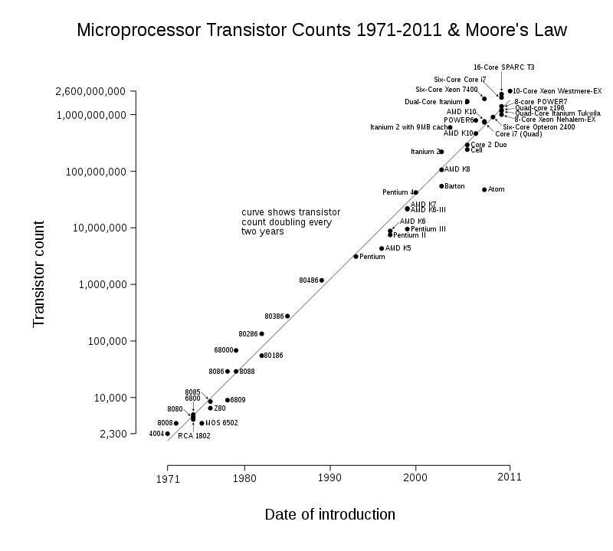

Figure 1: Microprocessor Transistor Count.

We must accept that hardware becomes cheaper and cheaper and advanced and more advanced. Compare your old computer with your current computer. What you see? For example, my old computer had 256MB Ram with Pentium 4 1.7 GHz but my current computer is Intel Core i7 with 8GB Ram. As you see, Hardware becomes faster and faster and cheap also, But Are you using all hardware capacity always? I bet most of your CPU and Ram is unused and just use Energy. What should we do? It's just a PC, but how about Servers? Servers using more energy and need extra equipment for keeping. Nowadays, machines just using 10 or 15 percent of their capacity and in the other word, 80 to 95 percent of machine power is unused. Remember Moore’s Law, after two years we have a more powerful hardware but for what? We can't use all hardware capacities and most of our equipment wasted. The Virtualization can solve our concerns. We can use all of our hardware capacity. As we said, IBM inspires VMware for creating Virtualization for x86.
In the computing world, x86 Virtualization means hardware Virtualization for x86 architecture. This technology allows multi OS use x86 processor resources in a safe and efficient cage. Early, x86 Virtualization was a complex software technology because it must fill the lack of hardware Virtualization but in 2006, Intel and AMD companies introduces limited hardware Virtualization with the names Intel (VT-x) and AMD (AMD-V). Both of them allow Virtualization.
The AMD-V was the first AMD generation Virtualization that developed under the code name "Pacifica" and the company introduced it as AMD Secure Virtual Machine (SVM) but changed it to AMD-V.
In 2006, AMD released the Athlon 64, the Athlon 64 X2 and the Athlon 64 FX and all of them use this technology and were the first AMD CPU generation that support Virtualization. In 2005, The Intel company released two models of the Pentium 4 (Model 662 and 672) as the first Intel processors that support VT-x. In 2015, All Intel CPUs support VT-x and most motherboards Inclusion it in their BIOS.
OK, let me jump to another section.

Types of Virtualization
If you do some research, then you can find different types of Virtualization. Some resource tells you that three main types of Virtualization exist and others tell four types of Virtualization exist. Three types are: client, server, and storage and Four types are: Operating system Virtualization, Server Virtualization, Storage Virtualization and Hardware Virtualization.
Let’s us mention something about each of them:

Operating system Virtualization or containers :
Client Virtualization refers to Virtualization on a Desktop or Laptop computer. OS Virtualization means the movement of the main Desktop OS in a virtual environment. In this method, The OS is hosted on a server and in the other words, One version on the server and copy of that is present on each user.
The user can modify his/her own OS without other users being affected. Containers can help you about moving an application from one computing environment to another and the Kernel of OS will be run on hardware with several isolated guest virtual machines. We said containers “isolated guests”. Popular containers are Docker, VagrantUp and LXC. Containers can help you about overhead and performance. The big problem in containers is security.

Server Virtualization :
Server Virtualization means moving a physical server into a virtual environment. This kind of Virtualization will solve the concerns in Data Centers. Nowadays, Servers can run more than one server simultaneously that help you about reducing the number of servers. IT companies very like it because they can gain more control of growing their server farms. Server Virtualization is critical for IT companies because with Server Virtualization they can add more machines and if they can't add more machines then they can't respond to customers needs, So they can't prepare necessary resources and they will be fail. Server Virtualization is very popular in the Web hosting and Databases and have many benefits because each server can run its own OS and rebooting each server can't affect on other servers.

Storage Virtualization :
Storage Virtualization means combining multiple physical HDD into a single virtualized storage. Another name for it is Cloud. The Cloud can enable better functionality and features. Storage Virtualization can help Administrator about Backup, archiving and recovery and administrator can do these tasks easily. This technology can be private, Public and mixed. Private is hosted by your company, Public is out of your company like “Drop Box”, “Microsoft One Drive”, “Amazon S3” and Mixed is a combination of both. In Cloud storage, Data stored in logical pools and physical storage and physical environment owned by the provider. The biggest responsibility of provider is that the Data must be available and accessible and physical environment must be protected and running always. Customers buying these storage and store their users, organization and important data. This technology have a lot of advantages like that companies just need to pay money for space during a month. Companies can save energy, Data availability and protection is better and This storage can be used for copying VM images or import them. Storage Virtualization have a better backup because of your data copied in different location around the world.

Hardware Virtualization
Hardware Virtualization means taking the components of a real machine and making them virtual. Another name for it is “platform Virtualization” that refer to creating a VM that behave like a real computer with an OS. Softwares that running on these kind of Vms is separated from Hardware resources because Virtualization hides the physical characteristics of users. For example, You can run Microsoft Windows 10 on a Linux machine or vice versa. Microsoft Windows 10 that running on a VM can't understand that it is Virtualized and thinking that it is a real machine. The software that creates a VM on hardware called a hypervisor or Virtual Machine Manager. The software is separated from Hardware resources.
Different Types of Hardware Virtualization exist :
• Full Virtualization
• Partial Virtualization
• ParaVirtualization

In “Full Virtualization”, The VM simulates hardware in a way that the Guest OS does not require any modification to run. In "Partial Virtualization”, The VM simulates multiple instances of hardware and this mean that the entire OS cannot run in the VM. This kind of Hardware Virtualization is important because of address space. In “ParaVirtualization”, The VM doesn't need any Hardware simulation, but offer a special API that can modify the Guest OS. As you see, OS modification is needed thus OS source Code must be Available. This technology introduced by the Xen Project team. It is so useful because don't need any Virtualization extensions on Host CPU and enable Virtualization on Hardware that do not support Hardware-assisted Virtualization.

Virtualization and Security
In the virtualization world, You can make a VM and convert and isolate the VM from the Host . For example, when you launch a Virtual network between VM’s and use Virtual HDDs for testing and forensics.
First of all, The Virtualization add additional layers of complexity and therefore monitor and find security vulnerabilities become more difficult. A hacker must do more research in order to discover more vulnerabilities. Virtualization can provide Isolation and it is the core feature of network virtualization. A network that is Virtualized is isolated from other Virtual networks and also physical networks. The important thing is that no Firewall, ACLs and… required for this isolation. Virtual Networks are isolated from physical infrastructure and it is because of traffic between hypervisors is encapsulated and our physical network operates in a different address space. A good example of it is that our network can be IPv6 and our Virtual network can be IPv4 or vice versa. As you see, its protect our underlying physical network from attacks. In networking we have a concept by the name of “Network Segmentation”. Its mean that you can split a computer network into subnetworks and each of them is a network segment. Network segmentation can improve security and performance. It provides security because when an attacker gain access to your network, Segmentation provide a good control for limit access to the network. This can implement by hypervisor switch or Open vSwitch.
You should keep in mind that these features can make some mistakes. For example, Securing a Virtual machine is same as a Physical machine and if you configure your VM in a bad way, For example, With open unnecessary ports then your VM can be at risk. Another mistake is about Virtual Network and if you host your vital data or databases without segmentation then...
Fortunately, Xen provides a good security feature that we will talk about it in the future.
A good example of an OS that created for security via Xen is “Qubes-OS”. For more information about this project see “https://www.qubes-os.org/”.
Another good example is “Sandbox”. The Sandbox is a mechanism for separating running programs. You use can Sandbox for executing untrusted code or program from untrusted users and websites. Sandboxes are a good example of Virtualization that running suspicious program without any harm to the host device.

Sandbox
A good example of sandbox implementations is “SELinux”, “Apparmor”, “Virtual machine”, “JVM”, “Sandboxie” and some features in the browser like “Chromium”. Sandboxie is an isolating program that developed by the Invincea Windows OS. It allows users to run and install applications without modifying your drive:
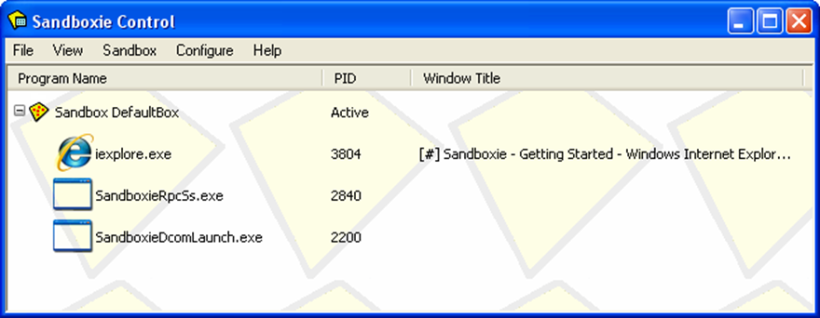

Figure 2: Sandboxie

You can download it from “http://www.sandboxie.com/”.
For Sandboxing under Linux see “Mbox” at “https://pdos.csail.mit.edu/archive/mbox/”.
As you understand, Virtualization have some advantage and disadvantage and with the passage of time Hackers and malware authors working on it and found some ways to bypass it. A good example of this es is “Paranoid Fish”. You can see more information about this project at “https://github.com/a0rtega/pafish”.

Containers vs Virtualization
The next topic is about Containers. If you remember we told you something about “Operating-system-level virtualization” but we want show you that this technology is various from Virtualization.
As we said, Container is not a new technology and Unix used it many years ago, but some nowadays technologies like “Docker”, “Vagrantup” and “LXC” make this technology alive and hot. In 2004, Docker team to contribute from other companies like Canonical, Google, Red Hat and Parallels create a standard that allows containers to work within Linux namespaces and control groups without any admin access and offer a better interface for all Linux Distro. This allows many containers to run in a single VM. Before it, you must use a VM for each application and separate them from each other, but now, You don't need it and you can run all of them in one VM environment. Thus, You don't need many Vms on a machine. A big problem with VM was overhead and Containers solved it. Containers solved a problem that System administrators and developers faced with it for many years. They produced a tool, but can't run on some environments because of version mismatch of any library or some packages not installed. Docker, Solved this problem via making an image of an entire application, with all its dependencies and move it to your target environment and your App can work everywhere. What do you think? I guess you are thinking that you can solve this problem via Vms too. Taking an image of an entire virtual host and launching it on the target. Containers are so light weight and your Apps is ready in few seconds. Containers with all the advantages have disadvantages too, and one of the biggest problems with them is “Security” and it is a huge problem for Cloud environments. The containers share the same hooks into the kernel and it is a problem because if any vulnerabilities exist in the Kernel then an attacker has a way to get into your containers. Until now, Containers can't provide a secure boundary like Vm’s. If you do some search about Docker vulnerabilities, then you can find some interesting topics. For example, A vulnerabilities in Docker let attackers to escape the system and gain full access to the server. A tool like “Clair” (https://github.com/coreos/clair) can help you about analysis of vulnerabilities in apps and docker containers. For more information about Docker security you can look at “http://www.cvedetails.com/product/28125/Docker-Docker.html?vendor_id=13534” and “https://www.blackhat.com/docs/eu-15/materials/eu-15-Bettini-Vulnerability-Exploitation-In-Docker-Container-Environments-wp.pdf”.
Another problem for containers is scalable. Five security concerns when using Docker are :
- Kernel exploits
- Denial-of-service attacks
- Container breakouts
- Poisoned images
- Compromising secrets.
The main idea behind a hypervisor was to emulate the underlying physical hardware and create Virtual Hardware for you,You can install your OS on top of these virtualized hardware. In below Diagrams you can find the different between Containers and VM :
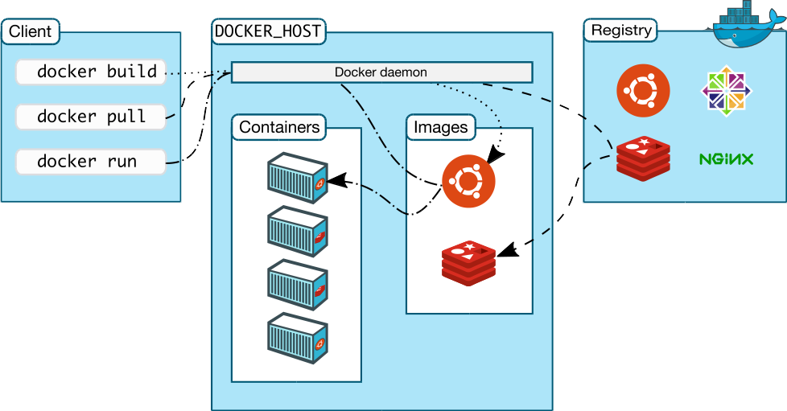

Figure 3: Docker Architecture.

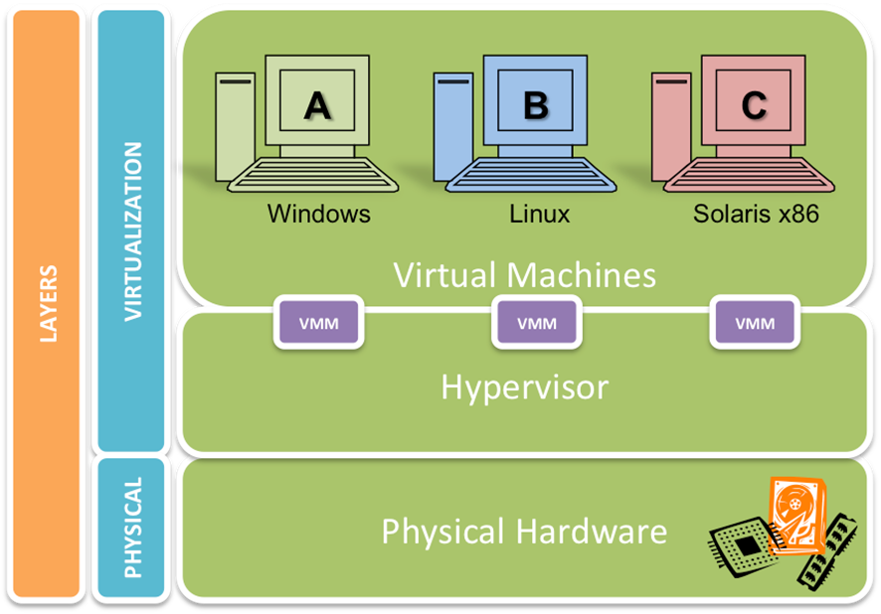
Figure 4: Virtual Machine Architecture.

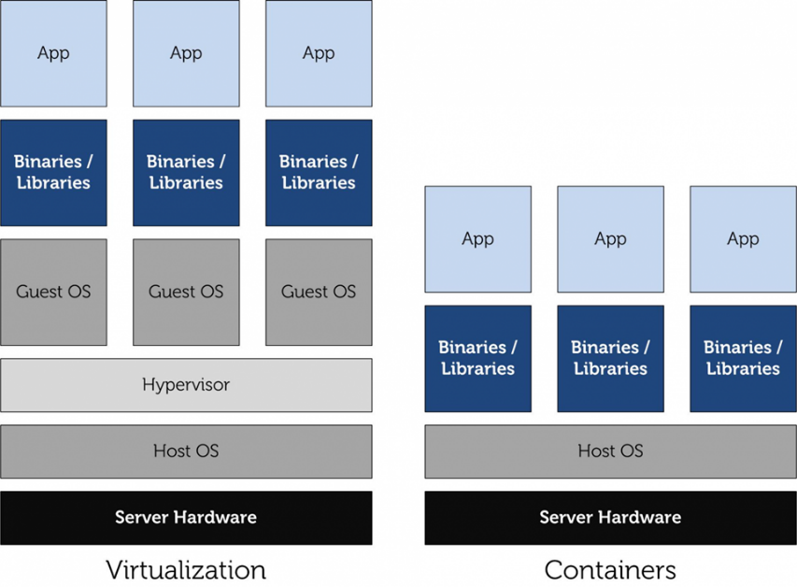

Figure 5: Different between Virtualization and Containers.

As you understand, If you need security, then your option is VM otherwise select containers.

Open Source Linux Virtualization Software
Now, the time has come and we want to look at some Virtualization software and familiar you with them.

Xen
Xen Project, born at University of Cambridge as a research project by Ian Pratt and Simon Crosby. Ian Pratt is co-founded XenSource and the first version of Xen made in 2003. Xen Project supported by XenSource Inc and in October 2007, Citrix company bought XenSource, Inc. Citrix bought Xen but continuing support of Free version of Xen and also sell an Enterprise version of it as “Citrix XenServer”. Citrix company using Xen brand on other products that not have any relationship to Xen, For example, "XenApp" and "XenDesktop". Xen changed a lot and in 15 April 2013, The Xen Project moved under the auspices of the Linux Foundation and “Xen” changed to “Xen Project” and differentiated from older name. With this changed, project members like Amazon, AMD, Bromium, Cisco, Citrix, Google, Intel, Oracle, Samsung and … continued support of the project. If you remember, We said something about Xen Project before, but we want to say more but not diving into it now.
Xen Project is a hypervisor that management CPU, Memory and other hardware for All Virtual Machines and most privileged domain. In Xen Project terms, Refer to Vms as “domains” and privileged domain as “dom0”. The dom0 is the only Virtual Machine that has direct access to hardware. From dom0, The hypervisor can manage and domU (unprivileged domains) can be launched.
The dom0 is a version of Linux or BSD and domains can be other OSes like Microsoft Windows.
The Linux Kernel from version 3.0, Inclusion supports of Xen for dom0 and domU in the Kernel. Xen Project can support live migration for Vms and also support load balancing that prevention downtime.
Load balancing, Distribute workloads across multiple computing resources, such as computers, clusters, network links, CPUs and Disks. Load balancing increases reliability and availability through redundancy.
We spoke something about types of Virtualization and Xen can support five types of Virtualization : HVM, HVM with PV drivers, PVHVM, PVH and Paravirtualization.

KVM
KVM or Kernel-based Virtual Machine is a Virtualization for Linux Kernel that turn Kernel into a hypervisor and Rise up from kernel version 2.6.20. KVM need a CPU that support hardware Virtualization. If you remember, We spoke about it (Intel VT-x or AMD-V). In KVM, The Linux Kernel act as a hosted hypervisor (Type 2 Hypervisor) that is a Virtual Machine manager that installed as a software on an existing OS. KVM, simple management and improving performance in Virtualized environments. KVM, Create a VM and coordinates CPU, Memory, HDD and other hardware equipment via the host OS for our VM.
KVM can support a wide range of OS like Linux, Windows, Solaris and even OS X. A modified version of QEMU can use KVM for run OS X. KVM, don't do any emulation, It uses /dev/kvm interface that a is a userspace for :

● Setup address space for guest VM.
● Creating a Virtual Machine.
● Reading and writing VCPU registers.
● Inject and interrupt into a VCPU.
● Running a VCPU.

For BIOS, KVM uses SeaBIOS. It is an Open Source implementation of a 16-bit x86 BIOS that support standard BIOS features.
You may ask yourself, What are KVM benefits? I will show you something :
Security : Because, KVM built on top of Linux kernel, then it can use capabilities of Selinux. With this benefit, KVM can provide Mandatory Access Control security between virtual machines.
QoS : As we said, KVM is part of the Linux Kernel thus a VM have not any different with another program that running on Linux thus administrator can define thresholds for CPU, Memory and...and guaranteeing QoS for Vms.
Open Source : KVM is an open source solution that provides Open source benefits and make interoperable solutions available. As you guess, New hardware features and support for the new generation CPU architectures can fix in it. For example, 64-bit ARMv8 architecture targets the server and mobile platform and KVM support it, Thus, KVM-on-ARMv8 is a key virtualization technology for many markets.
Other benefits are Full Virtualization and Near Native Performance.
With these advantages, KVM has some disadvantage too. For example, Complex Networking, Limited Processors and CPU Virtualization Support.
You can find a good Performance benchmarks about Xen and KVM at “https://major.io/2014/06/22/performance-benchmarks-kvm-vs-xen/”.
KVM acquired by Red Hat in 2008.

Below is a figure from Wikipedia about KVM architecture :
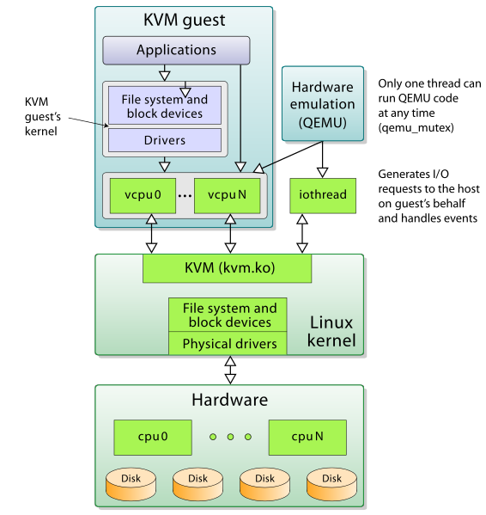

Figure 6: KVM Architecture.

OpenVZ
OpenVZ (Open Virtuozzo) is a technology for operating system-level virtualization in Linux that allow you to run multiple isolated OS on a server. It is a container like LXC. OpenVZ can't prepare full Virtualization like Xen Project and it's just a path for the Linux Kernel and can run only Linux. It is very fast but have a big disadvantage and it is that OpenVZ shares the same architecture and Kernel version. OpenVZ Virtual Machines are jailed containers and are not true Vms like Xen Project. OpenVZ improved and added a good feature. In old version of OpenVZ, Each virtual environment uses a same file system that isolated by “chroot” but in the current version of OpenVZ each container has its own file system.
A good advantage in OpenVZ is that memory allocation is soft, This means that a memory that's used by a virtual environment can't use by others. I guess you heard “ virtual private servers (VPSs)”. OpenVZ called VPS too, and in the computing world, The VPS is a VM that sold as a service. A VPS running its own OS and customer has full access to it and can install anything on it. VPSs in some ways are equal to dedicated servers, but their prices are so lower than dedicated servers. VPSs performance compared with dedicated servers are much lower because of they use shared hardware. I found a diagram about it and you can see it below :

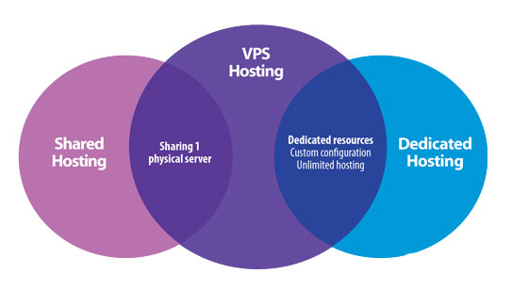

Figure 7 : VPS

In April 2006, two good features for OpenVZ released and they are “live migration” and “Checkpointing”. With live migration in OpenVZ you can move a container from one physical server to another without shutdown your container. The checkpointing mean that a container frozen and all of its states saved as a file on disk. Then you can move this file to another machine and restore it.
LXC 2.0 released and if you Google it, then you can find some articles about converting OpenVZ to LXC. For example, “https://pve.proxmox.com/wiki/Convert_OpenVZ_to_LXC”.
You can't run Windows OS on OpenVZ, but I found a trick about it : https://freevps.us/thread-2789.html

Linux-Vserver
The first version of Linux-VServer released in Oct 2001. The Linux-Vserver is like OpenVZ and adding operating system-level Virtualization capabilities to the Linux kernel. It is used for abstract computer resources like File System, CPU, Network and Memory based on Security Contexts and process can't launch DoS attack on others. With Linux-Vserver, you can create many independent VPSs that run on a physical server at full speed and shares hardware. As we said, VPSs are Independent and all services like SSH, Databases, Mail and… can start without or with a very small modification. VPSs are isolated and each VPS has different Authentication. Linux-Vserver like OpenVZ use “chroot” utility for providing security and just can run Linux guests. The Linux-Vserver does not emulate any hardware and the goal of it is isolating applications and this isolation done with Kernel. Linux-Vserver can integrate with Grsecuirty for providing better security. It has some advantage and disadvantage as below :

● Not have any overhead.
● Because of common file system, The Back-Up is easier.
● Networking is based on isolation not Virtualization, So we have not any additional overhead for packets.
● You can run it in a Xen guest.
● Host Kernel must be patched.
● Clustering and Live migration not supported.
● Because of Networking is based on isolation, Each VPS can't create its own internal routing or firewall.
● Additional patch for supporting IPv6.
● When you shut down a guest then the IP is brought down on the host also.

It has other features like “Resource sharing”, “Resource Limiting”, “Good disk scheduling”, “hide packet counters” and…
For more information about Building Guest Systems you can see “http://linux-vserver.org/Building_Guest_Systems “.

VirtualBox
The first version of VirtualBox released by a German company with the name Innotek GmbH as a Close Source software but free. In January 2007, Innotek GmbH releases an Open Source version of VirtualBox (VirtualBox Open Source Edition (OSE)) under GPL version 2. This company acquired by Sun Microsystems in February 2008 and Sun Microsystems acquired by Oracle in January 2010. When Sun Microsystems bought Innotek company and changed VirtualBox to Sun xVM VirtualBox. The xVM was a product line from Sun Microsystems that addressed virtualization technology on x86 platforms : Sun xVM hypervisor that was a component of Solaris OS and provided the standard features of a Xen-based hypervisor for x86 and Sun xVM Server that based on xVM hypervisor project and the goal of Sun Microsystems from it was Support Microsoft Windows, Linux and Solaris as guest OS. After that Oracle acquired Sun company the Sun VirtualBox name changed to Oracle VM VirtualBox.
VirtualBox or VB can install on many platforms, including Linux, Windows, Solaris, FreeBSD and OS X. VB can support many Guest OS on Linux and Windows platforms. For providing a better performance and graphic resolution, VB use "Guest Additions" package that make VB more powerful. It is a CD-ROM image under .iso format with the name “VboxGuestAdditions.iso”. After installing this package the Guest OS has a better performance and features as below :
● Mouse pointer integration
● Shared folders
● Better resolution and video support
● Seamless windows
● Shared clipboard

If you want to enable some features like “Support virtual USB 2.0/3.0 controller” , “PXE Bootfor Intel card ”, “disk image encryption” and “RDP” then you must use a Close Source pack for VirtualBox with the name “VirtualBox Extension Pack”. It is a file with “.vbox-extpack” extension and easy to install. Just double click on it.
VB provides “Full Virtualization” and if you remember we have written something about this technology. VB has good features and some of them are Experimental Features and we just refer to a number of them :

● 64 bit Guest (hardware virtualization support like Intel(VT-x) and AMD(AMD-V) are required)
● Snapshots.
● Seamless mode
● Command line interaction
● ICH9 chipset emulation
● EFI firmware
● Host CD/DVD drive pass-through

A diagram of VirtualBox Architecture is below :

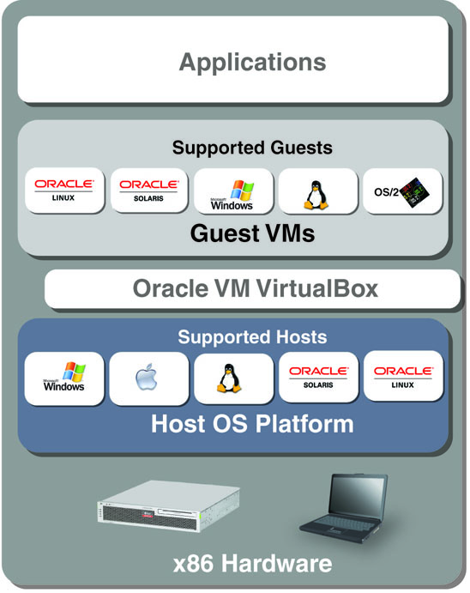

Figure 8: VirtualBox Architecture.

Compare Virtualization Software
In this section, I want to show you something about different Virtualization software and compare them with each other. We will not cover all Virtualization software, compare but will look at some of the most important :

Name | Full Virt | ParaVirt | OS Virt (Containers) | Host OS | Architectures | License
Xen |  |  |  | GNU/Linux, Unix-like | i686, x86-64, IA64, PPC | GPL V2
KVM |  |  |  | GNU/Linux, Unix-like | i686, x86-64, IA64, PPC, S390 | GPL V2
OpenVZ |  |  |  | Linux | i686, x86-64, IA64, PPC, SPARC | GPL
Linux-Vserver |  |  |  | Linux | Everywhere Linux is | GPL V2
VirtualBox |  |  |  | GNU/Linux, Windows, OS X x86, Solaris, FreeBSD, | i686, x86-64 | GPL V2
Citrix XenServer |  |  |  | No host OS | x86, x86-64, ARM, IA-64, PPC | GPL V2
VMware ESX |  |  |  | No host OS | i686, x86-64 | Close Source

OK.
At the end of this chapter, I want to write something about What is a VM. In the computing world, a VM is an emulation of a Computer. Virtual Machines based on computer architecture work as a real or virtual computer. As we said, Different kinds of Virtual Machines are existing and each of them provides different feature and the ability for us. The physical computer called the “Host” and Virtual Machine called “Guest” and guest OS thinking that it's running on a real computer.
You can manage your Hypervisor and Containers via different GUI and web manager :
● virt-manager (Xen and KVM)
● ConVirt (Xen and KVM)
● Ganeti (Xen and KVM)
● Cloudstack ( Xen, KVM and VMWare)
● phpVirtualBox (VirtualBox)
● XenCenter (Citrix XenServer)
● SolusVM (KVM, Xen & OpenVZ)
● OpenNode (KVM and OpenVZ)
● Xen Orchestra

Chapter 2 :

Xen Project

What is XenProject?
Welcome to chapter 2! In this chapter, we will talk about Xen Project more and cover Installation Xen Project. OK, Let's Start!
The Xen Project Hypervisor is an Open Source “Type-1” or Bare Metal Hypervisor which let you run many OS on your server. Operating systems on your server will run in parallel mode. Don't forget, when writing this book, The Xen Project is the only type-1 hypervisor that is Open Source. As we said, some companies like Citrix distribute Xen as a commercial product like “Citrix XenServer” but the range of Xen use is not limited to it and this project used in many areas like Desktop Virtualization, Server Virtualization, Cloud computing and…
Xen Project has tons of features, but we just consider some of the most important of them:

- Xen uses Microkernel design and according to the Xen Project Wiki it just 1MB in size but have a good security.
- Flexibility in Driver: By default, Linux Driver domains for launch back ends for guests depend on udev and it has some problems. For example, If driver crashed or infected, then the driver can be rebooted without affecting the rest of the system. In Xen 4.4, udev replaced with a custom daemon that built top of libxl and provide a good flexibility.
- Paravirtualization: We spoke about it and said that the Paravirtualization introduced by Xen Project. This allows your guest to run much faster and our Hypervisor can run on hardware that don't support Virtualization extension.
- Nested: The Xen Nested provides Hardware Virtualization to Guests and via this ability you can run Xen Project, KVM, Hyper-V and VMware ESX inside a guest and launching your test environment. The Hypervisor that run on real Hardware is called “Level 0” and the Hypervisor that run on Guest called “Level 1” and a guest that running via “Level 1” called “Level 2”.
- Better support of Virtual Desktops Protocols (SPICE). Via SPICE you can have a better Remote Desktop compared with VNC.
- A good news is that the Xen Project supports Grub 2 and don't need any custom implementation of Grub (PvGrub). In the past, The Xen project used “PyGrub” and its behave like Grub and read the standard grub file “menu.lst “ to provide the Xen Project for creating process. The PvGrub is a more efficient and secure alternative for “PyGrub”, But nowadays, The Xen project support “Grub” and it is a good feature.
- XAPI and Mirage OS: Both of them are sub-projects of Xen Project that written in Ocaml programming language. The Mirage is a Cloud OS for making secure and high performance network applications that using on Cloud computing, Embedded devices and Mobile platforms. The XAPI is another project that enables Power saving, cooling and management cost and let you to use your hardware in optimize mode and improve reliability.
- Guest EFI boot: EFI is a new booting standard that used instead of BIOS and nowadays some OS just uses EFI to boot. The Xen Project can support it and can be booted from EFI platform and bootloader like Grub.
- Support of ARM processor

They were some of the most Xen Project features and I bet you can find other important features too, but since our book is a short and practical book then we can't consider and dive into all of them.
In a below texts, I want to show you something about the Xen Project Architecture and I copy a good Figure from Xen Project web site :
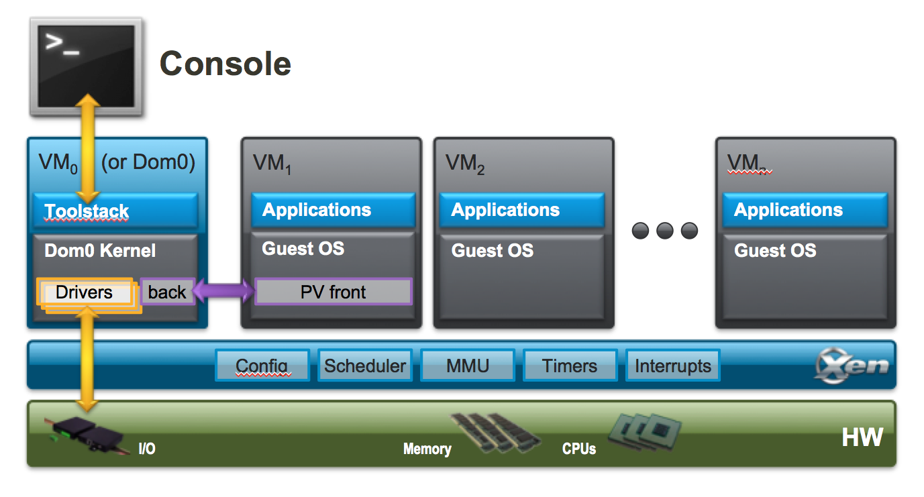

Figure 9 : The Xen Project Architecture.

A simple view of an old Xen diagram is as below:

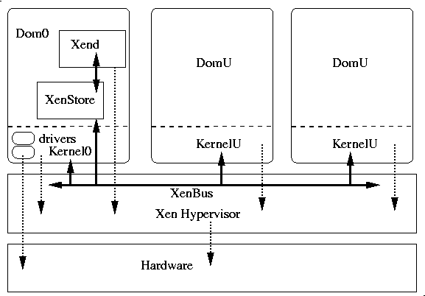

Figure 10 : A simple overview of Xen Architecture.

The Xen Hypervisor run on the hardware directly and managing hardware components like CPU, Memory, Storage and…. A VM called “Domain” or “Guest” and a special domain that belonging to Xen is “Domain 0” and contains of all Hardware drivers. We can say “Domain 0” is a special Virtual Machine too.
In the above diagram, you can see “Xend” that is discontinued and removed in Xen 4.5. It was a node control daemon that perform system management that related to Virtual Machines and control the Virtual Resources. The new replacement for “Xend” is “xl”. It is true that “xl” introduced in Xen 4.1 but “Xend” remain as default and with the advent of Xen 4.5 the “Xend” removed and give its place to “xl”.
The “xl” have better features compared with “Xend” and you can find a list of these features in below link: http://wiki.xen.org/wiki/XL_vs_Xend_Feature_Comparison
We said something about “Xend” and in Xen 2.X, The Toolstack actually used for managing Xen installations. In Xen 4.1, a new Toolstack called libxenlight that also know as libxl. The libxl is a Small and Low level Library that written in C language and easy to understand and modify. It has been designed to provide a simple API for all client Toolstacks. It is a good feature of Xen Project. One of the big differences between xend and libxl is that the “Xend” is stateful while libxl is stateless. With “Xend”, all client applications such as xm and libvirt see the same system state, but In libxl, client applications such as xl or libvirt must maintain state.

If we want wrap-up libxl features then they are:
- Stateless
- So simple
- Implement mechanisms, not policies
- Hide components like xenstore, libxenctrl, and libxenguest from higher levels

In the Xen Project, Each Toolstack provide an API that run different tools.We said something about XAPI and Xen project can run this default Toolstack or Libvirt. Some product like XenServer use special Xen API Toolstack with the name “XCP” or “Xen Cloud Platform”. It is a solution for Xen that provide Virtualization and Cloud computing. It is a not a regular Toolstack and have good abilities like manage pools of host systems for support advanced storage repositories and guarantees SLA and good support of Open vSwitch.
The XCP have two Flavors :
- XCP ISO that install like XenServer and have same drivers and codes. It is based on special version of Xen.
- XCP-XAPI Packages that are some packages that exist in Linux distros and installed via your Linux package manager.
In “https://wiki.xenserver.org/XCP/XenServer_Feature_Matrix” and “https://wiki.xenserver.org/XCP_Release_Features” Urls you can find a list of good features. With this kind of information I guess that you can understand which Toolstack to choose. In the figure below you will see an example of Xen Toolstack :

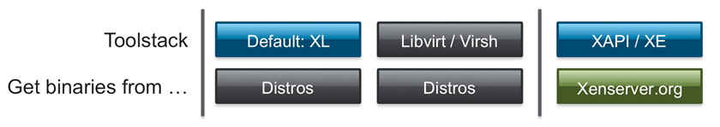

Figure 11 : Xen Tool Stack

Time has come for talk about Paravirtualization.
How does Paravirtualization work?
If you remember, Paravirtualization (PV) was introduced by Xen Project. PV does not require Virtualization Extension from CPU and enable Virtualization on Hardware that don't support Hardware Virtualization, But require Kernel support and special driver and Kernel built that nowadays are part of The Linux kernel and other OS.
PV is a new term for an old idea from IBM. In other hand, When Xen Hypervisor running on Hardware that doesn't support Hardware Virtualization then Xen need that the guest OS customized. This customized OS using an abstract hardware model that differs from the specific hardware that is available on the physical machine and can execute at lower privilege level than the hypervisor. As you know, The Hypervisor handle CPU, Memory, System calls and… and this technique known as “Paravirtualization” because our modified OS in order to handle privileged operations must communicate with the hypervisor that administrated by Xen.
As you know some Operating Systems like Microsoft Windows is Closed source and the Xen Project windows provide a kit of paravirtualization device drivers under GPL license that installed on Windows OS. I guess you understood that in PV, The Hypervisor act like a layer that control access of guest OS to the underlying hardware resource.
Why PV? Because it has some advantage over other techniques. Performance is the most obvious advantage because it is a very small amount of code and as we said PV is layered and can act like a traffic controller too. For example, Allowing one OS to have access to physical Hardware while stopping other OS from accessing the same resource. Another good feature is that PV shows you an unlimited way about device drivers in the guest OS. What do you think about Disadvantage? I know that your thinking about Closed Source OS like Microsoft Windows. You know that PV need the guest operating systems be modified in order Paravirtualization, but how? Fortunately, Citrix has provided a set of PV driver for Windows from XenServer product and these drivers become Open Source under BSD license. The team from Xen Project that working on Windows PV Drivers, maintaining and developing these drivers under Xen Project governance. These drivers can be found at “http://www.xenproject.org/downloads/windows-pv-drivers.html”. Again, As you remember, The Intel and AMD CPUs provide functionality that enables unmodified operating systems to be hosted by a paravirtualized hypervisor. In addition to the Citrix and other companies like Novell that provided PV Drivers, Some GPLed drivers produced by developers like “James Harper”. For more information, Please see “http://wiki.univention.de/index.php?title=Installing-signed-GPLPV-drivers”. As you see, All people Love Xen.
OK, Speaking about Xen is enough and Let me jump to the Xen installing.

How to Install Xen project?
For installing Xen Project, You have two options :
- Install via your Linux Distro package manager
- Install from source code.
First of all, Let me guess, what do you think! I guess you are thinking that which Linux Distro is better for Xen. I want to tell you that it is a personal preference and depended on your skill. If you have an experience in Fedora then Fedora is good for you and if you have a background with Debian then Debian is good, But Distros like Debian, Ubuntu, openSUSE, SUSE Linux Enterprise Server, Fedora, and NetBSD have a good support for Xen Project and if you want select CentOS then you must consider that CentOS needs extra software for it. For an update list about which distro is OK with Xen Project, Please look at the “http://wiki.xenproject.org/wiki/Dom0_Kernels_for_Xen” URL. I choose Fedora for as Dom0 and I consider that you installed Fedora on your server. If you don't know how you can install Linux then Please Google “how to install Fedora”. I choose “Fedora Server Edition” and when you want to install it, I recommended to select “Headless Virtualization”:
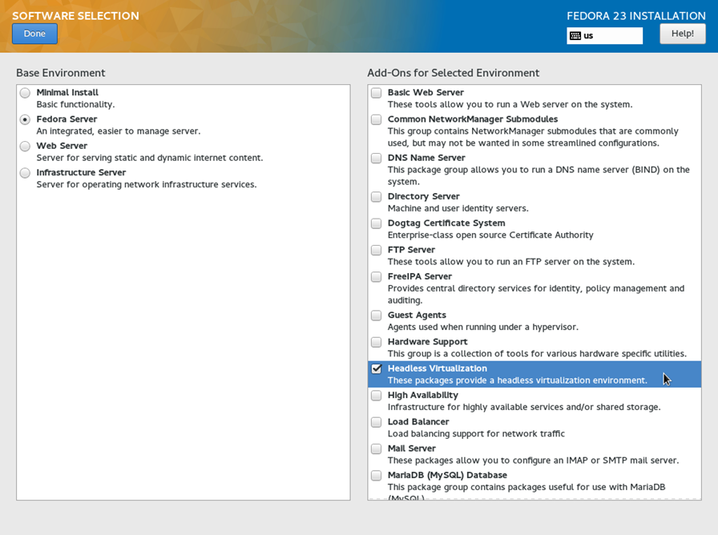
Figure 12: Fedora Server Edition

Welcome to Fedora, by default when you install Fedora, It will install some packages like “LibreOffice” but it depended to your install scenario. If you install Fedora Workstation then it installed “LibreOffice” and we don't like to update “LibreOffice”. If you like all of your Fedora components updated then just run “yum update” else follow me.
I don't like all of my Fedora components like “LibreOffice” updated because it is a server and I don't like to write and edit “.odt”, “.doc” and “.docx” files on it, So I want to exclude “LibreOffice” from the update. To exclude a package from update you should edit “yum.conf” file as below: 1- open “yum. conf” file from “/etc/yum.conf” with an editor like “vim” or “nano”(In newer version of Fedora it changed to “dnf. conf” and is under “ /etc/dnf/dnf.conf”).
In Fedora you can use “dnf” instead of “yum” and for more information see “http://dnf.readthedocs.org/en/latest/command_ref.html”. For example :
# yum update == # dnf update
2- use “exclude=” for ignoring specific packages. For example, for ignoring “LibreOffice” package adds “exclude=libreoffice*” and the star at the end of “LibreOffice” mean all packages with start “LibreOffice”. My “dnf.conf” file is as below :

[main]
gpgcheck=1
installonly_limit=3
clean_requirements_on_remove=True
exclude= LibreOffice *

Notice that you can use “--exclude=” parameter in command line too. For example :
# dnf update --exclude= LibreOffice *
3- Run “dnf update” as root user or via “sudo” command.
# dnf update
4- After an update, The time has come to install “Xen”, But you must consider that for the Xen Project on Fedora you must add a repository. It is not mandatory, but In order to enable this repository run below commands:
# cd /etc/yum.repos.d/
# wget http://fedorapeople.org/groups/virt/virt-preview/fedora-virt-preview.repo
# dnf update
5- You can install Xen Project now, but if you have any issues then you should Disable “Selinux”. The Selinux problems with Xen on Fedora 21 and later are solved, but for disable Selinux you can do below steps:
First of all, check Selinux status by a run “/usr/sbin/sestatus” :
[root@mohsen ~]# sestatus
SELinux status: enabled
SELinuxfs mount: /sys/fs/selinux
SELinux root directory: /etc/selinux
Loaded policy name: targeted
Current mode: enforcing
Mode from config file: enforcing
Policy MLS status: enabled
Policy deny_unknown status: allowed
Max kernel policy version: 29
For disable Selinux open “/etc/selinux/config” via nano and then change “SELINUX=enforcing” to “SELINUX=disabled” :
# This file controls the state of SELinux on the system.
# SELINUX= can take one of these three values:
# enforcing - SELinux security policy is enforced.
# permissive - SELinux prints warnings instead of enforcing.
# disabled - No SELinux policy is loaded.
SELINUX=disabled
# SELINUXTYPE= can take one of these three values:
# targeted - Targeted processes are protected,
# minimum - Modification of targeted policy. Only selected processes are protected.
# mls - Multi Level Security protection.
SELINUXTYPE=targeted

After it you are ready to install the Xen Project :
# dnf install xen
After that the Xen project installed successfully, then you must configure Grub. You below command for configure your grub:
# grub2-mkconfig -o /boot/grub2/grub.cfg
and
# reboot
When your system rebooted, then you can see other options on your grub menu: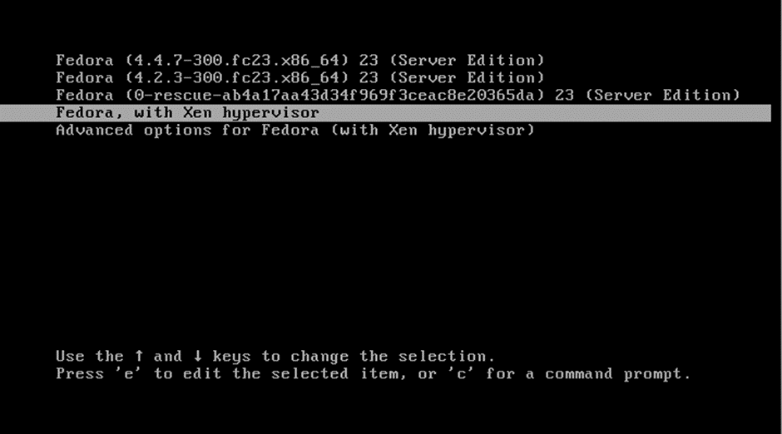
Figure 13 : Grub with Xen Hypervisor

By default grub use the first option to boot, but if you want your system boot via Xen Hypervisor always then you can change this default option via below commands:

# grep ^menuentry /boot/grub2/grub.cfg | cut -d "'" -f2
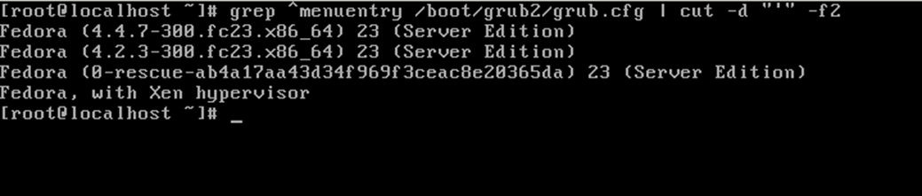
Figure 14 : Grub Entry
# grub2-set-default “Fedora, with Xen hypervisor”
# grub2-editenv list
# grub2-mkconfig -o /boot/grub2/grub.cfg

After it, You can see that “ Fedora, with Xen hypervisor” is selected by default.
OK, We boot Fedora via Xen Project and run below command to sure that The Xen Project installed successfully :
[root@localhost ~]# xl info
host : localhost.localdomain
release : 4.4.7-300.fc23.x86_64
version : #1 SMP Wed Apr 13 02:52:52 UTC 2016
machine : x86_64
nr_cpus : 8
max_cpu_id : 7
nr_nodes : 1
cores_per_socket : 4
threads_per_core : 2
cpu_mhz : 3392
hw_caps : bfebfbff:28100800:00000000:00003f00:179ae3bf:00000000:00000001:00000000
virt_caps : hvm
total_memory : 8109
free_memory : 128
sharing_freed_memory : 0
sharing_used_memory : 0
outstanding_claims : 0
free_cpus : 0
xen_major : 4
xen_minor : 5
xen_extra : .3
xen_version : 4.5.3
xen_caps : xen-3.0-x86_64 xen-3.0-x86_32p hvm-3.0-x86_32 hvm-3.0-x86_32p hvm-3.0-x86_64
xen_scheduler : credit
xen_pagesize : 4096
platform_params : virt_start=0xffff800000000000
xen_changeset :
xen_commandline : placeholder
cc_compiler : gcc (GCC) 5.3.1 20151207 (Red Hat 5.3.1-2)
cc_compile_by : mockbuild
cc_compile_domain : [unknown]
cc_compile_date : Wed Mar 30 19:19:01 UTC 2016
xend_config_format : 4

If you got any error like below :
# xl info
xc: error: Could not obtain handle on privileged command interface (2 = No such file or directory): Internal error)
libxl: error: libxl.c:114:libxl_ctx_alloc: cannot open libxc handle: No such file or directory
cannot init xl context

Then you must consider using commands like “systemctl enable xend.service” and “systemctl enable xendomains.service” and retry. The Xen Project has a good community and you can ask your questions from them.
Now that we have installed Xen and boot via its successfully, then we must cover something about the Xen itself.

Xen Project Compatibility
I guess compatibility is a big problem for you to use Xen. For example, You may ask yourself that is Xen Project compatible with my Hardware? Can I use Xen Project on my current Hardware? And etc.
You can run Xen on many hardware flavors like Laptops and you should not have any worry about it. The Xen project, Can support many architectures and if you see a table that we introduced it in Chapter one then you can understand it. Currently, The Xen project can support x86, x86_64 and ARM architectures. Another question that you mas ask is your VGA. Can the Xen Project support my Nvidia or ATI VGA card? The Xen Project has a good community about VGA adapters that you can find it at “http://wiki.xenproject.org/wiki/Xen_VGA_Passthrough_Tested_Adapters” and in this URL you can find a list of VGA models that tested by the community. By the way, at “https://wiki.centos.org/HowTos/Xen/NvidiaWithXen” URL you can see that some people installed Nvidia driver on Xen and it worked properly. As I said, Some OS like “qubes-os” use Xen and according to the “qubes-os” documents you can install Nvidia Driver with some tricks. For more information, Please see “https://www.qubes-os.org/doc/install-nvidia-driver/”. Citrix XenServer at “http://hcl.xenserver.org/” provide a good list of The Hardware and servers that supported by Citrix XenServer.
You can see your CPU features in Linux by below command :
# cat /proc/cpuinfo
And for mine it is something like :
processor : 0
vendor_id : GenuineIntel
cpu family : 6
model : 42
model name : Intel(R) Core(TM) i7-2600K CPU @ 3.40GHz
stepping : 7
microcode : 0x17
cpu MHz : 3392.414
cache size : 8192 KB
physical id : 0
siblings : 8
core id : 0
cpu cores : 4
apicid : 0
initial apicid : 0
fpu : yes
fpu_exception : yes
cpuid level : 13
wp : yes
flags : fpu de tsc msr pae mce cx8 apic sep mca cmov pat clflush acpi mmx fxsr sse sse2 ss ht syscall nx lm constant_tsc rep_good nopl nonstop_tsc eagerfpu pni pclmulqdq monitor est ssse3 cx16 sse4_1 sse4_2 popcnt tsc_deadline_timer aes xsave avx hypervisor lahf_lm ida arat epb pln pts dtherm xsaveopt
bugs :
…

I guess it is enough and main features are that The Xen Project can support popular architectures and Hardware. Let me to dive into the Xen Project components.

Xen project components
The Xen Project components consist of the Xen hypervisor, the Domain0 and DomU that is any number of VM. A Physical computer running all of these components that referred to it as a VM Host.
We spoke something about these components, but we do a short reminder:
The Xen Hypervisor:
It is a Virtual Machine Monitor that is an Open Source software that coordinate Low Level parts between Vms and Physical Hardware.

The Domain0:
The Domain0 is controlling domain that comprised of Host OS, The Xend daemon and a modified version of Qemu.

The VM Guest or DomU:
The DomU consist of Virtual Disk, Network Devices and other Hardware Plus Virtual Machine configuration files.

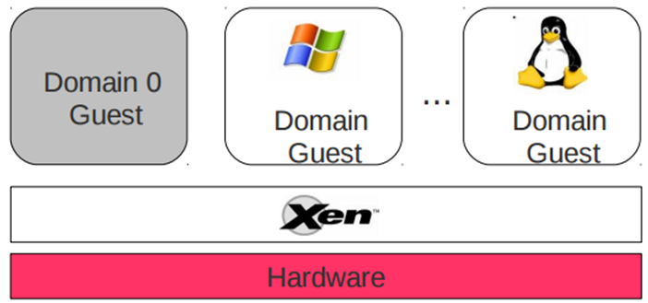
Figure 15: Another view of The Xen Project Components.

Xen Project Commands
OK, Now is a good time for speaking about Xen commands and if you remember we said that “xm” is removed from Xen version 4.5, Thus we will cover “xl” here. We will not cover all parameters of “xl” here, but we will most important of it.
You are as a Linux administrator familiar with “man” command and for finding a full details of “xl” command and parameters Please type “man xl” in your console. I prepared a table of most important commands that you can see it below :

Command Description
xl help View available options and help.
xl list Show active domains.
xl create Start and create a VM.
xl reboot Reboot a VM.
xl shutdown Shutdown a VM.
xl destroy Terminate a VM immediately. It is like Shutdown but work immediately.
xl console Attach to a VM console.
xl info Show information about Xen Host.
xl top Monitor host and domain in real time.
xl network-list List of Virtual network interfaces.
xl dmesg Read or clear dmesg buffer.
xl pause Pause A domain.
xl unpause Unpause a domain.
xl save Save a domain state.
xl vcpu-list List the VCPUs for all/some domains.
Xl uptime Show uptime for all/some domains

They are not all parameters and I'm sure you can find other useful parameters too. Just run “xl help” and you will find a list of all available parameters. We can't cover all of the here and we just show you some of them.

Compiling Xen from Source Code
I guess you are thinking that about installing The Xen Project from Source Code and we haven't forgotten it. To be frank, When your Linux Distro has package management and The Xen Project prepared as a package for your Linux Distro then most users (Administrators and novice) use it and don't like to compile it from Source Code unless you like to use special parameters when installing The Xen Project.
The Xen Project Wiki prepares a section about this goal and you can find useful information about it in “http://wiki.xenproject.org/wiki/Compiling_Xen_From_Source” URL.

Chapter 3:

Dom(s) and Grub

Welcome to Chapter 3. We want to speak about Dom0 and DomU. I'm sure that currently you know what is Xen Domain but we want to speak about it more.
Dom0 is the initial domain started by the Xen hypervisor on boot. Its mean “Domain0” and “Dom0” is an abbreviation for it. The Dom0 duty is a privilege domain that manages DomU domains. Without it our Hypervisor is useless and it is kind of “Host” OS, But have special and low level access to hardware. The Dom0 has Drivers for your Hardware but you must know something about the Backend Driver and Front-end Driver. These are two terms for Xen Project.
If DomU wants share hardware, then Dom0 must give it an interface for make requests for access to the hardware. This is done via Backend Driver. For access to the Hardware that shared between Domains, DomU must contact to Dom0. The Front-end Driver prepared for the OS in DomU and use XenBus, XenStore, Shared Pages and... for communicating with Backend Driver. I just want to tell you that “XenStore” is an information storage space that shred between domains and maintained by the Xenstored. The XenBus provides a bus abstraction for Paravirtualized drivers to communicate between domains.
For more information about “XenStore” and “XenBus” Please see “http://wiki.xenproject.org/wiki/XenStore” and “http://wiki.xenproject.org/wiki/XenBus”.
In below Figure, You can see a cute photo about Dom0 and DomU :

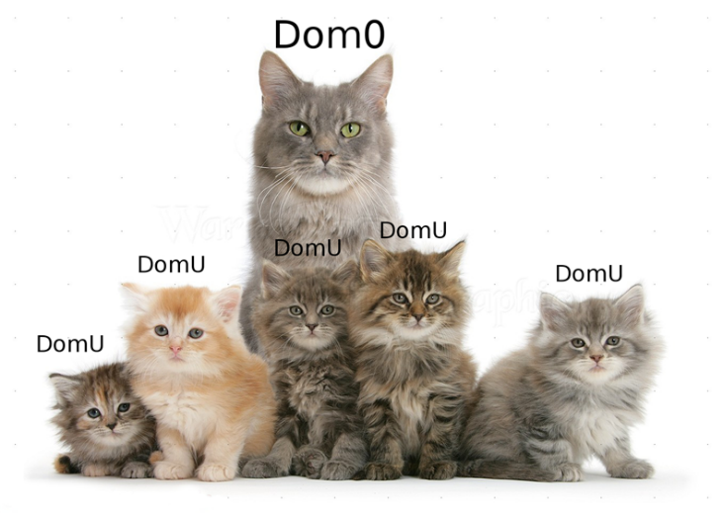
Figure 16: DomU and Dom0
I guess you are impatiently waiting for how you can configure Dom0 and DomU. The dome is used for configuration our Guest OS and we will configure it in the next chapter but we will Play with Dom0 here. I know that your thinking, that we want to hack Dom0 here, but your wrong, We just want to show you a way to manipulate:

Change Dom0 memory
For change memory setting you must open /etc/default/grub with an editor like “nano” and apply your Arbitrary settings :
[root@localhost ~]# cat /etc/default/grub
GRUB_TIMEOUT=5
GRUB_DISTRIBUTOR="$(sed 's, release .*$,,g' /etc/system-release)"
GRUB_DEFAULT=saved
GRUB_DISABLE_SUBMENU=true
GRUB_TERMINAL_OUTPUT="console"
GRUB_CMDLINE_LINUX="rd.lvm.lv=fedora/root00 rd.lvm.lv=fedora/swap rhgb quiet"
GRUB_DISABLE_RECOVERY="true"

Find “GRUB_CMDLINE_LINUX” and add “dom0_mem=512M, max: 512M” at the end of this line. After it, Your Dom0 will use 512 megabyte memory and “max” parameter means the maximum memory usage:

[root@localhost ~]# cat /etc/default/grub
GRUB_TIMEOUT=5
GRUB_DISTRIBUTOR="$(sed 's, release .*$,,g' /etc/system-release)"
GRUB_DEFAULT=saved
GRUB_DISABLE_SUBMENU=true
GRUB_TERMINAL_OUTPUT="console"
GRUB_CMDLINE_LINUX="rd.lvm.lv=fedora/root00 rd.lvm.lv=fedora/swap rhgb quiet dom0_mem=512M,max:512M"
GRUB_DISABLE_RECOVERY="true"

Then you must run “grub2-mkconfig -o /boot/grub2/grub.cfg” and reboot your system. After it, The Dom0 will use 512 Megabyte of memory. You can use B for bytes, K for kilobytes, M for megabytes, or G for gigabytes.
If you do some research the you will find a “ballooned” term. The Xen Project from version 3+ supporting memory “ballooning” that allow you to hot, add and remove memory from a running System. It is a technique that used to dynamically adjust the physical memory in use by a guest. Let me show you an example. I have a VM and give it 1024MB memory, but I notice that it just uses %50 of its memory and 512M of my memory wasted and The Xen Project let me to re-size my VM memory without any Downtime. Now that you are familiar with this Term, I want to show you that you can config it via “XL” command.
Open “/etc/xen/xl.conf” file and find “#autoballoon="auto"” then remove “#” and change “auto” to “0”. After it, the “xl” can't adjust the amount of memory assigned to dom0 :
[root@localhost ~]# cat /etc/xen/xl.conf
## Global XL config file ##

# Control whether dom0 is ballooned down when xen doesn't have enough
# free memory to create a domain. "auto" means only balloon if dom0
# starts with all the host's memory.
#autoballoon="auto"

# full path of the lockfile used by xl during domain creation
#lockfile="/var/lock/xl"
...

Change :
[root@localhost ~]# cat /etc/xen/xl.conf
## Global XL config file ##

# Control whether dom0 is ballooned down when xen doesn't have enough
# free memory to create a domain. "auto" means only balloon if dom0
# starts with all the host's memory.
autoballoon="0"

# full path of the lockfile used by xl during domain creation
#lockfile="/var/lock/xl"
...

You may ask yourself, Why you must dedicate the fixed amount of memory for Dom0. It is a good idea because :
● The Linux Kernel calculates various network parameters at the boot time and based on this memory.
● For store the memory metadata, The Linux need some amount of memory and this feature based on the memory on the boot time.
For more information about “Ballooned”, Please look at “https://blog.xenproject.org/2014/02/14/ballooning-rebooting-and-the-feature-youve-never-heard-of/” and “http://xenbits.xen.org/people/liuw/xen-balloon-driver-improvement.pdf”.

Limit the number of vcpus
To dedicate “vcpu” to Dom0 you must use “dom0_max_vcpus=X” option and “X” is the number of vcpu that you need. You must open “grub.conf” via an editor like “nano” and add above option to it :

# cat /etc/default/grub
GRUB_TIMEOUT=5
GRUB_DISTRIBUTOR="$(sed 's, release .*$,,g' /etc/system-release)"
GRUB_DEFAULT=saved
GRUB_DISABLE_SUBMENU=true
GRUB_TERMINAL_OUTPUT="console"
GRUB_CMDLINE_LINUX="rd.lvm.lv=fedora/root00 rd.lvm.lv=fedora/swap rhgb quiet dom0_max_vcpus=2"
GRUB_DISABLE_RECOVERY="true"

As you see, I dedicated two VCPUs to my Dom0.
Let me guess your question! I guess you are thinking about dedicate a CPU core to Dom0. Am I right? I must tell you that you can. It is possible and sometime is a good idea and guarantee that Dom0 always has Free CPU time and can process the I/O requests from DomUs. For doing it, You must use “ dom0_max_vcpus=X dom0_vcpus_pin” option in your “grub.conf” file :
# cat /etc/default/grub
GRUB_TIMEOUT=5
GRUB_DISTRIBUTOR="$(sed 's, release .*$,,g' /etc/system-release)"
GRUB_DEFAULT=saved
GRUB_DISABLE_SUBMENU=true
GRUB_TERMINAL_OUTPUT="console"
GRUB_CMDLINE_LINUX="rd.lvm.lv=fedora/root00 rd.lvm.lv=fedora/swap rhgb quiet dom0_max_vcpus=2 dom0_vcpus_pin"
GRUB_DISABLE_RECOVERY="true"

After rebooting you can test it via “xl vcpu-list” command.
After it, The next step is to configure your Guests. You must configure them because they must not use those same physical CPUs. This can do via the guest configuration file under “/etc/xen/<guest>.cfg” file. We will talk about it in the future.
You can do more research and find some interested parameters that you like. We prepared a table that shows you some dom0 options :

Option Description
dom0_mem=X Amount of Memory that allocated to Dom0.
apic=default Via this option you can manipulate interrupt controllers but it is detected automatically.
nolapic Don't use APIC even it is enabled by BIOS.
nosmp Disable SMP support.
watchdog It is using for debugging and can be helpful in reporting failures.
noreboot Don't reboot machine automatically when an error happened.
Vga Use VGA console.
com1 Use serial Port COM1.

To be honest, these options that are said are important, But you can find a list of these hacking at http://wiki.xenproject.org/wiki/Xen_3.x_Configuration_File_Options and http://wiki.xenproject.org/wiki/Tuning_Xen_for_Performance .
Next we would like to talk about the Xen Project and Grub.

Xen Project and Grub
If you remember, we briefly talked about PvGrub and PyGrub. The PyGrub enable you to start DomU with a Kernel that inside of DomU instead of Kernel that lies in the filesystem of the Dom0. As you see, this cause easier management and each DomU manage its own kernel and if you manipulate DomU kernel then it can't affect on Dom0 Kernel. The PyGrub have a behavior like Grub and read the standard Grub configuration file (grub.cfg).
The PyGrub, use libfsimage for support Ext2/3/4, FAT, ISO9660, REISERFS, UFS and ZFS File Systems. If you want your DomU use PyGrub then you must add “bootloader = "/usr/bin/pygrub"” in your DomU config file. The PyGrub just support Grub 1 & Grub 2, LILO and ExtLinux bootloaders. Don't forget, Use it is not as easy we said and some Linux Distros need special configuration for it. For example, For Configure it for Debian Please see “https://tipstricks.itmatrix.eu/using-pygrub-on-squeeze-to-boot-a-domu-kernel/”.
The PvGrub or ParaVirtual Grub is a boot manager for Xen Vms. It is a safer alternative for PyGrub to boot DomU images. We can say that the PvGrub is an adapted version of the grub boot loader. The PvGrub require Xen 3.3 or higher. It is provided by the Xen source and you don't need to install grub in DomU. PvGrub Compared with PyGrub has less bugs and is more secure. PvGrub is not scripted and is binary that has less dependencies. For a good How to about it, Please see “http://backdrift.org/xen-pvgrub-howto”.
Now, The time is come to speak about Grub bootloader.

Grub2
A boot loader is the first program that runs when a computer start. The boot loader is responsible for loading and transferring control to an operating system kernel like Linux and then the Kernel initialize the rest of the OS. Grub2 is a powerful boot loader that support modern OS. One the important feature of Grub is flexibility. GNU Grub can offer you a command-line interface and a menu interface. Via CLI you can type the drive and the kernel file manually, but via Menu you select an OS via arrow Keys.
Grub2 is a rewrite version of Grub and have some changes. For example, In the previous version of Grub, The config file name was “menu.lst” or “grub.conf” but in Grub2, It changed to “grub.cfg”. A good advantage of Grub2 is that it can support many file systems and not limited to ext4, HFS+, and NTFS. The “grub.conf” automatically generated by “grub-mkconfig” and it help you to handle various Kernel easier. I'm sure you can remember “grub-mkconfig” in recent chapter and worked with it for generating your Kernel.
If you like to have a good knowledge about Grub2 then IBM has a good article about it that can be found at “http://www.ibm.com/developerworks/library/l-grub2/”. We recommended to see “https://blog.xenproject.org/2015/01/07/using-grub-2-as-a-bootloader-for-xen-pv-guests/” for more information about Grub and Xen.
We showed you some important parameters that you can use them via Grub and the good point is that the GNU Grub is part of Xen by default.
In below Figure, You can see a diagram about The Linux Boot process:

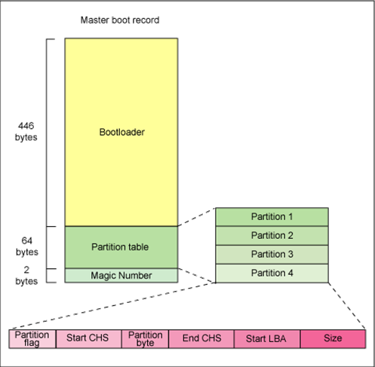
Figure 17 : Linux Boot Process
What do think? We showed you some important information about Boot and Xen Project and recommended to read the articles that introduced. In the article from Xen project, You can see and Learn how to install “pvgrub2” but this article may be removed or moved to other places in the future and I just show you the installing process :

1- Git grub :
# git clone git://git.savannah.gnu.org/grub.git
2- Compile :
# ./autogen.sh
3- Configure Grub to use Xen :
# ./configure --target=amd64 –with-platform=xen (For 64 bit)
# ./configure --target=i386 –with-platform=xen (For 32 bit)
4- make and install :
# make && make install

Now, Grub installed and you must create “pvgrub2” image :
1- create a file with the name “grub.cfg” and open it via “nano” editor and write below text to it :
normal (xen/xvda,msdos1)/boot/grub/grub.cfg
2- Build grub image using “grub-mkimage” utility :
# grub-mkimage -O x86_64-xen -c grub.cfg -o grub-x86_64-xen.bin $prefix/lib/grub/x86_64-xen/*.mod
3- Now, You can start a guest via “grub-x86_64-xen.bin” as a Kernel by writing below line in your guest configuration :
# kernel = "grub-x86_64-xen.bin"

Chapter 4:

Using Xen Project

Configuring and Booting Virtual Machines
Welcome to chapter 4, I bet this chapter is, the more interested chapter for you and you can learn to run and manage your Virtual Machines via The Xen Project. In this chapter, we show you how you can configure DomU and setting up your network and storage. We knows, You are familiar with Linux but we show you some Linux tools for manage LVM and create your partitions. After this chapter, You can manage Xen Project and your Virtual Machines and Install GNU/Linux and Windows OS on your Xen Project ax DomU. We will speak about a tool with the name “ virt-manager” that is a Graphical tool for managing your Vms.
By default, Fedora Server edition not have any Graphical Environment and as you know, The Graphical Environment need a lot of resources and not a good idea for server. So, System administrator don't like to install Graphical Environment and prefer CLI. You may ask yourself, Some Graphical Environment like “XFCE” need low resources but compared with CLI they need more resources.

Manage virtual machines with virt-manager
We want to show you “virt-manager” and it is a graphical program, Thus we need to install a Graphical Environment. Popular Desktops in Fedora are “Gnome” , “KDE” , “XFCE” and “MATE” but you can use other Desktops too.
For Install a Graphical Environment use below commands :
Gnome :
# yum groupinstall gnome
or
# yum groupinstall gdm
KDE :
# yum groupinstall kde
XFCE :
# yum groupinstall xfce
MATE :
# yum groupinstall "MATE Desktop”

When installing finished just run below command :
# startx
And after it you can see your Desktop. Mine is:
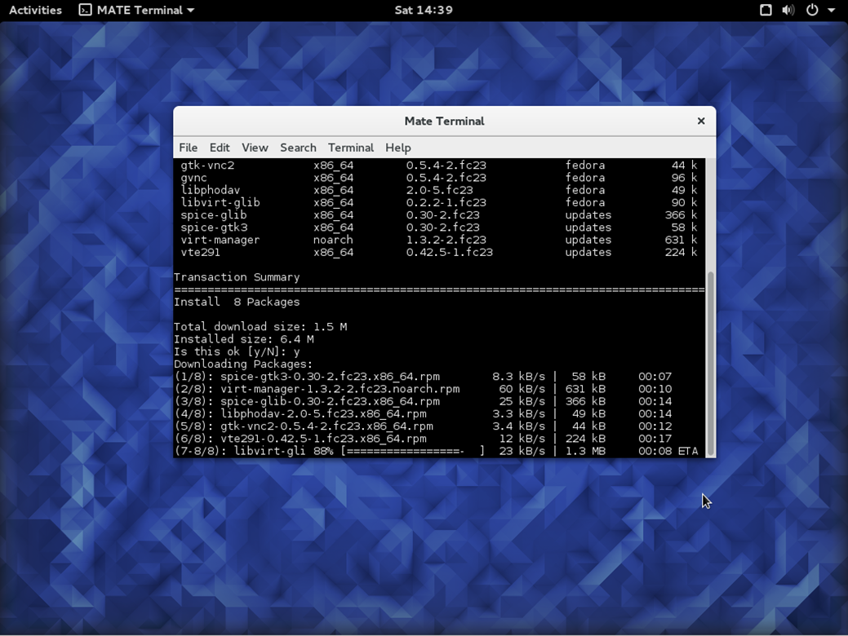
Figure 18 : MATE Desktop

Open a “Terminal” and type below command for installing “Virt-Manager” :
# yum install virt-manager
After it you can run “virt-manager”.
Usually, Xen Masters use LVM volumes to store the Xen guest virtual disks and we will explain it in the future and skip it now, But just know that you can use Virtual HDD and real partition for your Guest DomU.
The Virt-manager, provide a good GUI and you can create your DomU via it very easy :

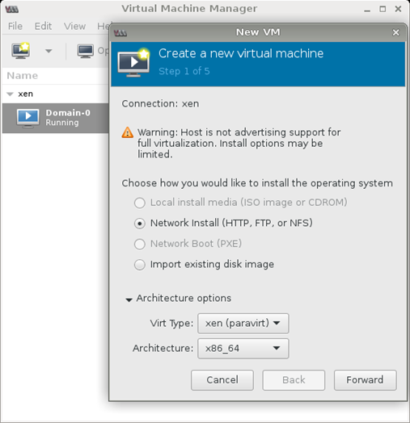
Figure 19: Virt-Manager (OpenSUSE)

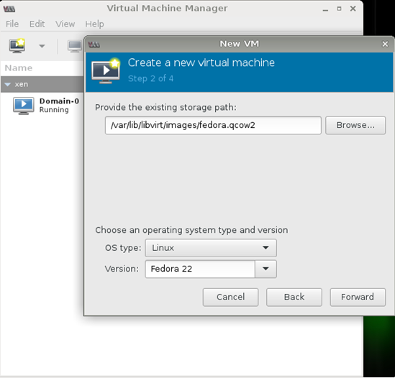
Figure 20: Virt-Manager (Create Fedora 22 as DomU on OpenSUSE)

As you see, It is easy as ABC and give you this ability to run your own DomU guest via a nice Graphical interface.
Note that, If after install Graphical Environment your Xen Project show you an error, Then don't worry and Just Reinstall the Xen Project via below command :
# dnf reinstall xen*
After, Everything back to a right point.
If you start “Virt-Manager” and see some error like “unable to connect to libvirt” then don't worry, Just type below command :
# service libvirtd restart

You as a Linux administrator know that Linux has “/var/log/” directory that record everything that happening in your system. After install Xen, The Xen Project create a directory with the name “xen” under “/var/log” and all Xen errors and...recorded under this directory. If you encounter with any error just see “/var/log/xen/”.
OK, It is enough and you are familiar with “Virt-Manager”. Now, It is a good time for speaking about “ Storage and Networking”. Let's Go!

Storage and Networking
The Xen Project can use your real partition on your HDD as a Guest HDD and you can add HDD image also. We say it “Local Storage”. The Local Storage can partitioned via a tool like “LVM” or you can save your HDD image as a file on it. Let me to speak about LVM more.
LVM or Logical Volume Manager is a device mapper in Linux. You may ask, What is Device Mapper? OK, The Device Mapper is a framework that provided by The Linux Kernel and its goal is mapping physical block devices onto high-level virtual block devices. Device Mapper passing data from a virtual block device to another block device. The LVM provide logical volume management for the Linux Kernel and a method of allocating space on storage devices. LVM is more flexible that traditional partitioning. When you install Linux, It selected a best method for partitioning by default.
You can consider “LVM” as a "dynamic partitions", Its mean that you can create/resize/delete partitions while your Linux is running and you don't need any reboot for influence. LVM have many benefits but some of important of them are :
● It can support more than one HDD.
● LVM can be created to support RAID. including RAID 1, RAID 5 and RAID 6
● It can support HA (High availability) and is a good option for Clusters.
● Save space. Small chunks of unused space from several disks can be combined to create a usable volume.

With a lot of features, It has some bad things too. For example, the initial set-up of LVM is more complex than just partitioning a disk and you must understand LVM scheme and models.
It a good figure that help you to understand LVM easily :

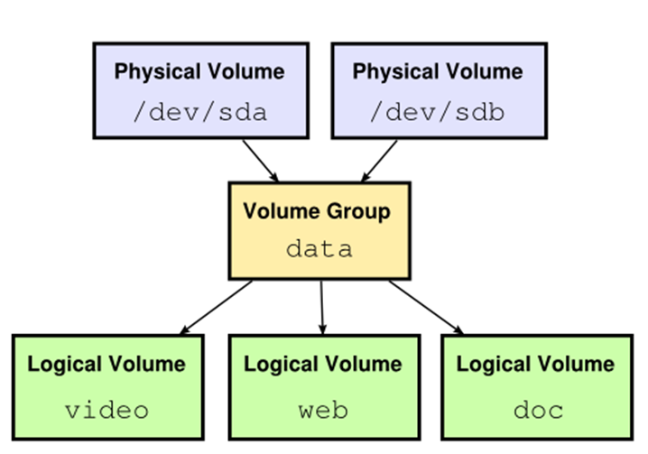
Figure 21: LVM Scheme.

I guess you understand it better. I want to show you some Linux Tools that via them you can manage your HDDs.
The first tool that we cover here is “fdisk” or “cfdisk”. Just type :
# cfdisk
or
# fdisk -l
I bet you will found “cfdisk” more friendly. The “fdisk -l” command will show you all of your partitions and HDD on your system. For example, For mine is :
[root@localhost ~]# fdisk -l
Disk /dev/sda: 931.5 GiB, 1000204886016 bytes, 1953525168 sectors
Units: sectors of 1 * 512 = 512 bytes
Sector size (logical/physical): 512 bytes / 512 bytes
I/O size (minimum/optimal): 512 bytes / 512 bytes
Disklabel type: dos
Disk identifier: 0xed8a6a75
Device Boot Start End Sectors Size Id Type
/dev/sda1 2048 662710271 662708224 316G 8e Linux LVM
Disk /dev/mapper/fedora-root00: 300 GiB, 322122547200 bytes, 629145600 sectors
Units: sectors of 1 * 512 = 512 bytes
Sector size (logical/physical): 512 bytes / 512 bytes
I/O size (minimum/optimal): 512 bytes / 512 bytes
Disk /dev/mapper/fedora-swap: 16 GiB, 17179869184 bytes, 33554432 sectors
Units: sectors of 1 * 512 = 512 bytes
Sector size (logical/physical): 512 bytes / 512 bytes
I/O size (minimum/optimal): 512 bytes / 512 bytes

And “cfdisk” :
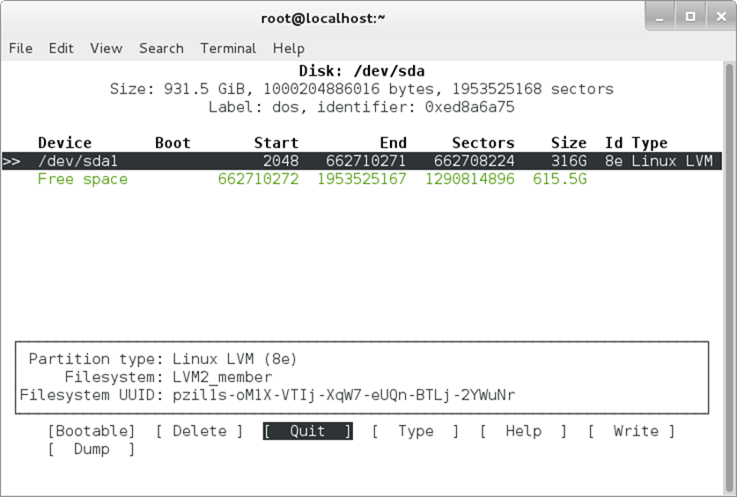
Figure 22: cfdisk.
OK. The first method that we choice is using your real partition as guest HDD.
I added a new HDD to my system and linux detected it as “sdb”. Let me to tell you how Linux detect Device/Drive names. If you look at “/dev/” directory then you will find interesting names. Linux detect IDE Disk as “hd” and SCSI disks as “sd”. The complete scheme is “/dev/xxyn”. The “xx” is “hd” or “sd” as we said and :
● Y : It is a letter that indicate the number of Hard Disk. For example, “hda” mean the first IDE disk and “sda” mean the first SCSI Disk.
● N : It is a number that indicate the number of partition. Don't forget, The first four partitions (primary or extended) are in range 1..4. Logical partitions start from 5. For example, “/dev/hda2” mean the first IDE Hard Disk and The second primary or extended partition and “/dev/sdb5” mean the first logical partition on second SCSI hard disk.
We explained it because we don't like you remove other partitions and lost your data.
I added a new HDD to my system and Linus detected it as “sdb”. I use below command for look at my new HDD :
# cfdisk /dev/sdb
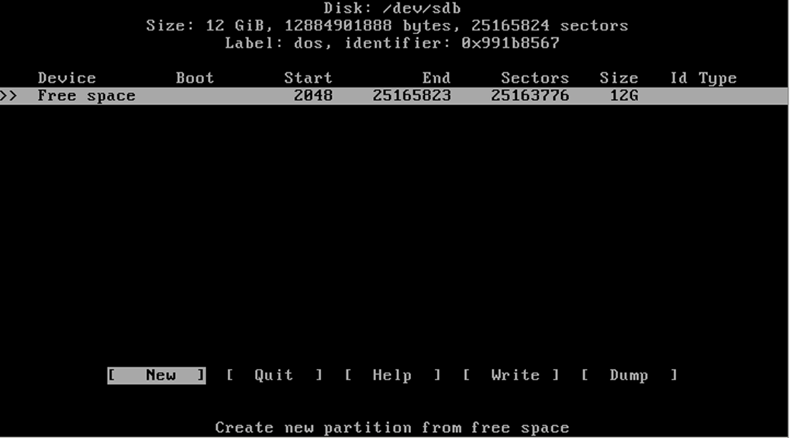
Figure 23: cfdisk
Create a partition via “cfdisk” is straightforward and don't need any teach, But don't forget to select “Empty” as your file system. Our suggestion is that don't create any partition and just use “parted” tool as below.
I used a tool with the name “parted” as below :
# parted /dev/sdb mklabel msdos
It show you a warning message about that all of your information will be destroy. Type “yes” and enter. Then, Write below command :
# parted /dev/sdb mkpart primary
after this command, Linux ask you some questions, I selected default file system (ext2) and enter “1” as “Start” and “100%” as “End”.
What do you see? Linux created a partition for you with the name “/dev/sdb1”. You can confirm it via below command :
# fdisk /dev/sdb -l
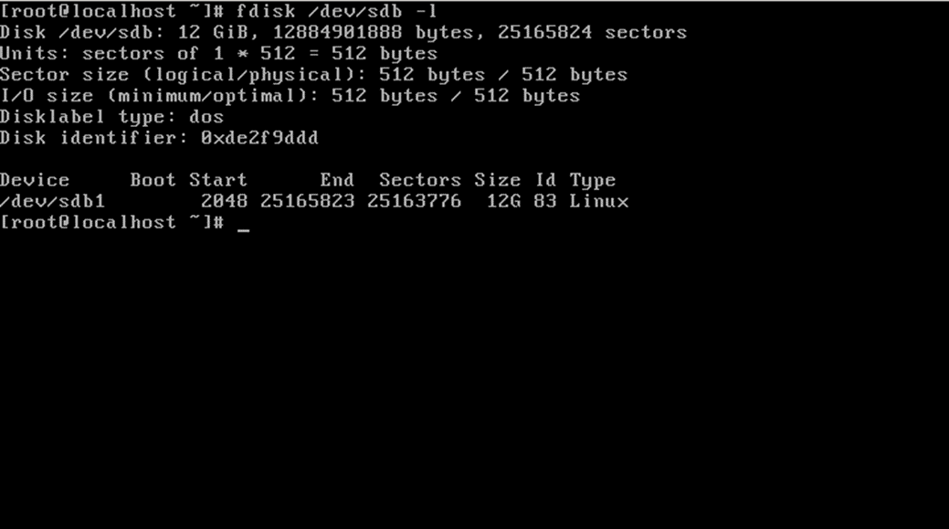
Figure 24: fdisk
After it, I want enable “LVM” for this partition and use below command :
# parted -s /dev/sdb set 1 lvm on
In above command I used “set 1” that mean partition 1. Let me to see our partitions via “fdisk” command :
# fdisk /dev/sdb -l
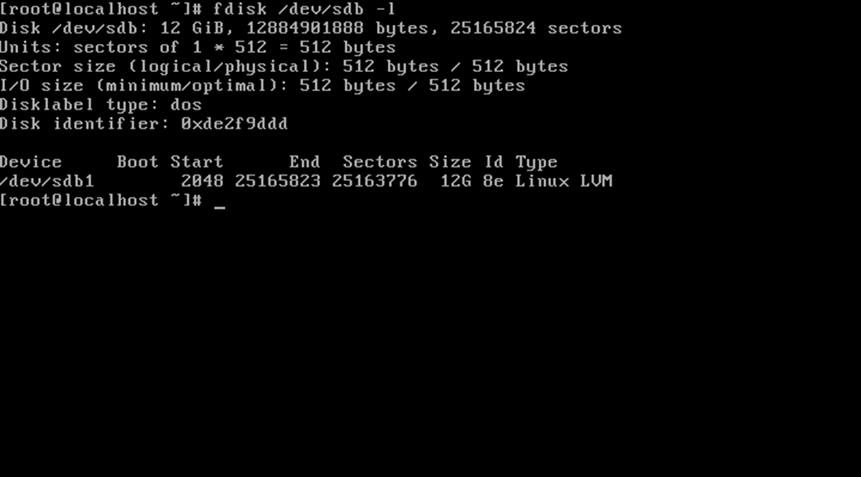
Figure 25: fdisk -l

Look carefully, You can see “LVM” at the end of line. It mean that “LVM” enable for our partition.
Type below command :
# pvcreate /dev/sdb1
# vgcreate Xen /dev/sdb1 -v
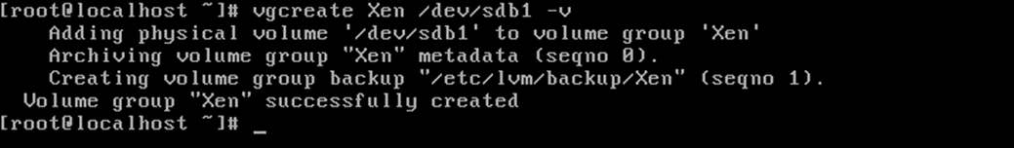
Figure 26: vgcreate
# lvcreate -L 8G -v -n Fedora Xen
In above command, You should select your size (We selected 8 Gigabyte) and logical volume name (Fedora) and a name that you typed in the previous command (Xen). The output is :
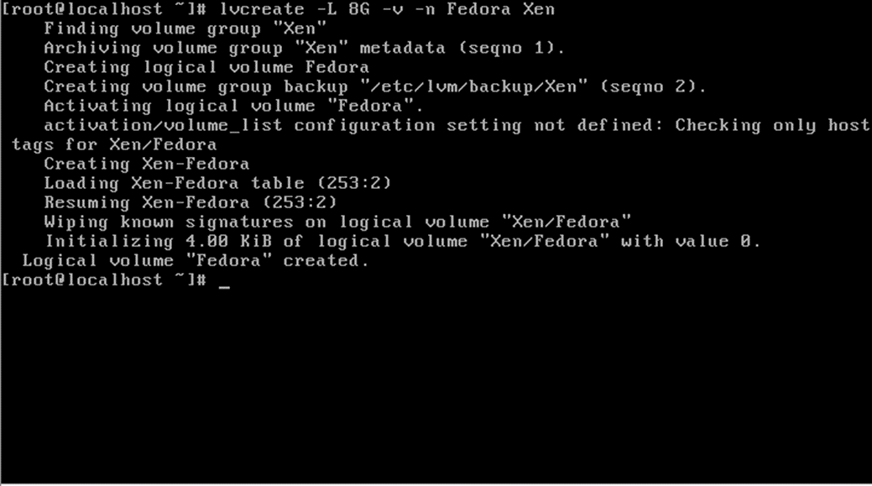
Figure 27: lvcreate
Let me to see our LVM via “vgdisplay” command :
# vgdisplay | more
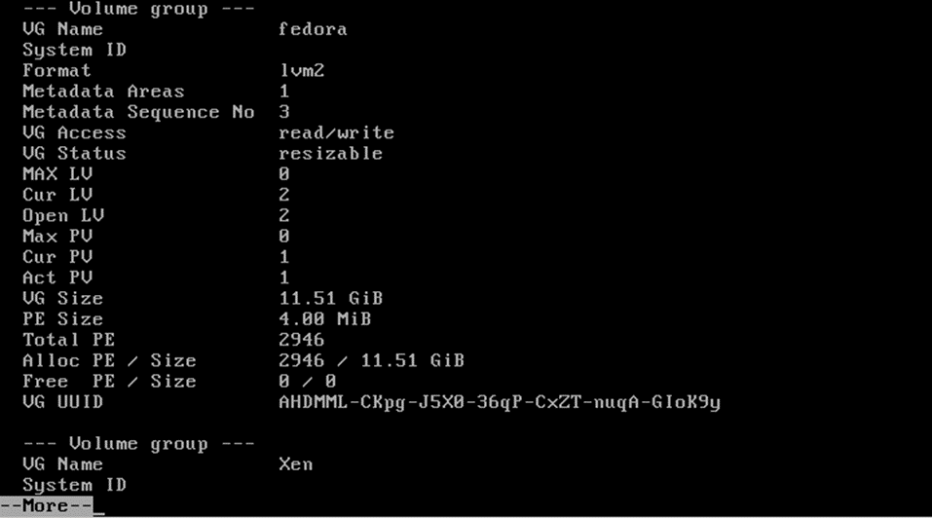
Figure 28: vgdisplay-1
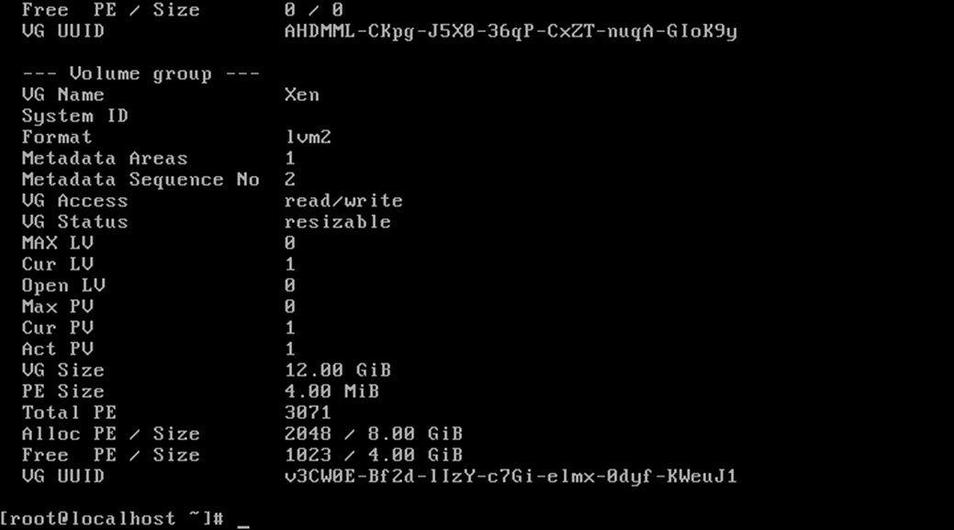
Figure 29: vgdisplay-2

OK, our storage is ready and we just need to create a config file for our VM. Before we dive into config file, Please let us for write something about “Networking”.

Networking in Xen
Create and configure network in real world is a hard job and can be complex in some areas. In VM world it can be complex too and depending on the network diagram. We never explain networking here complete byt we just show you how you can configure a simple network for your VM and your VM able to see external world.
It is true that Virtual Machines share your interfaces but it is not true that you must not concern about the security.
The Xen Project support some kind of networking that we will show you them here :

Bridge : Dom0 and DomU are connected to each other via a virtual network. It is a default and most common configuration. In this configuration, a software bridge created in the backend domain and the Virtual network connected to your physical network. For bridging you can use two schemes :1) Linux detect your NIC as “eth0” and in the first scheme, Your eth0 renamed to other name (myeth0) and bridge changed to eth0 2) in the second scheme, Your NIC remain eth0 and your bridge is mybr0.
Names are personalisation and you can select other names.
NAT : Network Address Translation or NAT is kind of routing and each guest have its own IP address. In NAT, Dom0 configured to forward your packets and iptables used to configure your Dom0 Kernel as a IP packet filter. NAT using RFC1918 addresses (http://tools.ietf.org/html/rfc1918).

Routing : In Routing your Dom0 configured for forward packets and a point-to-point link created between Dom0 and each DomU Virtual NIC. Don't forget, because of nature of routing, each of guest NIC must have static IP address.

OK, Xen need bridge for running and we want to show that you how you can create a Bridge for The Xen Project.
Depend on your Linux Distro (Dom0) you can use some tools for create a bridge in easy way. For example, On Fedora and Debian you can use “bridge-utils” for configure your Bridge.
My Current config are :

enp7s0: flags=4163<UP,BROADCAST,RUNNING,MULTICAST> mtu 1500
inet 172.30.9.20 netmask 255.255.255.0 broadcast 172.30.9.255
inet6 fe80::52e5:49ff:fe40:c48f prefixlen 64 scopeid 0x20<link>
ether 50:e5:49:40:c4:8f txqueuelen 1000 (Ethernet)
RX packets 989 bytes 84310 (82.3 KiB)
RX errors 0 dropped 0 overruns 0 frame 0
TX packets 77 bytes 9575 (9.3 KiB)
TX errors 0 dropped 0 overruns 0 carrier 0 collisions 0

lo: flags=73<UP,LOOPBACK,RUNNING> mtu 65536
inet 127.0.0.1 netmask 255.0.0.0
inet6 ::1 prefixlen 128 scopeid 0x10<host>
loop txqueuelen 1 (Local Loopback)
RX packets 83 bytes 9332 (9.1 KiB)
RX errors 0 dropped 0 overruns 0 frame 0
TX packets 83 bytes 9332 (9.1 KiB)
TX errors 0 dropped 0 overruns 0 carrier 0 collisions 0

virbr0: flags=4099<UP,BROADCAST,MULTICAST> mtu 1500
inet 192.168.122.1 netmask 255.255.255.0 broadcast 192.168.122.255
ether 52:54:00:8b:c5:55 txqueuelen 1000 (Ethernet)
RX packets 0 bytes 0 (0.0 B)
RX errors 0 dropped 0 overruns 0 frame 0
TX packets 0 bytes 0 (0.0 B)
TX errors 0 dropped 0 overruns 0 carrier 0 collisions 0

As you see, Fedora detect my NIC as “enp7s0” and its IP address is “172.30.9.20”. I must tell you that it is a static IP and not DHCP. I will tell you something about DHCP too.
I want to create a bridge that use this static IP, So I create a file via below command :

# touch /etc/sysconfig/network-scripts/ifcfg-br0
Then open it via an editor like “nano” and fill it with below information :
DEVICE=br0
TYPE=Bridge
BOOTPROTO=none
ONBOOT=yes
IPADDR=172.30.9.20
PREFIX=24
GATEWAY=172.30.9.254
DNS1=172.30.9.1
DELAY=0
NM_CONTROLLED=no

But, If your real NIC use DHCP protocol then you should use below config for Bridge :

DEVICE=br0
TYPE=Bridge
BOOTPROTO=dhcp
ONBOOT=yes
DELAY=0
NM_CONTROLLED=no

After it, I must change my real NIC configuration, So I open it via an editor :
# nano /etc/sysconfig/network-scripts/ifcfg-enp7s0
HWADDR=50:E5:49:40:C4:8F
TYPE=Ethernet
BOOTPROTO=none
DEFROUTE=yes
IPV4_FAILURE_FATAL=no
IPV6INIT=yes
IPV6_AUTOCONF=yes
IPV6_DEFROUTE=yes
IPV6_FAILURE_FATAL=no
NAME=enp7s0
UUID=5e520f04-b32c-4116-b61f-89c190868edc
ONBOOT=yes
#IPADDR=172.30.9.20
#PREFIX=24
#GATEWAY=172.30.9.254
#DNS1=172.30.9.1
IPV6_PEERDNS=yes
IPV6_PEERROUTES=yes
IPV6_PRIVACY=no
NM_CONTROLLED=no
BRIDGE=br0
As you see, My current NIC configuration use “BOOTPROTO=none” and its mean Static IP and if it was “DHCP” then you can't see any parts like “IPADDR”, “ PREFIX”, “GATEWAY” and “ DNS1” because all of these parts gaining automatically. Because of I added all of these parts to my Bridge then I must remove these parts from real NIC configuration file and add “NM_CONTROLLED=no” and “BRIDGE=br0” at the end of file. Don't forget, “br0” is my bridge name and you can select any name that you like.
If my NIC use DHCP protocol then I didn't need any extra works.
Everything is ready and I must restart my network service for take affect :
# systemctl restart network.service
After it, you can see current configuration via “ifconfig” command as below :
br0: flags=4163<UP,BROADCAST,RUNNING,MULTICAST> mtu 1500
inet 172.30.9.20 netmask 255.255.255.0 broadcast 172.30.9.255
inet6 fe80::52e5:49ff:fe40:c48f prefixlen 64 scopeid 0x20<link>
ether 50:e5:49:40:c4:8f txqueuelen 1000 (Ethernet)
RX packets 846 bytes 62175 (60.7 KiB)
RX errors 0 dropped 0 overruns 0 frame 0
TX packets 129 bytes 11550 (11.2 KiB)
TX errors 0 dropped 0 overruns 0 carrier 0 collisions 0

enp7s0: flags=4163<UP,BROADCAST,RUNNING,MULTICAST> mtu 1500
inet6 fe80::52e5:49ff:fe40:c48f prefixlen 64 scopeid 0x20<link>
ether 50:e5:49:40:c4:8f txqueuelen 1000 (Ethernet)
RX packets 5479 bytes 468651 (457.6 KiB)
RX errors 0 dropped 0 overruns 0 frame 0
TX packets 558 bytes 75815 (74.0 KiB)
TX errors 0 dropped 0 overruns 0 carrier 0 collisions 0

lo: flags=73<UP,LOOPBACK,RUNNING> mtu 65536
inet 127.0.0.1 netmask 255.0.0.0
inet6 ::1 prefixlen 128 scopeid 0x10<host>
loop txqueuelen 1 (Local Loopback)
RX packets 83 bytes 9332 (9.1 KiB)
RX errors 0 dropped 0 overruns 0 frame 0
TX packets 83 bytes 9332 (9.1 KiB)
TX errors 0 dropped 0 overruns 0 carrier 0 collisions 0

virbr0: flags=4099<UP,BROADCAST,MULTICAST> mtu 1500
inet 192.168.122.1 netmask 255.255.255.0 broadcast 192.168.122.255
ether 52:54:00:8b:c5:55 txqueuelen 1000 (Ethernet)
RX packets 0 bytes 0 (0.0 B)
RX errors 0 dropped 0 overruns 0 frame 0
TX packets 0 bytes 0 (0.0 B)
TX errors 0 dropped 0 overruns 0 carrier 0 collisions 0

As you see, A Bridge with the name “br0” created and all information of my real NIC (enp7s0) given to my bridge. So, my Bridge work like my real NIC. Don't forget for each Physical NIC you should create a Bridge.
Our network is ready and we must create a Guest config.

Installing Windows as HVM domainU Guest
Huh, Are you ready? It is the most exciting part of our book and we to show you how you can install your Guest OS.
We choice Window 7 Enterprise for install as Guest and show you that how you can configure your Xen to use this “.iso” file and start your VM.
First of all, We must create a config file for our VM. Let me to create it via “touch” command in Linux :
# touch /etc/xen/windows.cfg

Then, I open it via an editor like “nano” as below :

# nano /etc/xen/windows.cfg

And fill this file via below information :

name = "Windows7"
builder = "hvm"
vcpus = 4
memory = "4096"
maxmex= "8192"
vif=['bridge=br0']
disk=['phy:/dev/Xen/Fedora,hda,w','file:/home/mohsen/windows7.iso,hdc:cdrom,r']
vnc="1"
vnclisten="172.30.9.20"
vncconsole="0"
boot="dc"
stdvga=1
videoram=32
on_poweroff = "destroy"
on_reboot = "restart"
on_crash = "restart"

I must tell you something about this file :
● vif=['bridge=br0'] : Because of we choice “br0” as a name of our Bridge then we must write “'bridge=br0'” ,But if your Bridge name is different then you must write your Bridge name instead of it here.
● disk=['phy:/dev/Xen/Fedora,hda,w','file:/home/mohsen/windows7.iso,hdc:cdrom,r'] : If you remember, We want to use our real partition as our Guest partition, Thus it is not a File that act as a real HDD. Because of it, We used “phy” that mean Physical. The “Xen” is our LVM and I choice “Fedora” as a name of my 20 GB partition on LVM. You may selected other name that you must put it here.
● Vnclisten="172.30.9.20" : Because I use the Xen Project on other server and not on my current PC, I must define the IP address of my Xen Server. My Xen Server IP is “172.30.9.20” and if your situation is like us then you must write your Xen Server IP here but if you run the Xen Project on your PC and not another PC or Server then you must write “vnclisten="0.0.0.0"”. When you select “0.0.0.0” as IP then it is your local host.
● boot="dc" : the “d” mean “CDROM” and “c” mean your HDD. It is your Boot order and when you Guest installed you can change it to “boot=”c””. The Xen Project parameters are boot on floppy (a), hard disk (c), Network (n) and CD-ROM (d).

Let us start our Guest. Just type below command :
# xl create /etc/xen/windows.cfg
and if you have not any error in your syntax then your xen just show “Parsing config from /etc/xen/windows.cfg” and your VM started.
After it write below command :
# xl list
and you can see something like below :
Name ID Mem VCPUs State Time(s)
Domain-0 0 3659 8 r----- 887.6
Windows7 19 4096 4 -b---- 23.1

As you see, “Windows7” is running and we just need connect to it via “vncviewer”. But you must did something on your Firewall.
Linux use “iptables” as Firewall and VNC Port is not opened by default and we must open this port for connect to our VNC remotely. Don't forget, We doing it because our Xen server is on another PC and we must connect to it remotely thus we need open VNC Port. The VNC use Port 5900 and TCP protocol.
I use “netstat -nat” command for show our current network connections :

# netstat -nat
Active Internet connections (servers and established)
Proto Recv-Q Send-Q Local Address Foreign Address State
tcp 0 0 172.30.9.20:5900 0.0.0.0:* LISTEN
tcp 0 0 192.168.122.1:53 0.0.0.0:* LISTEN
tcp 0 0 0.0.0.0:22 0.0.0.0:* LISTEN
tcp 0 0 172.30.9.20:22 172.30.10.18:49824 ESTABLISHED
tcp6 0 0 :::9090 :::* LISTEN
tcp6 0 0 :::22 :::* LISTEN

As you see, The IP “172.30.9.20” and Port “5900” are ready for connect but we must doing some steps for connect to our VM :
1- First of all, Install a tool like “vncviewer” on your Linux Distro.
2- Depend on your Linux Distro (Dom0) you must use “iptables” for open VNC Port on Dom0 :
# iptables -A INPUT -p tcp --dport 5900 -j ACCEPT
# iptables-save
After it, The Port “5900” is open on your Dom0 and you can connect to it remotely. You can use “iptables -L” for show your current iptables rules.
We ready ready to connect to our Xen Server :
# vncviewer 172.30.9.20:5900
And after it, A window displayed and we can do Windows install process:
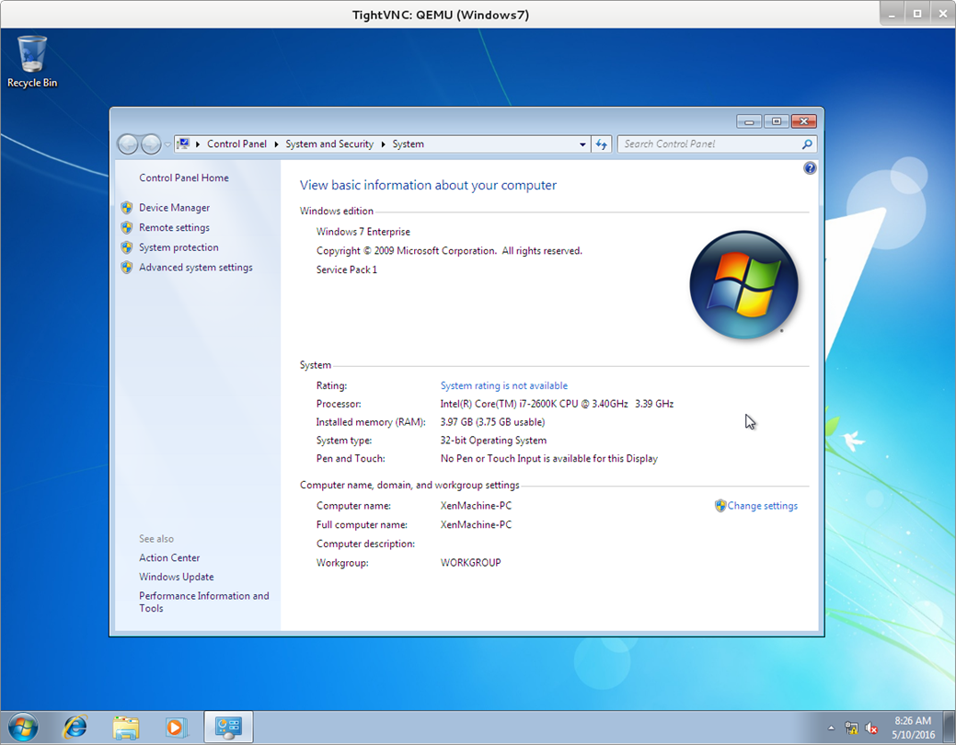
Figure 30: Windows 7 on Xen

Sometimes you don't like your VM viewed by others and you want set password for it, For do it use below parameter in your VM config file :
vncpasswd=”Your Password”
After it, When you want view your VM via VNC you must enter a password :
vncviewer 172.30.9.20:5900
Connected to RFB server, using protocol version 3.8
Performing standard VNC authentication
Password:

When you working with Your VM, You may have some problems with your Display and you must consider below Links for Troubleshooting your problems :
http://wiki.xenproject.org/wiki/Xen_Common_Problems#How_do_I_change_the_resolution_of_Xen_PV_domU_vfb_graphical_VNC_console.3F
http://wiki.xenproject.org/wiki/Xen_Common_Problems#How_can_I_get_resolutions_larger_than_800x600_for_Xen_HVM_guest_graphical_VNC_console.3F
A good note that you must consider it is that you should install “Windows PV Drivers” for your Xen VM. Navigate to “http://www.xenproject.org/downloads/windows-pv-drivers.html” and download .TAR files and extract them, then configure your NIC IP address and see your network and copy these files and install them on your Windows Guest. In below figure you can see that I choice a static IP for my Windows Guest :

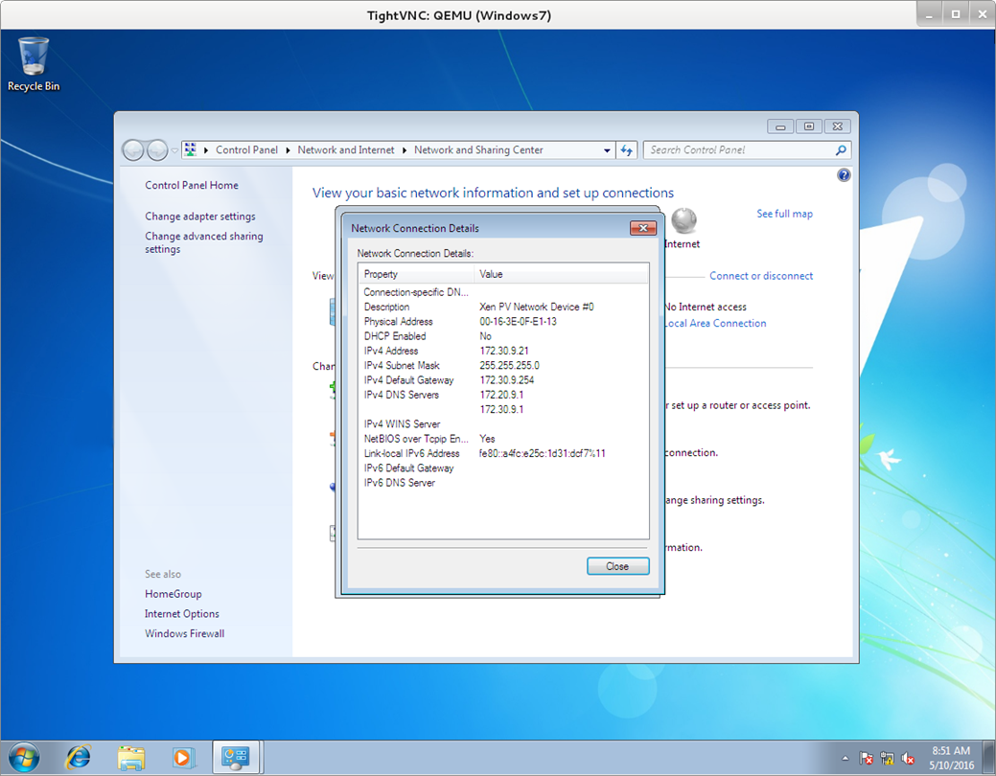
Figure 31: Static IP

When you create another VM:
[root@localhost ~]# netstat -nat
Active Internet connections (servers and established)
Proto Recv-Q Send-Q Local Address Foreign Address State
tcp 0 0 172.30.9.20:5900 0.0.0.0:* LISTEN
tcp 0 0 172.30.9.20:5901 0.0.0.0:* LISTEN
tcp 0 0 192.168.122.1:53 0.0.0.0:* LISTEN
tcp 0 0 0.0.0.0:22 0.0.0.0:* LISTEN
tcp 0 0 172.30.9.20:5900 172.30.10.18:33869 ESTABLISHED
tcp 0 0 172.30.9.20:22 172.30.10.18:55000 ESTABLISHED
tcp 0 180 172.30.9.20:22 172.30.10.18:54616 ESTABLISHED
tcp6 0 0 :::9090 :::* LISTEN
tcp6 0 0 :::22 :::* LISTEN

[root@localhost ~]# xl list
Name ID Mem VCPUs State Time(s)
Domain-0 0 1590 8 r----- 192.7
Windows7 9 4096 4 -b---- 21.0
linux 10 2048 1 r----- 64.8

If you pay attention to the output of “ifconfig” command then you will see a default Bridge with the name “virbr0”. We can use this Bridge for add other NIC to our VM. For example, We need more than one NIC on our VM.
For adding more than one NIC you can use :
vif=['bridge=br0','mac=00:16:17:a5:6y:89,bridge=virbr0']

The “mac” defined the MAC address for our NIC.
We can use our first Bridge(br0) for adding more than NIC too but we should add a MAC address fpr each NIC :
vif=['bridge=br0,mac=00:13:r6:45:g6:9o','mac=00:16:17:a5:6y:89,bridge=br0']

In above example, We used the Bridge br0 for adding two NICs but we can't create another Bridge(br1) and attach it other Physical NIC and use it here.

Share storage between VMS
In some situation, You may want to use another HDD or other Vms HDD in a VM. It is so easy and you can write the name of your other HDD in “disk” in the config file :
disk=['phy:/dev/Xen/Fedora,hda,w','phy:/dev/Xen/linux,hdb,w','file:/home/mohsen/Windows7.iso,hdc:cdrom,r']

In above example, my main HDD is “Fedora” and I mount another HDD (linux) as “hdb”. When I fire my “vm” then I can see other HDD in my vm. If you noted, Then you can see “w” and “r” word at the end of my lines. What are these? The “w” mean “read-write” and “r” mean “read-only”.

VM States in The Xen Project
When you run a VM through Xen and run “xl list” then you can see a column with the name “State” and a word that changed sometimes. What does this word mean?
For example, I run “xl list” and the output is as below :
[root@localhost ~]# xl list
Name ID Mem VCPUs State Time(s)
Domain-0 0 1590 8 r----- 1211.3
OpenSUSE 44 2048 1 r----- 4.6

I will tel you something about these words :
● r - running
The domain is currently running.
● b - blocked
The domain is blocked, and not running or runnable. This happened when the domain is waiting on IO or going to sleep because there was nothing else for it to do.
● p - paused
The domain has been paused, and may administrator paused it via “xl pause” command. When a VM paused, The domain will still consume allocated resources like memory, but will not be eligible for scheduling by the Xen hypervisor.
● s - shutdown
The guest has requested to be shutdown, rebooted or suspended.
● c - crashed
The domain has crashed. It may if the domain has been configured not to restart on crash.
● d - dying
The domain is in process of dying, but hasn't completely shutdown or crashed.

In below example, my “OpenSUSE” VM is running and established :
[root@localhost ~]# xl list
Name ID Mem VCPUs State Time(s)
Domain-0 0 1590 8 r----- 1245.3
OpenSUSE 44 2048 2 -b---- 127.4

Then, I run below command for “Pause” it :
# xl pause OpenSUSE
and my current state is:
[root@localhost ~]# xl list
Name ID Mem VCPUs State Time(s)
Domain-0 0 1590 8 r----- 1248.0
OpenSUSE 44 2048 2 --p--- 127.5

For “unpause” a VM you can use below command :
# xl unpause OpenSUSE
[root@localhost ~]# xl list
Name ID Mem VCPUs State Time(s)
Domain-0 0 1590 8 r----- 1257.0
OpenSUSE 44 2048 2 -b---- 128.3

Add USB Devices to your VM
Sometime you may want to add a USB device to your VM. Linux has a command with the name “lsudb” that show your USB controllers on your Server :
[root@localhost ~]# lsusb
Bus 002 Device 002: ID 8087:0024 Intel Corp. Integrated Rate Matching Hub
Bus 002 Device 001: ID 1d6b:0002 Linux Foundation 2.0 root hub
Bus 006 Device 001: ID 1d6b:0003 Linux Foundation 3.0 root hub
Bus 005 Device 001: ID 1d6b:0002 Linux Foundation 2.0 root hub
Bus 004 Device 001: ID 1d6b:0003 Linux Foundation 3.0 root hub
Bus 003 Device 001: ID 1d6b:0002 Linux Foundation 2.0 root hub
Bus 001 Device 003: ID 13ba:0017 PCPlay PS/2 Keyboard+Mouse Adapter
Bus 001 Device 002: ID 8087:0024 Intel Corp. Integrated Rate Matching Hub
Bus 001 Device 001: ID 1d6b:0002 Linux Foundation 2.0 root hub

As you see, My Server has USB 2.0 and USB 3,0 controllers. I plugged a HP Pendrive to my server and run command again :
[root@localhost ~]# lsusb
Bus 002 Device 003: ID 03f0:5607 Hewlett-Packard
Bus 002 Device 002: ID 8087:0024 Intel Corp. Integrated Rate Matching Hub
Bus 002 Device 001: ID 1d6b:0002 Linux Foundation 2.0 root hub
Bus 006 Device 001: ID 1d6b:0003 Linux Foundation 3.0 root hub
Bus 005 Device 001: ID 1d6b:0002 Linux Foundation 2.0 root hub
Bus 004 Device 001: ID 1d6b:0003 Linux Foundation 3.0 root hub
Bus 003 Device 001: ID 1d6b:0002 Linux Foundation 2.0 root hub
Bus 001 Device 003: ID 13ba:0017 PCPlay PS/2 Keyboard+Mouse Adapter
Bus 001 Device 002: ID 8087:0024 Intel Corp. Integrated Rate Matching Hub
Bus 001 Device 001: ID 1d6b:0002 Linux Foundation 2.0 root hub

What happened? As you see, “Hewlett-Packard “ added to my list. If you look at the output more then you see some numbers behind the device name. What are these? These are vendor and product numbers are in “[vendor]:[product]” form.
For example, My Pendrive from HP company has “03f0:5607” and If you navigate to the “http://www.linux-usb.org/usb.ids” and search “ 03f0” then you can see that it is a vendor number for HP company.
A good web site for search and find the devices models is “http://www.the-sz.com/products/usbid/”. You can browse it and enter the device “vendor” and “product” numbers and click on search then you can see the model of your device :
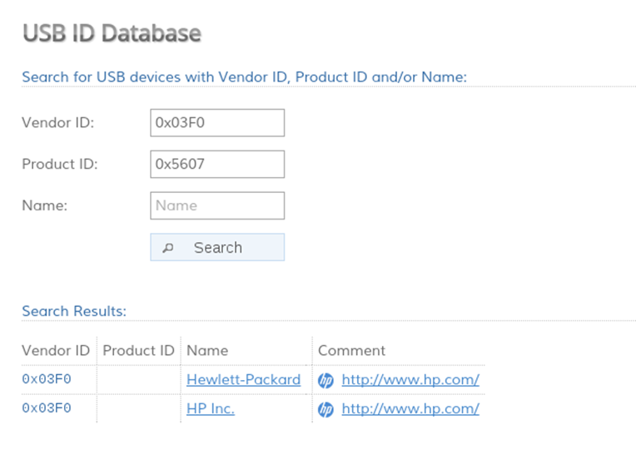
Figure 32: USB ID Database

OK, We want add out Pendrive to our VM and copy and paste some files from/to it from our VM.
Fist of all, You must open your VM cofing file via an editor like “nano” :
# nano /etc/xen/linux.cg
Then add below lines to your config file :
usb="1"
usbdevice=['host:03f0:5607']

The “usb=”1”” cause enable USB controller and via “usbdevice” you can select your USB device for appear in VM. As you see, My HP Pendrive “vendor” and “product” numbers are “03f0:5607” and I written “usbdevice=['host:03f0:5607']” to my config file.
After it, When I start my VM then I can see my Pendrive that mounted in my VM. In below Figure, You can see that my HP Pendrive mounted in OpenSUSE Linux :

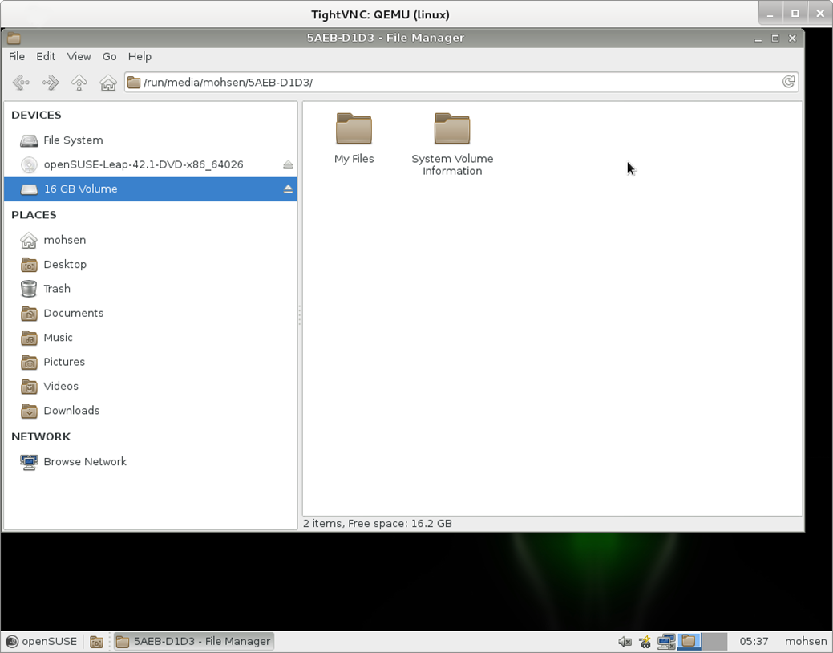
Figure 33: USB Mounted

Use Physical CD/DVD ROM
It is True that installing OS from ISO files is more faster and better but sometime for some problems you can't use the .ISO file for install OS. For example, Your Dom0 not have enough space or you have CD or DVD of your OS. The Xen Project let you to use your Physical CD/DVD ROM for install OS.
Linux detect all devices as file, Thus your CD/DVD ROM is a file too. You can run “lsblk” command to find your CD/DVD ROM device :
[root@localhost ~]# lsblk
NAME MAJ:MIN RM SIZE RO TYPE MOUNTPOINT
sda 8:0 0 931.5G 0 disk
├─sda1 8:1 0 316G 0 part
│ ├─fedora-root00 253:0 0 300G 0 lvm /
│ └─fedora-swap 253:1 0 16G 0 lvm [SWAP]
└─sda2 8:2 0 615.5G 0 part
├─Xen-Fedora 253:2 0 20G 0 lvm
└─Xen-linux 253:3 0 20G 0 lvm
sdb 8:16 1 15.1G 0 disk
sr0 11:0 1 158.5M 0 rom

As you see, Linux detected my DVD ROM as “sr0”, Thus my DVD is “/dev/sr0” and I can use it. If I want my VM boot via Physical CD/DVD ROM then I just add below line to my VM config :
disk=['phy:/dev/sr0,hdc:cdrom,r']

If you remember, Int he previous config we used “disk=['file:/home/mohsen/opensuse.iso,hdc:cdrom,r']” and “file” was for .ISO file but for Physical devices we use “Phy” instead of “file”. After it, My VM booted via Physical DVD ROM.
If DVD Drive not detected automatically then use below command :
# eject
This command eject DVD from the Guest and if you change CD or DVD then for detect the insertion use below command :
# eject -t

Create a VM via .img
We showed you how you can create a VM via “LVM” but sometime for some reasons you don't like to create a LVM and like to boot your VM via an image. We will show you it. It is so easy and just need some steps.
First of all, Please let me to create a directory via “mkdir” for our Virtual HDD :
# mkdir Windows
change to “Windows” directory via “cd” command :
# cd Windows/
And run below command for create a Virtual HDD about 40GB :
# dd if=/dev/zero of=windows.img bs=1M count=40000
[root@localhost Windows]# dd if=/dev/zero of=windows.img bs=1M count=40000
40000+0 records in
40000+0 records out
41943040000 bytes (42 GB) copied, 332.735 s, 126 MB/s

If you list files and directory via “ls” command then you will see something like below :
[root@localhost Windows]# ls
windows.img

As you see, A file with the name “windows.img” created for us. Now, We must change VM config file for use this file as Virtual HDD.
Open your VM config file via an editor like “Nano” and add below line as your HDD :
disk=['file:/home/mohsen/Windows/windows.img,hda,w']
As you see, We used “file” instead of “phy”.

You must note that if you install Windows 10 and see below error the don't worry, It is because of your Windows date and you must use updated .ISO file :
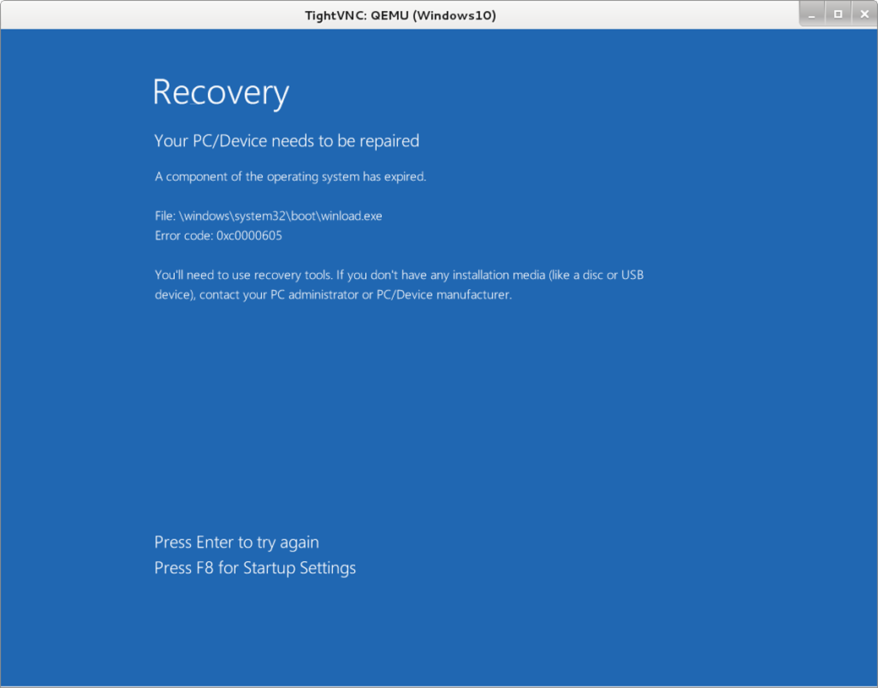
Figure 34: Windows 10 Error.

VGA Passthrough
A good feature and trick in Virtualization is VGA Passthrough. I don't know why someone need it but they have their reason for it. For example, Someone need run Graphical application under Vms and these application need a real VGA and can't work with a standard VGA Or some people like to Play Games :)
The Xen Project offer you this feature and you can use your real VGA in your VM but with some limitation. For example, Your CPU must support IOMMU.
Xen 4.0.0 is the first version Xen that support VGA graphics adapter passthrough. With this feature you can give the Guest Full control of graphic adapter and have Full 3D support in a VM. For enable this feature, Xen need IOMMU (Intel VT-d) support from the motherboard chipset. VT-d Pass-Through is a technique in Xen that give DomU this ability to access PCI using the IOMMU. An important note that you must consider is that “Only devices with FLR capabilities are supported” and otherwise you will see an Error. To check your PCI device for FLR feature you can run “lspci -w” on Dom0 and if in the output you see “FLReset-” then your device not supported and if you see “FLReset+” then it is OK.
We use Fedora and “-w” parameter not exist and thus we must use below commands :
First of all, Run below command to see a list of Hardware :

# lspci
Then run :
# lspci -vv -s PCI ID | grep FLR
For example :
# lspci -vv -s 00:02.0 | grep FLR
[root@localhost ~]# lspci -vv -s 00:02.0 | grep FLR
AFCap: TP+ FLR+
AFCtrl: FLR-

OK, We consider that your device support FLR and I will tell you that how you can attach it.
First of all, Execute below command :
# modprobe xen-pciback
Create a file via “touch” command and fill it with below information :
remove_device () {
BDF=$1
# Unbind a PCI function from its driver as necessary
[ ! -e /sys/bus/pci/devices/$BDF/driver/unbind ] || \
echo -n $BDF > /sys/bus/pci/devices/$BDF/driver/unbind
# Add a new slot to the PCI Backend's list
echo -n $BDF > /sys/bus/pci/drivers/pciback/new_slot
# Now that the backend is watching for the slot, bind to it
echo -n $BDF > /sys/bus/pci/drivers/pciback/bind
}

remove_device "Your PCI ID"
# For example : remove_device "0000:01:00.1"

Save the file and run this script via “sh yourfilename”.
After it, You must edit your VM config file. Open you config file via an editor like “Nano” :
# nano /etc/xen/windows.cfg
Then add below line to your config file :
pci=['Your PCI ID','Your PCI ID']
# For example : pci=['01:00.1','00:1a.0']

Then run your VM and your PCI device will attached to your VM.

Swap
Before we speak about Swap in Linux, Let me to tell something about “Paging”. The Paging is a scheme of memory management that your system use it for store and retrieves data from it. Why its named paging? It is because the OS retrieves data from a secondary storage in specific size that called pages. It is an important part of Virtual memory that implemented in modern OS and let you to run Applications that are larger than your Physical memory.
What is the Swap? Swap space usually is a disk partition but can be a file too. When you installing Linux, you can define a partition as Swap space but it can be done later too. The Swap space is recommended for users that have less than 1 GB of RAM. It is a area on your HDD which is part of your Virtual Memory. The Swap space used when your system sense that need more Physical memory for active processes and after it, Inactive pages on your Physical memory moving the Swap space and your Physical memory freed and have more free space for others. You must note that The Swap space exist on your HDD and the speed of HDDs are slower then Physical memory. It is true that HDD with new technologies like SSD has more speed but don't consider the Swap space as a replacement for the Physical memory. For define a Swap space you must define it twice of Physical memory. For example, If you have 4GB RAM then your Swap should be 8GB.
For check the Swap space of your system use below command :

# swapon --show
[root@localhost ~]# swapon --show
NAME TYPE SIZE USED PRIO
/dev/dm-1 partition 16G 0B -1
[root@localhost ~]#

As you see, My system has 16GB Swap space.
You can use “free -h” command too :
[root@localhost ~]# free -h
total used free shared buff/cache available
Mem: 7.5G 186M 7.0G 4.4M 325M 7.2G
Swap: 15G 0B 15G
[root@localhost ~]#

If you install the Linux as your VM then you may like to define an extended Swap space for it. It is true that you can use your Virtual HDD as a Swap space but you can define another HDD as Swap too.
First of all, We use “dd” command for create an image :
# dd if=/dev/zero of=linuxswap.swap bs=1024 count=”Your size”
For example :
[root@localhost mohsen]# dd if=/dev/zero of=linuxswap.swap bs=1024 count=4096000
4096000+0 records in
4096000+0 records out
4194304000 bytes (4.2 GB) copied, 32.8729 s, 128 MB/s

Then :
[root@localhost mohsen]# mkswap linuxswap.swap
mkswap: linuxswap.swap: insecure permissions 0644, 0600 suggested.
Setting up swapspace version 1, size = 3.9 GiB (4194299904 bytes)
no label, UUID=f2464b51-c7ef-4990-8cb6-8d50d151b52e

Now, It is a good time for attach our Swap space to our VM. Open your VM config file via an editor like “nano” and add below line to your VM config file :
file:/YourPath/linuxswap.swap,hdb,w

The complete line is something like :
disk=['phy:/dev/Xen/linux,hda,w','file:/home/mohsen/linuxswap.swap,hdb,w']

Now, Start your VM and when your VM is booted then your Swap space is “hdb” and your just need to enable it. You can use below command to enable your Swap in your VM :
# swapon /dev/hdb

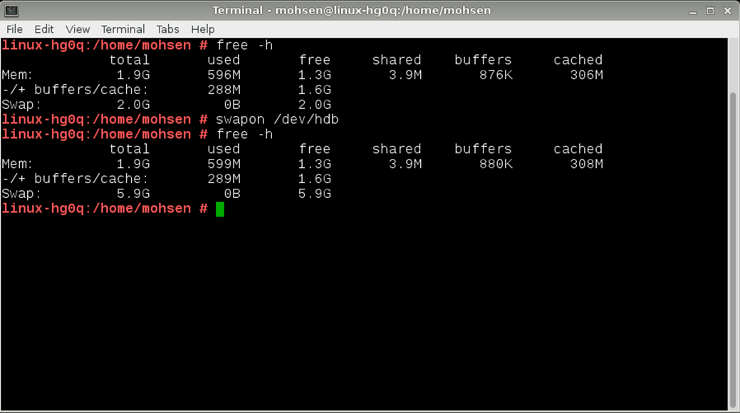
Figure 35: Swap Space

As you see, My Linux had 2GB of Swap and after it my Linux VM has 5.9GB Swap Space.
For mount it automatically via boot just doing following steps :
1- Open “fstab” file from “/etc/fstab” via an editor like “nano”.
2- add below line :
/dev/XXX none swap defaults 0 0
# For example : /dev/hdb none swap defaults 0 0

3- Save file and reboot your system.

Using Xen-Tools
What is Xen-Tools? It is a collection of Perl Scripts that allow you to create a new guest Xen domain. It is compatible with Debian more but nowadays can support Ubuntu, CentOS and others. OK, Let start!
Go to “http://xen-tools.org/” and download the Xen-Tools. After it, For install “Xen-Tools” we must install some packages on CentOS. Run following command :
# yum install debootstrap perl-Text-Template perl-Config-IniFiles perl-File-Slurp perl-File-Which perl-Data-Dumper
After it go to the location that downloaded file is there and use “gunzip” and “tar” command for extract it. Then use “cd” command for change the current location and when you are in “Xen-Tools” directory run “make install” command. You will see something like below :

[root@localhost xen-tools-4.6.2]# make install
for i in hooks/*/*-*; do chmod 755 $i; done
chmod 755 hooks/common.sh
chmod 644 etc/*.conf
chmod 644 etc/xm.tmpl
chmod 644 etc/xm-nfs.tmpl
chmod 644 misc/*
mkdir -p /usr/bin
cp bin/xen-create-image /usr/bin
cp bin/xen-create-nfs /usr/bin
cp bin/xt-customize-image /usr/bin
cp bin/xt-install-image /usr/bin
cp bin/xt-create-xen-config /usr/bin
cp bin/xen-delete-image /usr/bin
cp bin/xen-list-images /usr/bin
cp bin/xen-update-image /usr/bin
cp bin/xt-guess-suite-and-mirror /usr/bin
chmod 755 /usr/bin/xen-create-image
chmod 755 /usr/bin/xen-create-nfs
chmod 755 /usr/bin/xt-customize-image
chmod 755 /usr/bin/xt-install-image
chmod 755 /usr/bin/xt-create-xen-config
chmod 755 /usr/bin/xen-delete-image
chmod 755 /usr/bin/xen-list-images
chmod 755 /usr/bin/xen-update-image
chmod 755 /usr/bin/xt-guess-suite-and-mirror
mkdir -p /etc/xen-tools
if [ -d /etc/xen-tools/hook.d ]; then mv /etc/xen-tools/hook.d/ /etc/xen-tools/hook.d.obsolete ; fi
mkdir -p /etc/xen-tools/skel/
mkdir -p /etc/xen-tools/role.d/
mkdir -p /etc/xen-tools/partitions.d/
cp etc/*.conf /etc/xen-tools/
cp etc/xm.tmpl /etc/xen-tools/
cp etc/xm-nfs.tmpl /etc/xen-tools/
cp partitions/*-* /etc/xen-tools/partitions.d/
mkdir -p /usr/share/bash-completion/completions/
cp misc/xen-tools.bash-completion /usr/share/bash-completion/completions/xen-tools
mkdir -p /etc/initramfs-tools/conf.d/
cp misc/xen-tools.initramfs-tools /etc/initramfs-tools/conf.d/xen-tools
for i in roles/* ; do if [ -f $i ]; then cp $i /etc/xen-tools/role.d; fi ; done
for i in /usr/share/xen-tools/*.d; do if [ -L "$i" ]; then rm -vf "$i"; fi; done
mkdir -p /usr/share/xen-tools/centos-4.d/
mkdir -p /usr/share/xen-tools/centos-5.d/
mkdir -p /usr/share/xen-tools/centos-6.d/
mkdir -p /usr/share/xen-tools/fedora-core-6.d/
cp -R hooks/centos-4/*-* /usr/share/xen-tools/centos-4.d
cp -R hooks/centos-5/*-* /usr/share/xen-tools/centos-5.d
cp -R hooks/centos-6/*-* /usr/share/xen-tools/centos-6.d
cp -R hooks/fedora-core-6/*-* /usr/share/xen-tools/fedora-core-6.d
cd /usr/share/xen-tools/ && ln -s fedora-core-6.d fedora-core-4.d
cd /usr/share/xen-tools/ && ln -s fedora-core-6.d fedora-core-5.d
cd /usr/share/xen-tools/ && ln -s fedora-core-6.d fedora-core-7.d
cd /usr/share/xen-tools/ && ln -s fedora-core-6.d fedora-core-8.d
cd /usr/share/xen-tools/ && ln -s fedora-core-6.d fedora-core-9.d
cd /usr/share/xen-tools/ && ln -s fedora-core-6.d fedora-core-10.d
cd /usr/share/xen-tools/ && ln -s fedora-core-6.d fedora-core-11.d
cd /usr/share/xen-tools/ && ln -s fedora-core-6.d fedora-core-12.d
cd /usr/share/xen-tools/ && ln -s fedora-core-6.d fedora-core-13.d
cd /usr/share/xen-tools/ && ln -s fedora-core-6.d fedora-core-14.d
cd /usr/share/xen-tools/ && ln -s fedora-core-6.d fedora-core-15.d
cd /usr/share/xen-tools/ && ln -s fedora-core-6.d fedora-core-16.d
cd /usr/share/xen-tools/ && ln -s fedora-core-6.d fedora-core-17.d
mkdir -p /usr/share/xen-tools/debian.d/
cp -R hooks/debian/*-* /usr/share/xen-tools/debian.d
cd /usr/share/xen-tools/ && ln -s debian.d sarge.d
cd /usr/share/xen-tools/ && ln -s debian.d etch.d
cd /usr/share/xen-tools/ && ln -s debian.d lenny.d
cd /usr/share/xen-tools/ && ln -s debian.d squeeze.d
cd /usr/share/xen-tools/ && ln -s debian.d wheezy.d
cd /usr/share/xen-tools/ && ln -s debian.d jessie.d
cd /usr/share/xen-tools/ && ln -s debian.d stretch.d
cd /usr/share/xen-tools/ && ln -s debian.d sid.d
cd /usr/share/xen-tools/ && ln -s debian.d unstable.d
cd /usr/share/xen-tools/ && ln -s debian.d testing.d
cd /usr/share/xen-tools/ && ln -s debian.d stable.d
cd /usr/share/xen-tools/ && ln -s debian.d oldstable.d
cd /usr/share/xen-tools/ && ln -s debian.d oldoldstable.d
mkdir -p /usr/share/xen-tools/gentoo.d/
cp -R hooks/gentoo/*-* /usr/share/xen-tools/gentoo.d
mkdir -p /usr/share/xen-tools/dapper.d/
cp -R hooks/dapper/*-* /usr/share/xen-tools/dapper.d/
mkdir -p /usr/share/xen-tools/edgy.d/
cp -R hooks/edgy/*-* /usr/share/xen-tools/edgy.d/
cd /usr/share/xen-tools/ && ln -s edgy.d feisty.d
cd /usr/share/xen-tools/ && ln -s edgy.d gutsy.d
cd /usr/share/xen-tools/ && ln -s edgy.d hardy.d
mkdir -p /usr/share/xen-tools/intrepid.d/
cp -R hooks/intrepid/*-* /usr/share/xen-tools/intrepid.d/
cd /usr/share/xen-tools/ && ln -s intrepid.d jaunty.d
mkdir -p /usr/share/xen-tools/karmic.d/
cp -R hooks/karmic/*-* /usr/share/xen-tools/karmic.d/
cd /usr/share/xen-tools/ && ln -s karmic.d lucid.d
cd /usr/share/xen-tools/ && ln -s karmic.d maverick.d
cd /usr/share/xen-tools/ && ln -s karmic.d natty.d
cd /usr/share/xen-tools/ && ln -s karmic.d oneiric.d
cd /usr/share/xen-tools/ && ln -s karmic.d precise.d
cd /usr/share/xen-tools/ && ln -s karmic.d quantal.d
cd /usr/share/xen-tools/ && ln -s karmic.d raring.d
cd /usr/share/xen-tools/ && ln -s karmic.d saucy.d
cd /usr/share/xen-tools/ && ln -s karmic.d trusty.d
cd /usr/share/xen-tools/ && ln -s karmic.d utopic.d
cd /usr/share/xen-tools/ && ln -s karmic.d vivid.d
cd /usr/share/xen-tools/ && ln -s karmic.d wily.d
cd /usr/share/xen-tools/ && ln -s karmic.d xenial.d
cp hooks/common.sh /usr/share/xen-tools
cp -r hooks/common /usr/share/xen-tools
mkdir -p /usr/share/perl5/Xen/Tools
cp ./lib/Xen/Tools/*.pm /usr/share/perl5/Xen/Tools
mkdir -p man
cd bin; for i in *-*[!y]; do pod2man --release=4.6.2 --official --section=8 $i ../man/$i.8; done
for i in man/*.8; do gzip --force -9 $i; done
mkdir -p /usr/share/man/man8/
cp man/*.8.gz /usr/share/man/man8/

OK, “Xen-Tools” installed successfully and you can use it.
For install under Debian Dom0 just run :
# apt-get install xen-tools
Let me to run “xen-create-image” and see what happen :
[root@localhost ~]# xen-create-image
Can't locate Env.pm in @INC (you may need to install the Env module) (@INC contains: /usr/local/lib64/perl5 /usr/local/share/perl5 /usr/lib64/perl5/vendor_perl /usr/share/perl5/vendor_perl /usr/lib64/perl5 /usr/share/perl5 .) at /usr/bin/xen-create-image line 802.
BEGIN failed--compilation aborted at /usr/bin/xen-create-image line 802.

OK, It is an error and can solved via install “perl-Env” package :
# yum install perl-Env
If after install “perl-Env” you got other errors then :
1- yum install cpan
2- Then use “cpan” with the package that you see. For example :
[root@localhost ~]# xen-create-image
Can't locate Term/UI.pm in @INC (you may need to install the Term::UI module) (@INC contains: /usr/local/lib64/perl5 /usr/local/share/perl5 /usr/lib64/perl5/vendor_perl /usr/share/perl5/vendor_perl /usr/lib64/perl5 /usr/share/perl5 .) at /usr/bin/xen-create-image line 814.
BEGIN failed--compilation aborted at /usr/bin/xen-create-image line 814.

As you see, I got an error about a package with the name “Term::UI module” then I use below command for install it :
# cpan Term::UI module
You may need to doing it for some packages but after it you are ready for work with “Xen-tools”.
OK, I consider you installed all modules and “Xen-tools” is ready for work.
I run “xen-create-image” :
[root@localhost ~]# xen-create-image
Couldn't find a useful entry in the sources.list files of the Dom0. Tried:
/etc/apt/sources.list
The '--hostname' argument is mandatory.
[root@localhost ~]#

It is a tool for automate creating. The syntax is straightforward and you can see more options just with “--help” option.
[root@localhost ~]# xen-create-image --size=4Gb --swap=512Mb --ip=172.30.9.21 --netmask=255.255.255.0 --gateway=172.30.9.254 --dir=/home/mohsen --hostname=linux.via.xentools –dist=jessie --kernel /boot/vmlinuz-4.2.3-300.fc23.x86_64 --initrd /boot/initrd-plymouth.img --role gdm

[root@localhost mohsen]# xen-create-image --size=4Gb --swap=512Mb --ip=172.30.9.21 --netmask=255.255.255.0 --gateway=172.30.9.254 --dir=/home/mohsen --hostname=linux.via.xentools --dist=jessie --kernel /boot/vmlinuz-4.2.3-300.fc23.x86_64 --initrd /boot/initrd-plymouth.img --role gdm
Couldn't find a useful entry in the sources.list files of the Dom0. Tried:
/etc/apt/sources.list

General Information
--------------------
Hostname : linux.via.xentools
Distribution : jessie
Mirror : http://httpredir.debian.org/debian
Partitions : swap 512Mb (swap)
/ 4Gb (ext3)
Image type : sparse
Memory size : 128M
Kernel path : /boot/vmlinuz-4.4.7-300.fc23.x86_64
Initrd path : /boot/initrd.img-4.4.7-300.fc23.x86_64

Networking Information
----------------------
IP Address 1 : 172.30.9.21 [MAC: 00:16:3E:52:EF:69]
Netmask : 255.255.255.0
Gateway : 172.30.9.254

Creating partition image: /home/mohsen/domains/linux.via.xentools/swap.img
Done

Creating swap on /home/mohsen/domains/linux.via.xentools/swap.img
Done

Creating partition image: /home/mohsen/domains/linux.via.xentools/disk.img
Done

Creating ext3 filesystem on /home/mohsen/domains/linux.via.xentools/disk.img
Done
Installation method: debootstrap

Running hooks
Done

No role scripts were specified. Skipping

Creating Xen configuration file
Done

No role scripts were specified. Skipping
Setting up root password
Generating a password for the new guest.
All done

Logfile produced at:
/var/log/xen-tools/linux.via.xentools.log

Installation Summary
---------------------
Hostname : linux.via.xentools
Distribution : jessie
MAC Address : 00:16:3E:52:EF:69
IP Address(es) : 172.30.9.21
SSH Fingerprint : SHA256:oRLrvjgRgIcJkVeuQKJRQEKM656GVD9t4EQOmgrAr0k (DSA)
SSH Fingerprint : SHA256:vynLLpUihRZ14l7zExPh8CDcGg/PgVjCs2RVe9QbD64 (RSA)
Root Password : z8gCMQGvyumHiQFSjWV9iXd

Everything is Done and if you look at “/etc/xen/” then you see a config file with the name of “--hostname” opting. For example, our “--hostname” was “ linux.via.xentools” and a file created with “ linux.via.xentools” under “/etc/xen”. Just run :
# xl create /etc/xen/linux.via.xentools.cfg
You can change “dist” parameter and for Linux Distros that supported, Please look at “/usr/share/xen-tools/”.
[root@localhost boot]# xl create /etc/xen/linux.via.xentools.cfg
Parsing config from /etc/xen/linux.via.xentools.cfg
libxl: error: libxl_exec.c:118:libxl_report_child_exitstatus: /etc/xen/scripts/vif-bridge online [-1] exited with error status 1
libxl: error: libxl_device.c:1078:device_hotplug_child_death_cb: script: Could not find bridge device xenbr0
libxl: error: libxl_create.c:1362:domcreate_attach_vtpms: unable to add nic devices
libxl: error: libxl_exec.c:118:libxl_report_child_exitstatus: /etc/xen/scripts/vif-bridge offline [-1] exited with error status 1
libxl: error: libxl_device.c:1078:device_hotplug_child_death_cb: script: Could not find bridge device xenbr0
libxl: info: libxl.c:1698:devices_destroy_cb: forked pid 24683 for destroy of domain 15

What happened? As you see, By default it need a Bridge with the name “xenbr0” but we defined our bridges as “br0” thus we must define it in our config file.
Open your config file that generated by “Xen-Tools” via an editor like “nano” and add below lines to it :

interface=['br0']
vif = [ 'ip=172.30.9.21 ,mac=00:16:3E:52:EF:69, bridge=br0' ]
vnc="1"
vnclisten="172.30.9.20"

I bold the parts that you must adding to your config file.
For More information about the Xen-Tools you can read the man page of it via below link :
http://man.cx/xen-create-image

Monitoring Xen project
We want talk to you about monitoring the Xen Project. I bet it is so important and you can see what happened on your Xen host. Fortunately, The Xen Project and Linux provide some tools for it and we will show you something about it.
A default tools that provided by Xen project is “XenMon”. It is a useful tool that you can use it for monitoring the performance of Xen Dom0 and finding which domains use highest I/O or processing. You can start this tool via XenMon.py command :

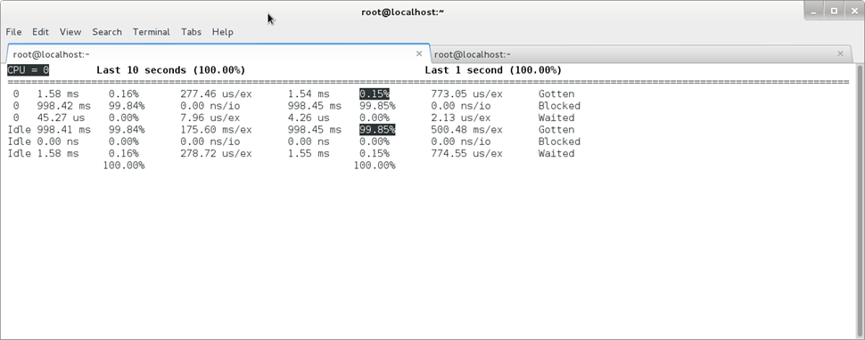
Figure 36: Xenmon.py
As you see, The XenMon provide two columns. The left hand show you statistics that captured over the preceding 10 seconds and on the right hand you can see the data for the last 1 second.
The first row (Gotten) is the amount of time that each domain spent as executing. The second row (Blocked) show the statistics for idle time and the finally row (Waited) show you the amount of time the domain has been in a wait state.
As you on the top of console, By default the XenMon display information for CPU 0and if you have more than one Physical CPU the you can use “p” and “n” keys for move forward to other CPUs. For quit from the XenMon Environment you can use “q” key and XenMon show you the summary of data like below :

[root@localhost ~]# xenmon.py
ms_per_sample = 100
Initialized with 8 cpu's
CPU Frequency = 3392.37
Event counts:
104856299 Other
00000000 Add Domain
00000000 Remove Domain
00002256 Sleep
03238839 Wake
01477357 Block
06431042 Switch
00000000 Timer Func
06431042 Switch Prev
06431042 Switch Next
00000000 Page Map
00000000 Page Unmap
00000000 Page Transfer
processed 128867877 total records in 761 seconds (169340 per second)
woke up 22863 times in 761 seconds (30 per second)
[root@localhost ~]#
We recommended to look at “xenmon.py --help” command and you can see a bunch of useful parameters. For example, You just like to see the information about the first CPU then you can use “xenmon.py --cpu=1” or you just like to see the information about I/O count for each domain then you can use “xenmon.py –iocount”. The XenMon can accept The combination of parameters :
# xenmon.py --iocount --cpu=1 --allocated
Another useful tool is “xentop”. You as a Linux administrator are familiar with “top” command in Linux Environment.
# xentop
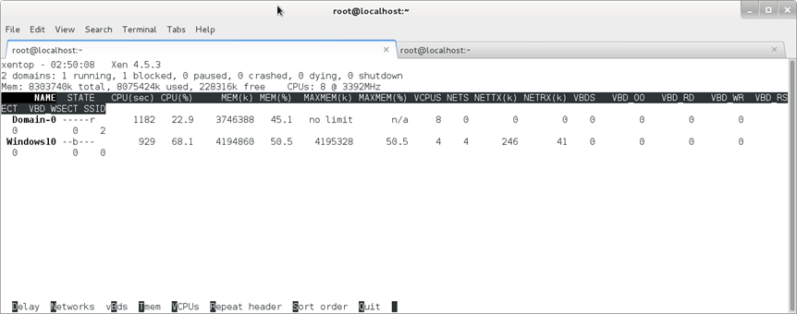
Figure 37: Xentop
The “Xentop” command is “top” command that dedicated for the Xen Project. When you run this command, You can see a bunch of useful features at the end of window. For example, Press “n” key for display information about the networks and packets that are sent and received.
I will show you other useful tools that some of them are installed by default and some of them must be installed by yourself.

1- VmStat
It is a useful command that display statistics of virtual memory, kernerl threads, disks, system processes, I/O blocks, interrupts, CPU activity and...
[root@localhost ~]# vmstat
procs -----------memory---------- ---swap-- -----io---- -system-- ------cpu-----
r b swpd free buff cache si so bi bo in cs us sy id wa st
0 2 60 130248 36912 3107996 0 0 7 7 20 9 0 0 100 0 0

2- Tcpdump
It is good tool for network packet analyzer or packets sniffer and I bet if you work with it then it become a popular tool in your list. It provide good options for capture packets in a file.
# tcpdump -i enp7s0
05:24:08.332952 IP localhost.localdomain.ssh > 172.30.10.18.54923: Flags [P.], seq 1997228:1997456, ack 417, win 309, options [nop,nop,TS val 187046219 ecr 3827389], length 228
05:24:08.333148 IP localhost.localdomain.ssh > 172.30.10.18.54923: Flags [P.], seq 1997456:1997684, ack 417, win 309, options [nop,nop,TS val 187046219 ecr 3827389], length 228
05:24:08.333345 IP localhost.localdomain.ssh > 172.30.10.18.54923: Flags [P.], seq 1997684:1997912, ack 417, win 309, options [nop,nop,TS val 187046220 ecr 3827389], length 228
05:24:08.333542 IP localhost.localdomain.ssh > 172.30.10.18.54923: Flags [P.], seq 1997912:1998140, ack 417, win 309, options [nop,nop,TS val 187046220 ecr 3827389], length 228
05:24:08.333738 IP localhost.localdomain.ssh > 172.30.10.18.54923: Flags [P.], seq 1998140:1998368, ack 417, win 309, options [nop,nop,TS val 187046220 ecr 3827389], length 228
05:24:08.333895 IP 172.30.10.18.54923 > localhost.localdomain.ssh: Flags [.], ack 1998368, win 1995, options [nop,nop,TS val 3827394 ecr 187046201], length 0
05:24:08.333949 IP localhost.localdomain.ssh > 172.30.10.18.54923: Flags [P.], seq 1998368:1998596, ack 417, win 309, options [nop,nop,TS val 187046220 ecr 3827394], length 228
^C05:24:08.334048 IP localhost.localdomain.ssh > 172.30.10.18.54923: Flags [.], ack 521, win 309, options [nop,nop,TS val 187046220 ecr 3827394], length 0

9184 packets captured
9194 packets received by filter
7 packets dropped by kernel
3- Htop
It is a useful tool for monitor Linux process in real time. It is not installed by default and you can install it via “yum” or “dnf”.

# htop
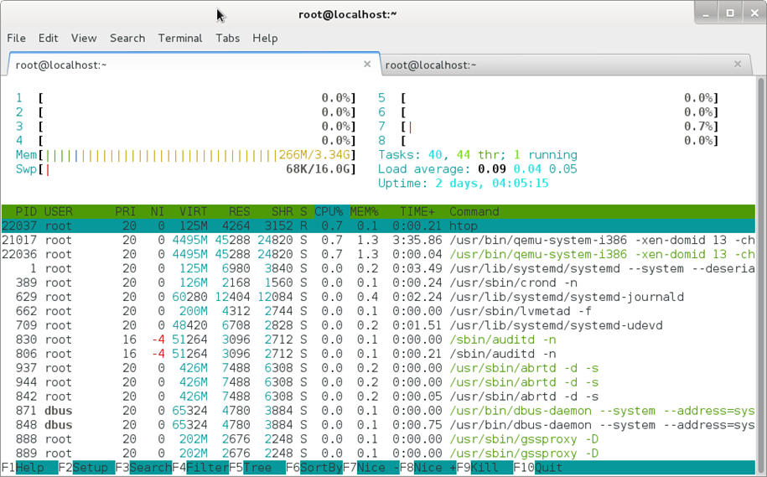
Figure 38: Htop

4- IPTraf
It is a Real Time IP LAN Monitoring and can help you for collect useful information across the network. It is not installed by default and you must install it via “yum” or “dnf”.
# iptraf-ng
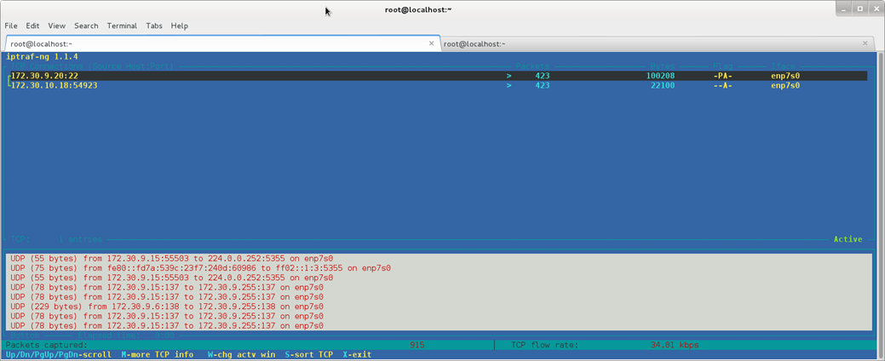
Figure 39: IPTraf

5- Nmon
Nmon or Nigel’s performance Monitor is a tool that used to monitor all Linux resources like CPU, Memory, Network and… It is not installed by default and you must use “yum” or “dnf” for install it.
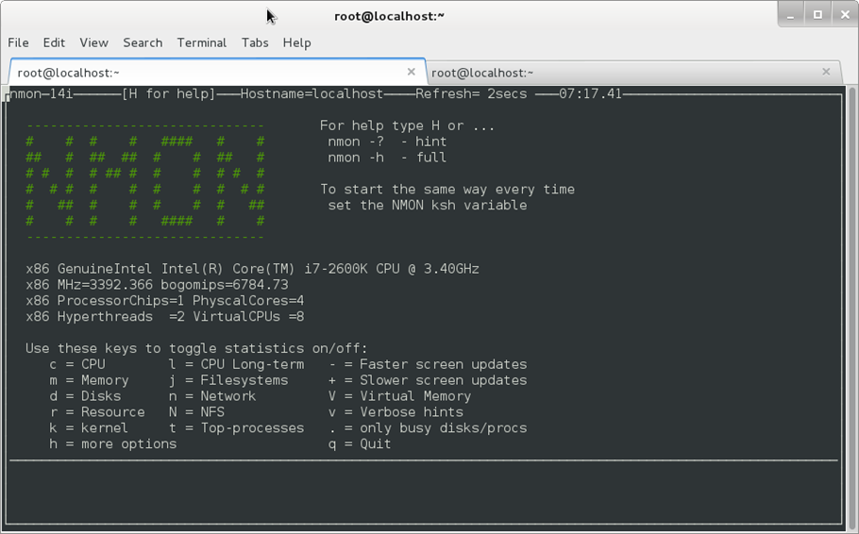
Figure 40: Nmon

XCP
XCP means “Xen Cloud Platform” that is a Virtualization solution that provide out-of-the box virtualization and cloud computing. The XCP provide some features as below :
● Provide a way to manage Pools.
● Support of advantage storage.
● Support of SLA and mutli-tenancy.

The XCP has two flavors : 1) XCP ISO 2) XCP-XAPI Packages. The first one is like XenServer and come with same drivers and the second one is a package that exist in some Linux Distros. A good comparison exist at http://wiki.xenproject.org/wiki/Xen_/_XCP_/_XCP_on_Linux_Overview .
Unfortunately, “XAPI” not exist for Fedora anymore and if you look at https://fedoraproject.org/wiki/Features/XAPI then you see “Targeted release: Fedora 17”, But don't worry we use a trick for install it.
Download “XenServer” .iso file from “http://xenserver.org/open-source-virtualization-download.html” and move it to your Xen Project Server. You can use “scp” command for do it. For example :
# scp XenServer-7.0.0-main.iso root@172.30.9.20:/home/mohsen/
After it, We must mount this .iso file thus create a directory with the name “cd” under “/mnt/” directory :

# mkdir cd /mnt
Then use below command to mount .iso file to “/mnt/cd” directory :
# mount -o loop /home/mohsen/XenServer-7.0.0-main.iso /mnt/cd
Then change to “/mnt/cd” directory via “cd” command :
[root@localhost ~]# cd /mnt/cd/
[root@localhost cd]# ls
boot client_install EFI EULA install.img LICENSES Packages Read_Me_First.html repodata

You can see a directory with the name “ Packages” and move to it via “cd” command. After it you can find “XAPI” package here :
[root@localhost Packages]# ls xapi-xe*
xapi-xe-1.9.57-8535.x86_64.rpm

Then use “rpm” command to install it as below :

[root@localhost Packages]# rpm -Uvh xapi-xe-1.9.57-8535.x86_64.rpm
Preparing... ################################# [100%]
Updating / installing...
1:xapi-xe-1.9.57-8535 ################################# [100%]

After it you can see that we installed “xe” successfully and can use it :
[root@localhost Packages]# xe
Usage: xe <cmd> [-s server] [-p port] ([-u username] [-pw password] or [-pwf <password file>]) <other arguments>
A full list of commands can be obtained by running
xe help -s <server> -p <port>
You may ask why we did it, We did it because you can control a Citrix XenServer host from your Xen Project or your Linux client. We will tell something about Citrix XenServer in the next chapter.
OK, This chapter Finished and you can test your knowledge after it. At the end of this chapter I just want to show you something that maybe useful : 1-For more information about DomU and Virt-Manager Please look at “http://wiki.xenproject.org/wiki/DomU_Install_with_Virt-Manager”.
2- For learn “virsh” command and use it via Xen Project Please look at http://wiki.xenproject.org/wiki/Virsh_Commands .
3- For more information about VGA Passthrough Please look at : http://wiki.xen.org/wiki/Xen_VGA_Passthrough , http://wiki.xen.org/wiki/VTdHowTo , http://wiki.xen.org/wiki/XenGT , https://blog.xenproject.org/2014/03/11/xen-graphics-virtualization-xengt/ and http://events.linuxfoundation.org/sites/events/files/slides/XenGT-LinuxCollaborationSummit-final_1.pdf

Chapter 5:

Have fun with The Xen Project

Have fun with The Xen Project
Welcome to the final chapter of our book. In this chapter, we want show you some extra works that you can doing with the Xen Project.

Converting VirtualBox VM to The Xen Project
Open the VirtualBox and select your VM in VB. Right click on your VM and select “Settings...”. The Settings windows opened and after it click on “Storage” :

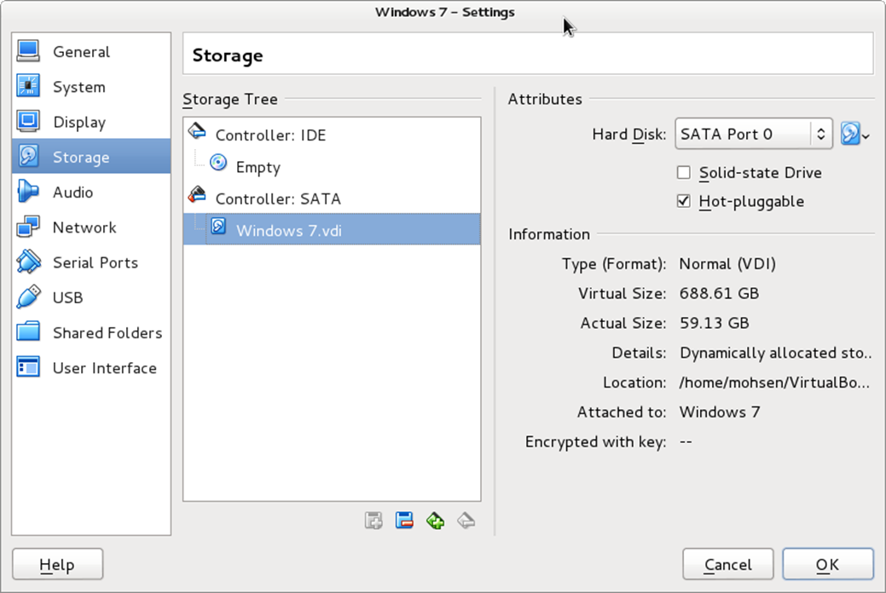
Figure 41: Settings Window.

In “Controller” section you can see your Virtual HDD name and in the right panel you can see its location. For example, My Virtual HDD name is “Windows 7.vdi” and location is “/home/mohsen/VirtualBox VMs/Windows 7”. You have two options : 1) Install VirtualBox on your Xen Server and then convert your VM on your Xen 2) Convert file locally and move it to your Xen Server. OK, If you like the first options then Navigate to the location and copy *.vdi file to your Xen Server via “scp” command or any tools that you are being comfortable with it. Your .vdi file maybe large so it is better to compress it via “zip” command. After copying then you must doing steps that we introduced below :
We assume you installed VirtualBox on your local computer or Xen Server and everything is OK. We will show you how you can convert your VM. The VB provide a command with the name “VboxManage” and we will use it for Clone our HDD. Use below command :
# VBoxManage clonehd YourVDIName.vdi OutPut.img -format RAW
For example :
mohsen@Keep-calm-and-use-Linux:~/VirtualBox VMs/Windows$ VBoxManage clonehd Windows7.vdi Windows7.img --format RAW
0%...10%...20%...30%...40%...50%...60%...70%...80%...90%...100%
Clone medium created in format 'RAW'. UUID: df5344f3-4756-4d04-9395-90a88431c0d3
mohsen@Keep-calm-and-use-Linux:~/VirtualBox VMs/Windows$

As you see, Converting Done and we must move it to our Xen Server (I choice option 2).
We assume you moved it your Xen Server and everything is OK. After it, We must create a config file for our new VM. I used “touch” command for create a config file as below :
# touch /etc/xen/windows.via.virtualbox.cfg
Open your config file via an editor like “nano” and fill it :
name = "Windows Converted"
builder = "hvm"
uuid = "df5344f3-4756-4d04-9395-90a88431c0d3"
memory = 1024
vcpus = 2
interface=['br0']
vif = [ "mac=00:16:3e:46:e6:fb,bridge=br0" ]
disk = [ "file:/home/mohsen/Windows7.img,xvda,w" ]
vnc=”1”
vnclisten=”172.30.9.20”
on_poweroff = "destroy"
on_reboot = "restart"
on_crash = "restart"

If you pay attention then you see a section with the name “ UUID” in the output of “ VboxManage” command. We must copy and paste it exactly in our Xen config file as above. The “Disk” option is like older config and you must specific your .img file. Finally, just run below command :
# xl create /etc/xen/YourConfigName.cfg
Don't forget, Migration VMs between Virtualization Platforms is not a very good idea and you may got some problems. For example, Windows show your Blue Page or...

Selinux and Xen Project
The SElinux Project is a Linux Kernel module that provide a security mechanism for supporting mandatory access controls (MAC). It is a very good tool for enhanced security under Linux and added to various Linux Distros. The main sponsors of this project are NSA and Red Hat. We don't like cover All aspects of Selinux here because its need a Bible book but as NSA team said : The Selinux is a set of patches to Linux kernel that provide flexible mandatory access control (MAC) architecture into the major subsystems of the kernel. The Selinux provide a mechanism that by help it malicious or flawed applications can't bypass security mechanisms. By default, Selinux provide a set of sample security policy configuration files for general-purpose security goals.
We just want to show you some good options for use Selinux under your Xen Project. You can see your Selinux status via “sestatus” command :
[root@localhost ~]# sestatus
SELinux status: enabled
SELinuxfs mount: /sys/fs/selinux
SELinux root directory: /etc/selinux
Loaded policy name: targeted
Current mode: enforcing
Mode from config file: enforcing
Policy MLS status: enabled
Policy deny_unknown status: allowed
Max kernel policy version: 30

The Selinux, provide three modes :
- Enforcing : It is the default mode that enable and enforce the SELinux security policy on your system and based on Selinux policy rules denied your access.
- Permissive : In this mode, Selinux enabled but will not enforce the security policy and just show you warning messages and log actions. This mode is very good for troubleshooting SELinux problems.
- Disabled : Needless to say.
For change between modes you can use “setenforce” command :
[root@localhost ~]# setenforce
usage: setenforce [ Enforcing | Permissive | 1 | 0 ]

Please note that when you use “setenforce” command, changes do not persist across reboots. To change Selinux to enforcing mode run “setenforce 1” and to change permissive mode just run “ setenforce 0”. the “1” mean “ Enforcing” and the “0” mean “ Permissive” :
setenforce 1 == setenforce Enforcing
Finally, To view the current SELinux mode just use “getenforce” command :
[root@localhost ~]# getenforce
Enforcing
For Disable Selinux you can edit “/etc/sysconfig/selinux” and change “SELINUX=permissive” to “SELINUX=disabled”.
# This file controls the state of SELinux on the system.
# SELINUX= can take one of these three values:
# enforcing - SELinux security policy is enforced.
# permissive - SELinux prints warnings instead of enforcing.
# disabled - No SELinux policy is loaded.
SELINUX=enforcing
# SELINUXTYPE= can take one of these three values:
# targeted - Targeted processes are protected,
# minimum - Modification of targeted policy. Only selected processes are protected.
# mls - Multi Level Security protection.
SELINUXTYPE=targeted

You can see a list of Selinux modules by running “semodule -l” :
[root@localhost ~]# semodule -l
BackupPC
abrt
accountsd
acct
afs
aiccu
aide
ajaxterm
alsa
amanda
amtu
anaconda
antivirus
apache
...

Selinux provide a Policy with the name “Booleans”. With “Booleans” you can change the policy without any knowledge about Selinux policy writing. Booleans provide a good feature and it is that you can change setting without reloading or recompiling SELinux policy.
For see a list of Booleans you can use below command :
# semanage boolean -l
For example :
[root@localhost ~]# semanage boolean -l | grep xen
xend_run_qemu (on , on) Allow xend to run qemu
xend_run_blktap (on , on) Allow xend to run blktap
xen_use_nfs (off , off) Allow xen to use nfs

As you see, By default the Xen Project denied to use “nft” and you can enable it :
# setsebool -P xen_use_nfs on
and if you see the booleans again then :
[root@localhost ~]# semanage boolean -l | grep xen
xen_use_nfs (on , on) Allow xen to use nfs
xend_run_blktap (on , on) Allow xend to run blktap
xend_run_qemu (on , on) Allow xend to run qemu

As you see, Options changed to “on”. This allow The Xen Project to use “nfs”. We used “-P” option because with this option our changes remain after reboot.
As we said, We don't like to dive into Selinux and just ant to show you how you can doing Virtualization with Selinux enabled. If you remember we setup LVM for our Xen Project VM :
[root@localhost ~]# lvdisplay
--- Logical volume ---
LV Path /dev/Xen/OpenSUSE
LV Name OpenSUSE
VG Name Xen
LV UUID dt4UiA-66k5-dd51-2AQ9-CLob-PyR3-Uvcy7u
LV Write Access read/write
LV Creation host, time localhost.localdomain, 2016-05-08 04:33:19 -0400
LV Status available
# open 0
LV Size 20.00 GiB
Current LE 5120
Segments 1
Allocation inherit
Read ahead sectors auto
- currently set to 256
Block device 253:2
...

With below command we can set the SELinux context for the underlying block device and volume group :
[root@localhost ~]# semanage fcontext -a -t xen_image_t -f b /dev/Xen/OpenSUSE
After it, When you run “semanage fcontext -l | grep 'OpenSUSE'” then :
[root@localhost ~]# semanage fcontext -l | grep 'OpenSUSE'
/dev/Xen/OpenSUSE block device system_u:object_r:xen_image_t:s0

[root@localhost ~]# ls -Z /dev/Xen/OpenSUSE
system_u:object_r:device_t:s0 /dev/Xen/OpenSUSE

You can use “restorecon” command to restore file(s) default SELinux security contexts :
# restorecon /dev/Xen/OpenSUSE

After this Selinux protection, other process can't access to our device and just VM managers can access to our device. It is True that Selinux is not an Antivirus but it can protect the Linux system a lot. For example, A big Xen Vulnerability that released recently was “VENOM” (http://venom.crowdstrike.com/), It is fixed very soon in Xen and all new Xen versions are protected but you can use Selinux for protect your Xen too. For more information, Please see http://danwalsh.livejournal.com/71489.html . For more information about Xen Project security and hardening it, Please look at http://wiki.xenproject.org/wiki/Securing_Xen .
OK, Now a good time for speaking about Citrix XenServer.

Citrix XenServer
If you remember, We spoke something about XenServer. The Citrix XenServer is the leader of open source virtualization platform that using for managing Cloud and Server Virtualization. Installing XenServer is so easy even easier than OS and just take some minutes. A company with XenServer can launch a Virtualization server in some minutes and XenServer will meet all your needs. XenServer is so fast and have a Good flexibility, performance and Most importantly have a low cost. If you used other products like VMWare ESXi then I recommend install the XenServer and test it. I bet you will surprise.
For download XenServer go to “http://xenserver.org/open-source-virtualization-download.html” and click on “XenServer Installation ISO” and a file about 633 MB in .iso format will be download. After it you should download “XenCenter” that is a Windows Management Console for XenServer. For download the XenCenter just click on “XenCenter Windows Management Console“ on above link. For other OS like Linux you can use “SSH” and other management tool like “OpenXenManager” (https://sourceforge.net/projects/openxenmanager/). The XenCenter is written in .Net programming language and it is true that Microsoft open sourced .Net programming language and this language can run in Linux too but The Citrix not produced XenCenter for Linux till now, But we hope to see it under linux very soon.
OK, I suppose that you downloaded XenServer and write it on a CD or make a bootable USB for install it. As I said, Install it is so easy and don't need any special knowledge. I just want to show some steps that you will see them :
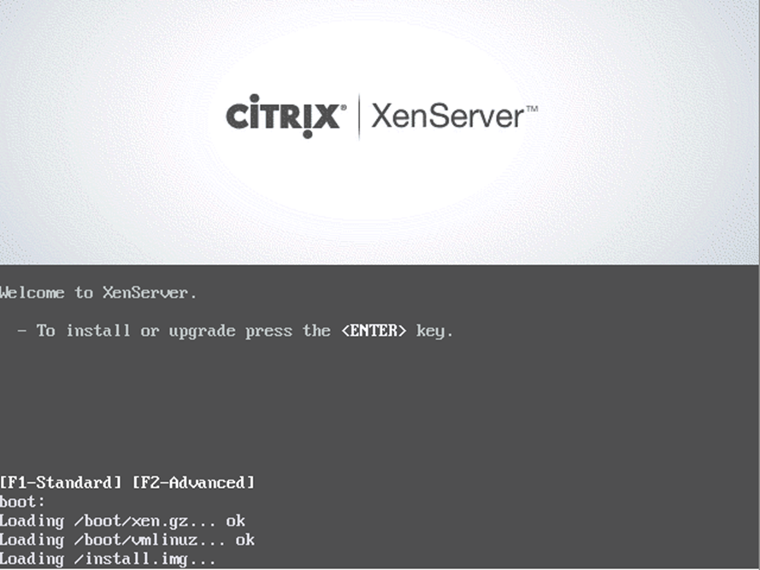
Figure 42: Main screen of XenServer
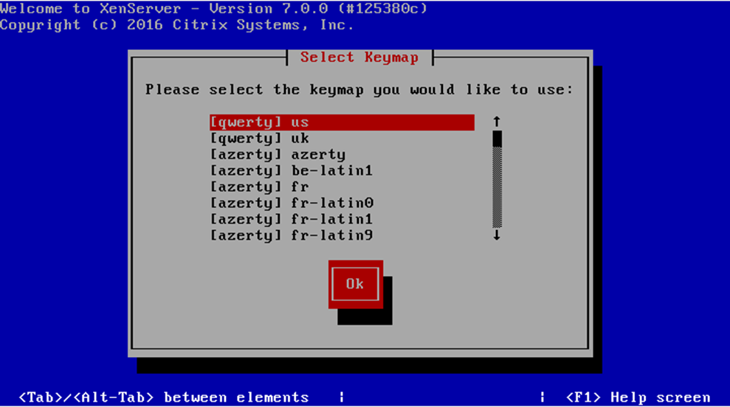
Figure 43: Select your Keymap

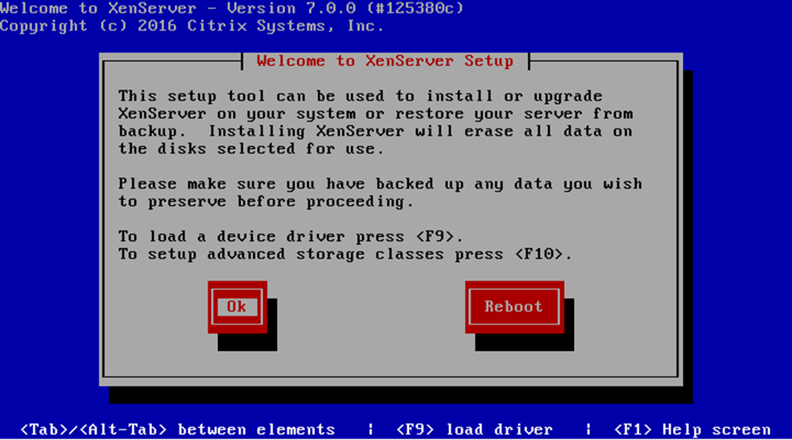
Figure 44: Read the text and if you are Agree then Click OK
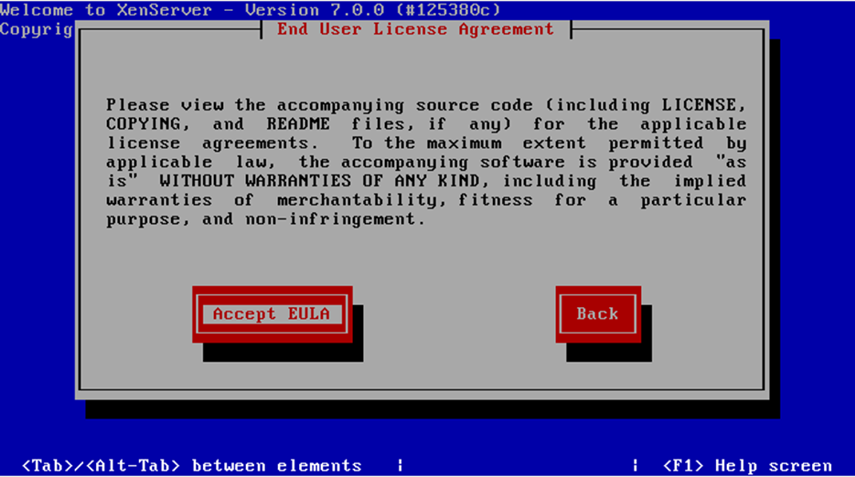
Figure 45: Accept the License
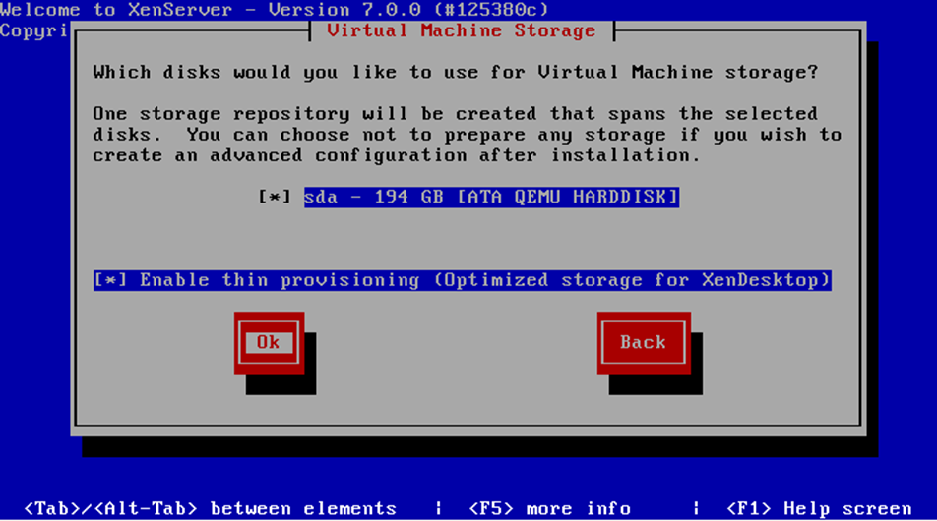
Figure 46: Select your Storage and click OK
Note : XenServer will remove all your data on HDD and create one partition as your storage. If you use RAID then you can tell XenServer to install on specific partition and not remove all of your data.
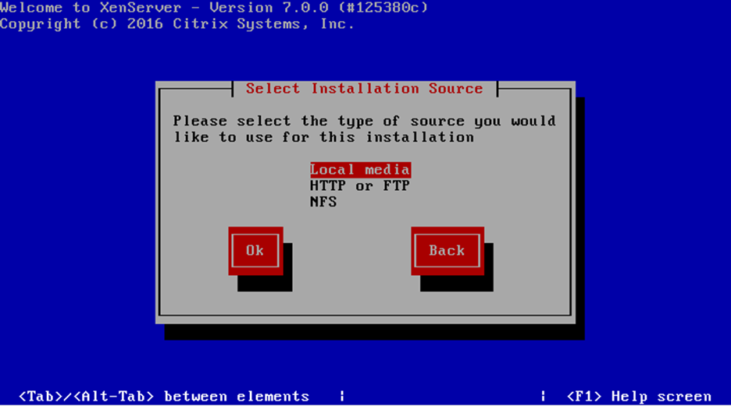
Figure 47: Select your Installation Source
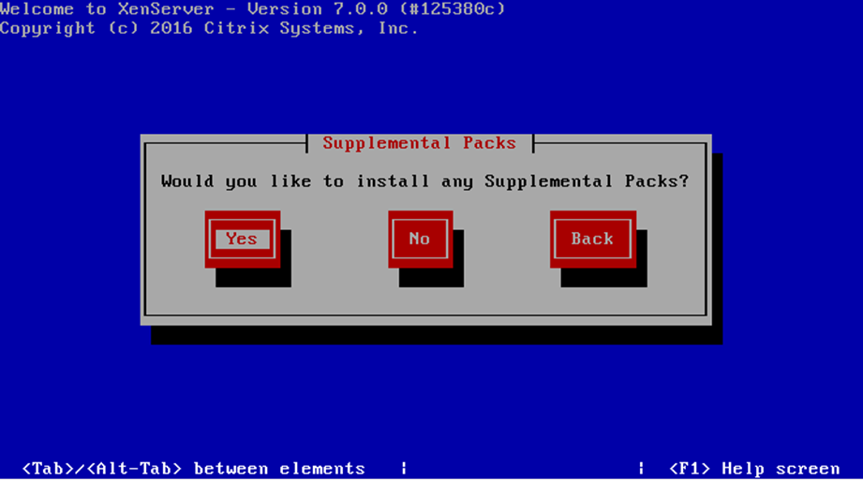
Figure 48: If you have External packages then Click Yes otherwise click No

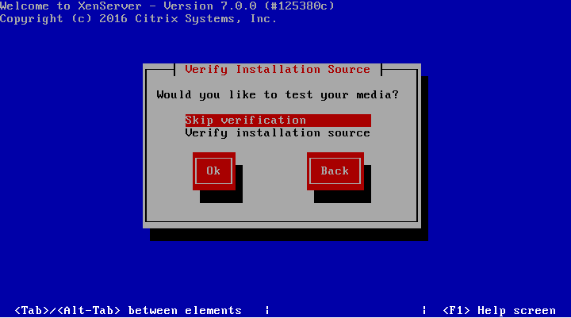
Figure 49: Select the prepare option

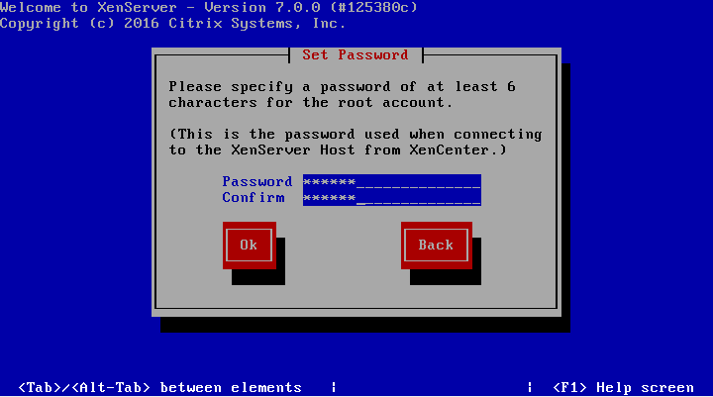
Figure 50 : Set “root” password

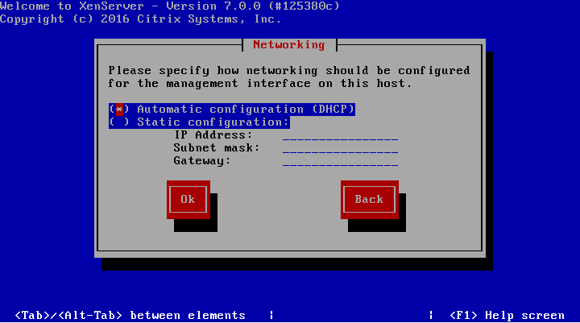
Figure 51 : Select the prepare option for obtain the IP address

Note : Server must have Static IP and select “DHCP” is not a good option.

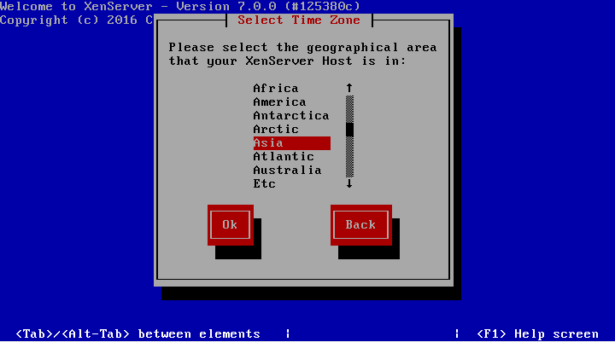
Figure 52 : Select correct Time Zone

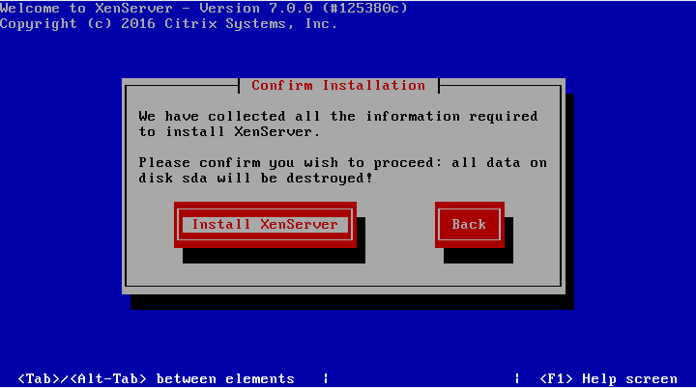
Figure 53 : Select “Install XenSever” to start installation

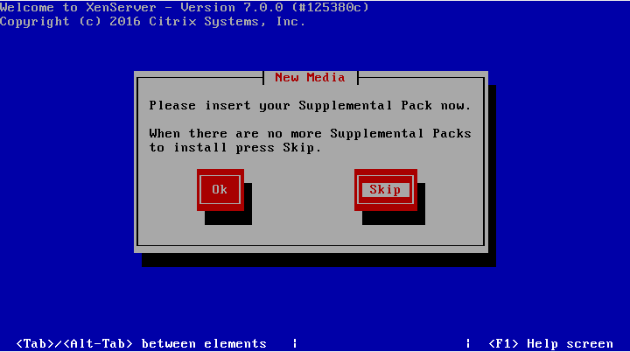
Figure 54 : XenSever installation
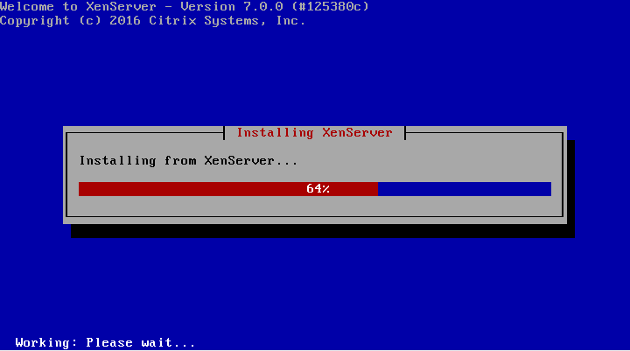
Figure 55 : Select prepare option

Note : If you don't have “Supplemental Pack” then select “Skip”
OK, You installed XenServer successfully. It was not hard, Is it ?
When you reboot you server then you will see something like below :

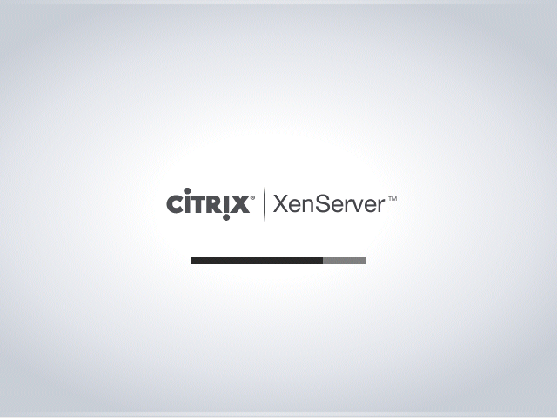
Figure 56 : Loading XenServer
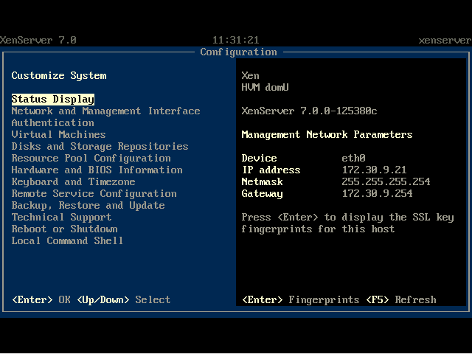
Figure 56: XenServer is ready to use
I assume you installed “XenCenter” on Windows or “OpenXenManager” on Linux. Installing “XenCenter” is easy and just doing with some clicks but for install “ OpenXenManager” you should doing some steps :
- Install “git” if your system not have it.
- Install package dependencies. Packages are “python-gtk2 glade python-gtk-vnc python-glade2 python-configobj”.
- Clone the repo from GitHub :
# git clone https://github.com/OpenXenManager/openxenmanager.git
- Install “OpenXenManager” :
# cd openxenmanager
# sudo python setup.py install
- Run the OpenXenManager
$ openxenmanager
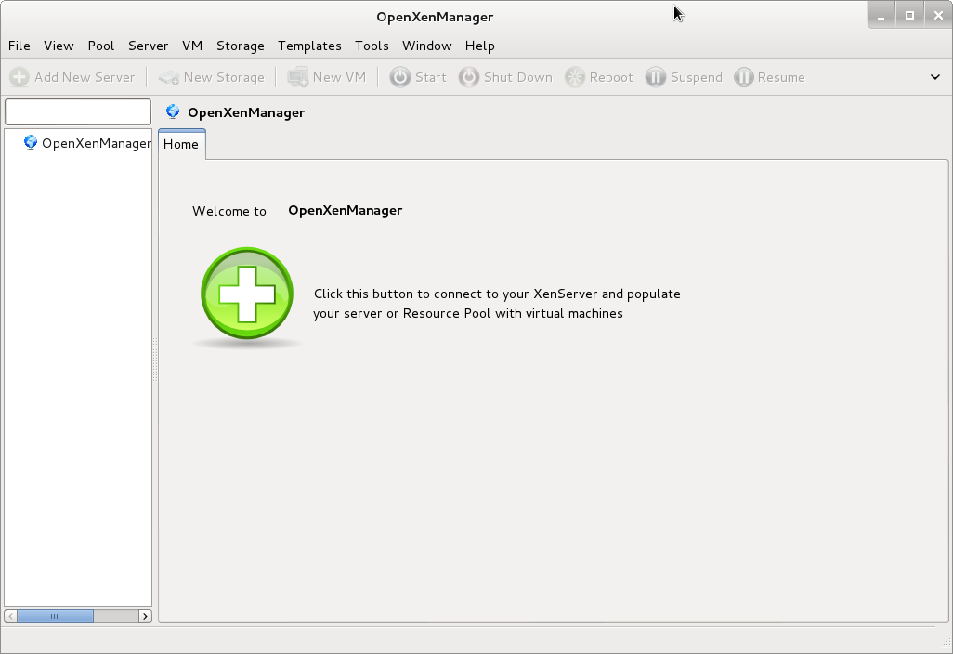
Figure 57: Open XenManager

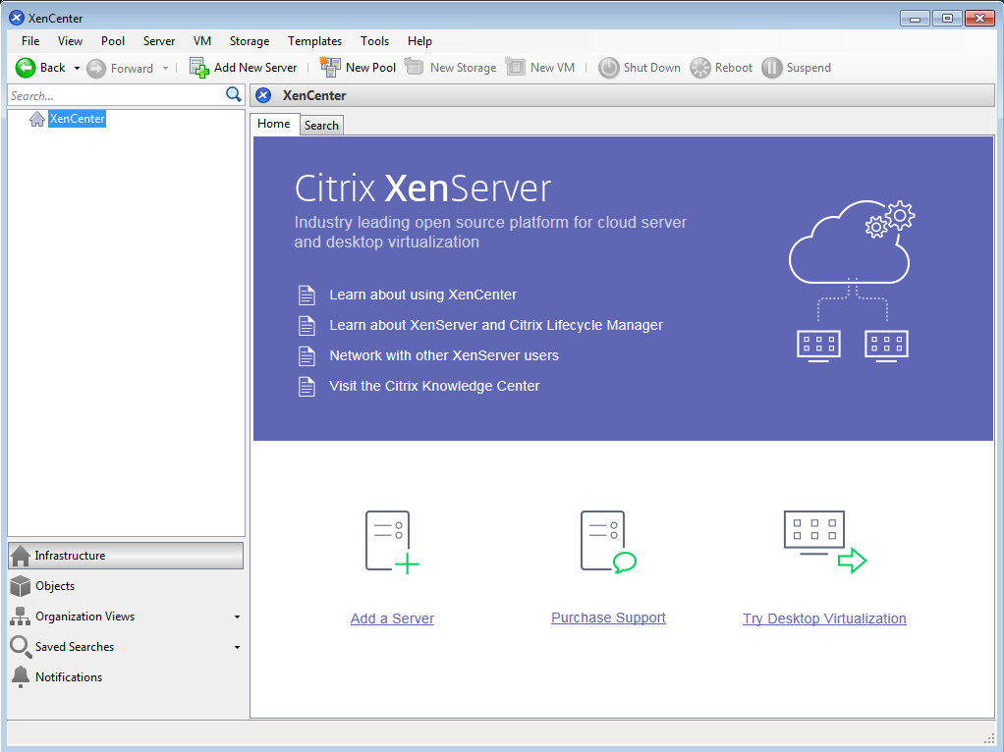
Figure 58: Citrix XenCenter

Once Everything is ready, you can connect to your XenServer via these tools.
We will show you how you can manage your XenServer but not deeply because it need another book. Firs of all, write “openxenmanager” in your terminal and press Enter key. The OpenXenManager window become apparent then select “Server” menu and then click on “add”. A window become apparent and you must fill the information that it needs:

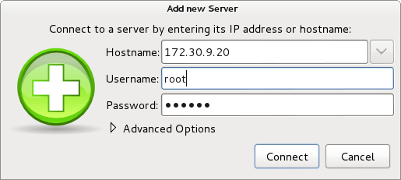
Figure 59: Open XenManager
After it, Click on “Connect”. As you see, Your XenServer added.
In Citrix XenCenter you can do similar task. Open XenCenter then click on “Add New Server” and you will see a similar windows as below :

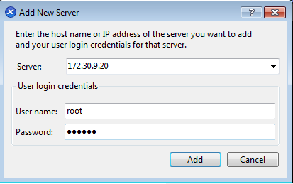
Figure 60: XenCenter
Then click on “Add”. As you see, A windows show a security warning and you just click on “Accept”.

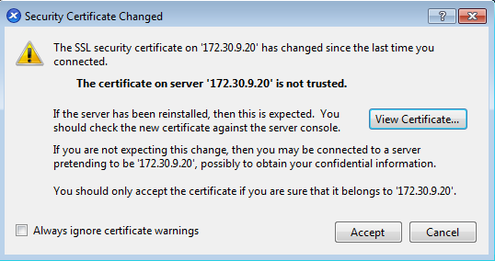
Figure 61: XenCenter security warning

After it, You can see your XenServer and can work with it :

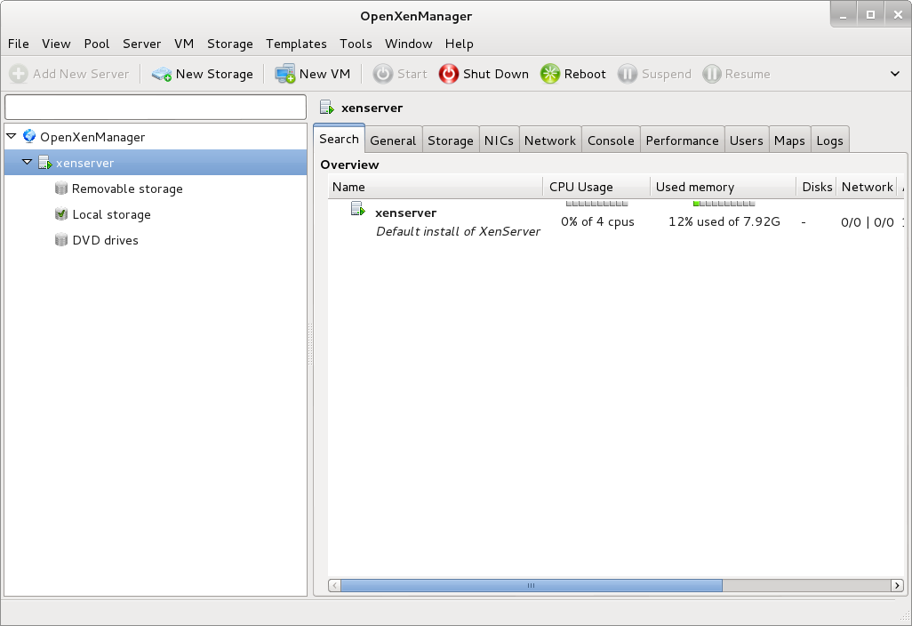
Figure 62: OpenXenManager

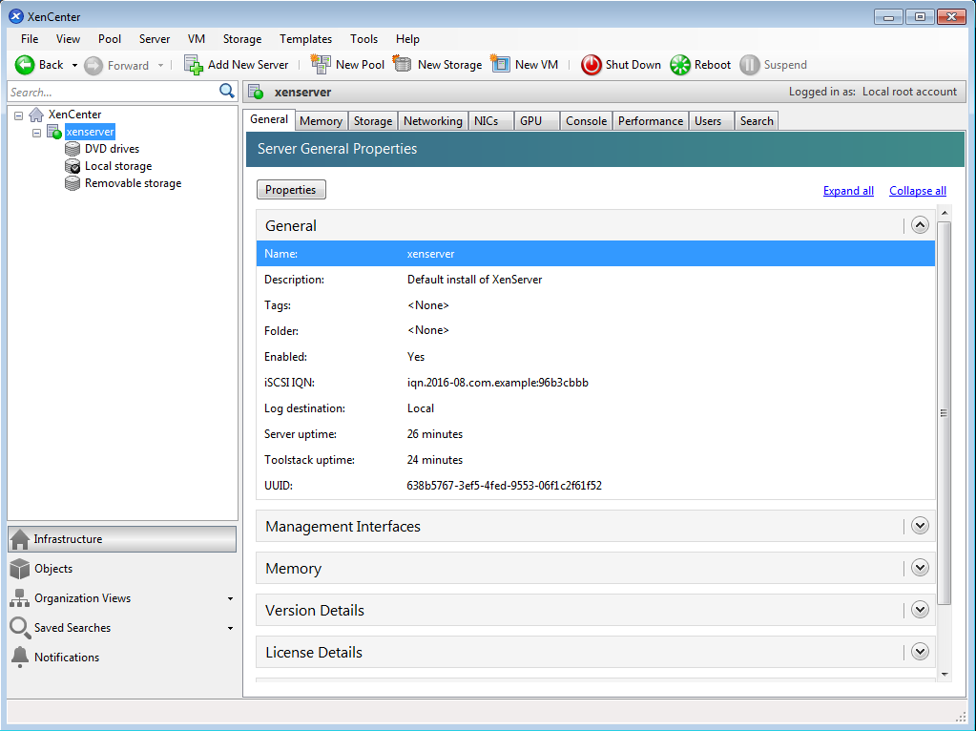
Figure 63: XenCenter

You can see your XenServer in the left panel. Let's start and create our Vms. We will focus on “OpenXenManager” more because you can run it under Linux.
Open “OpenXenManager” and click on “New VM” or from “VM” menu click on “New”. You can see a Windows like below :
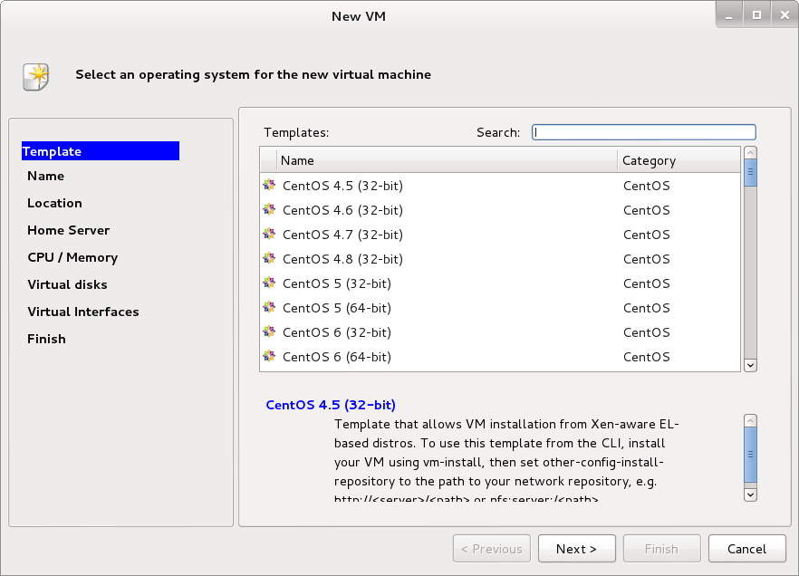
Figure 64 : New VM Window

As you see, Some OS templates are listed and you can select your OS that you want install it. If your OS not listed here then you can select “Other install media”. Select your “Template” and click “Next”. In the next window select a Name for your VM and you can write a description about it too. After it, Click “Next”. In the “Location” section you can select your method for installation OS. If you like install your OS via CD\DVD drive on Server then select “Physical DVD drive” and if you have .ISO file from your OS the select “ISO Image” option, But you must upload your .ISO file to your XenServer. In the Citrix XenCenter you can run “Windows File Sharing” for do it. Let me to upload my .ISO file to XenSever server. You can use “scp” command for do it.
I created a directory in “/var/opt/xen/ISO”. Then you must open your XenServer console. You can do it by click on “Console” tab or SSH to your XenServer. When you on Xenserver, doing below command :
# mkdir /var/opt/xen/ISO
# xe sr-create name-label=LocalISO type=iso device-config:location=/var/opt/xen/ISO device-config:legacy_mode=true content-type=iso
[root@xenserver home]# xe sr-create name-label=LocalISO type=iso device-config:location=/var/opt/xen/ISO device-config:legacy_mode=true content-type=iso
2cb6a58b-2c4f-21fa-f58b-a1fca665cc38

After it, You must put .ISO file in “/var/opt/xen/ISO”. After it in the main windows you can see the new SR :

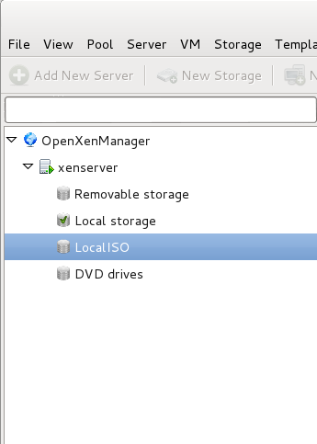
Figure 65: Local ISO
Lets see what happened in “Location” option:

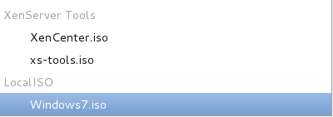
Figure 66: .ISO file

As you see, Our .ISO file appear there.
If you don't like command line then you can use “New Storage” option in the main window of “OpenXenManager”. Click on it and you see a Windows like below:
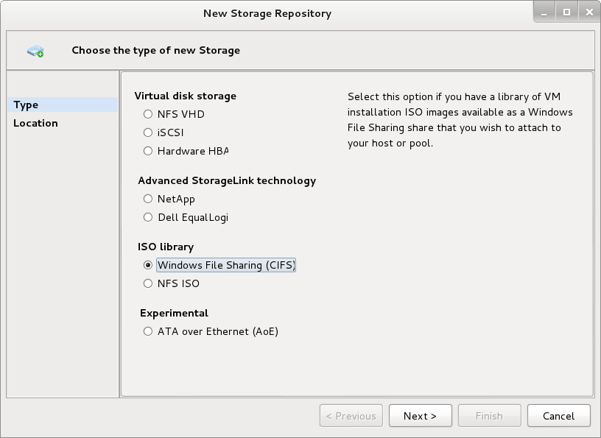
Figure 67: New Storage Window
In this window, Select “Windows File Sharing (CIFS)” and click next. In the next windows, specific the folder patch that .ISO file is in it and if your network use domain then select “use different user name” and fill the fields with correct information. Don't forget, use “yourdomainname\username” :

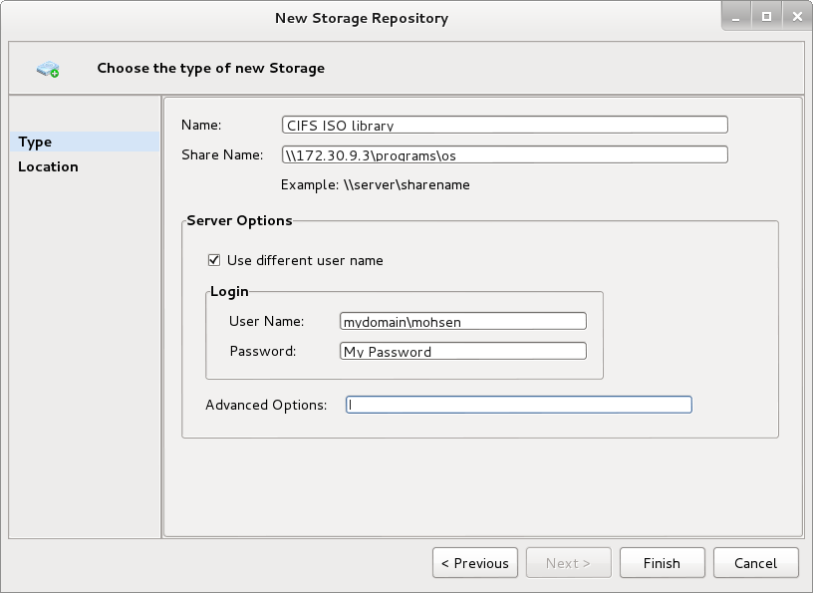
Figure 68: specific the correct path
Then click “Finish” and in the main Window you can see a new SR with the name “CIFS ISO library”. Click on it and select “storage” tab. In this tab you can see all .ISO file that exist in the path that you specified:

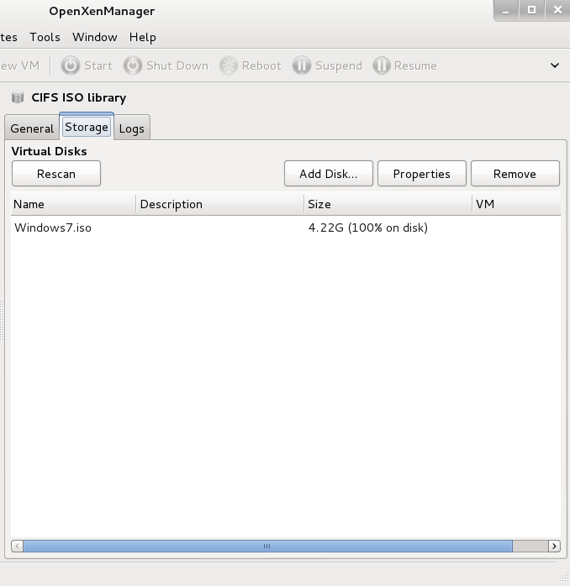
Figure 69: Storage tab
In other pages you can select the number of CPU, Size of Memory and Disk. In “Virtual Interfaces” section you can add your NIC by click on “add” button. At the end, by click on “Finish” our VM will be created. If you like your VM started automatically after it created then click select “Start VM automatically”.
OK, After your VM created then in the main window you can see a Blue button with the name “Start” :

Figure 70: “Start” button

click on it and at the end of main window you can see something like percent and when your VM launched completely then you can see that this strip show you a “completed” text like below :
Figure 71 : main window strip
Click on “Console” tab and you can start installation progress :
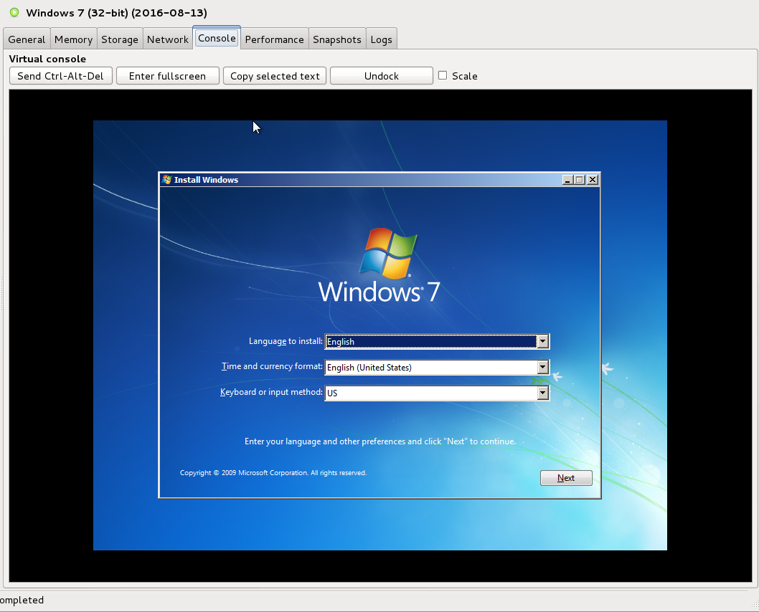
Figure 72: “Console” tab
When your OS installation started, Please click on “General” tab. What do you see? You can see some information about your VM that created but a read text flaunted :
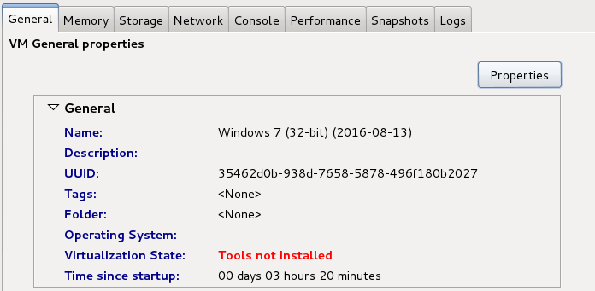
Figure 73: General tab

It tell you that “Tools not installed” and it is the first job that we must do it when OS installed. According to the XenServer documentation : “XenServer Tools provides high performance Windows drivers and a management agent, enhancing disk and network performance for XenServer Vms”. As you see, It is mandatory and help us to get a better performance. Other tab show you some useful information like Performance and…. We will speak about “Snapshots” later. OK, Our OS installed and we must install “XenServer Tools”. You can do it by click on “VM” menu and select “Install XenServer Tools” but first of all Please eject the previous CD\DVD (OS). For do it, Click on “Storage” tab and and select “<empty>” for “DVD drive:”. If you select “xs-tools.iso” instead of “<empty>” then you are ready for install XenServer Tools. When you select “ xs-tools.iso” and open “My computer” on Windows then you will see something like below:

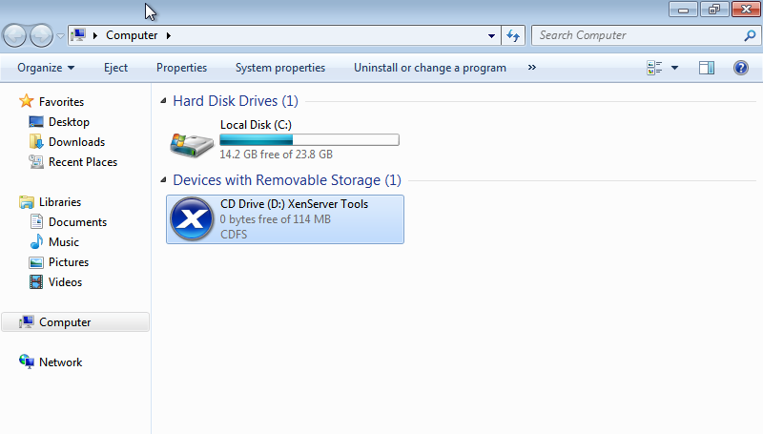
Figure 74: Install XenServer Tools

Just click on “CD Drive” and install progress will start.
You can all of the stuff via “xe” command too. We never dive into this because it is very vast and need another book but will will cover something that you need it.
For create a new vm via command line do below steps :
# xe template-list
then select your template name and :
# xe vm-install template="Debian Squeeze 6.0 (32-bit)" new-name-label="My Debian" sr-uuid= Your SR UUID
For find SR UUID use below command :
# xe sr-list
[root@xenserver ~]# xe sr-list
uuid ( RO) : 30f0541d-eb20-ab50-ba41-94eeb92eb104
name-label ( RW): Removable storage
name-description ( RW):
host ( RO): xenserver
type ( RO): udev
content-type ( RO): disk

uuid ( RO) : 09b22fe6-df17-2fc3-333f-43f559f7a2e5
name-label ( RW): CIFS ISO library
name-description ( RW): CIFS ISO Library [\\172.30.9.3\programs\os]
host ( RO): xenserver
type ( RO): iso
content-type ( RO): iso
uuid ( RO): f6bc99a1-070a-2470-c091-ee89fe2bae7e
name-label ( RW): DVD drives
name-description ( RW): Physical DVD drives
host ( RO): xenserver
type ( RO): udev
content-type ( RO): iso
uuid ( RO): dc2d6d43-b60b-097d-22c6-5275d185d8e7
name-label ( RW): Local storage
name-description ( RW):
host ( RO): xenserver
type ( RO): ext
content-type ( RO): user
uuid ( RO): 6972a5fc-f265-d32c-52ff-47bf96221309
name-label ( RW): XenServer Tools
name-description ( RW): XenServer Tools ISOs
host ( RO): xenserver
type ( RO): iso
content-type ( RO): iso

You must use your “Local Storage” ID thus our full command is :
# xe vm-install template="Debian Squeeze 6.0 (32-bit)" new-name-label="My Debian" sr-uuid=dc2d6d43-b60b-097d-22c6-5275d185d8e7
[root@xenserver ~]# xe vm-install template="Debian Squeeze 6.0 (32-bit)" new-name-label="My Debian" sr-uuid=dc2d6d43-b60b-097d-22c6-5275d185d8e7
e3ac9c9f-07be-96ca-ebb7-b5304cd45f50

After it, If you check your “OpenXenManager” then you will see a new VM with the name “My Debian”.
You can change your VM setting via “xe” too. For example, By default, XenServer assigned 1 CPU to our VM and we want change it to 4 CPUs :
# xe vm-list
[root@xenserver ~]# xe vm-list
uuid ( RO) : e3ac9c9f-07be-96ca-ebb7-b5304cd45f50
name-label ( RW): My Debian
power-state ( RO): halted

uuid ( RO) : 35462d0b-938d-7658-5878-496f180b2027
name-label ( RW): Windows 7 (32-bit) (2016-08-13)
power-state ( RO): halted

uuid ( RO) : 51c9e0e0-f2b0-4bec-806d-1f632437c474
name-label ( RW): Control domain on host: xenserver
power-state ( RO): running

Then :
# xe vm-param-set VCPUs-max=4 uuid= Your VM UUID
xe vm-param-set VCPUs-max=4 uuid=e3ac9c9f-07be-96ca-ebb7-b5304cd45f50

Then :
# xe vm-param-set VCPUs-at-startup=4 uuid= Your VM UUID
xe vm-param-set VCPUs-at-startup=4 uuid=e3ac9c9f-07be-96ca-ebb7-b5304cd45f50

After it, If you see the VM properties then you can see that our VCPU changed :
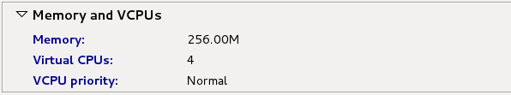
Figure 75 : Change VCPU
You can change memory setting too. The commands that you must use are :
- xe vm-param-set memory-static-max=”Maximum size for static memory” uuid=replace_with_uuid
- xe vm-param-set memory-dynamic-max=”Maximum size for dynamic memory” uuid=replace_with_uuid
- xe vm-param-set memory-dynamic-min=”Minimum size for dynamic memory” uuid=replace_with_uuid
- xe vm-param-set memory-static-min=”Minimum size for static memory” uuid=replace_with_uuid
For example :
[root@xenserver ~]# xe vm-param-set memory-static-max=
2147483648 268435456 788529152
[root@xenserver ~]# xe vm-param-set memory-static-max=788529152 uuid=e3ac9c9f-07be-96ca-ebb7-b5304cd45f50
[root@xenserver ~]# xe vm-param-set memory-dynamic-max=788529152 uuid=e3ac9c9f-07be-96ca-ebb7-b5304cd45f50
[root@xenserver ~]# xe vm-param-set memory-dynamic-min=
2147483648 268435456 788529152
[root@xenserver ~]# xe vm-param-set memory-dynamic-min=268435456 uuid=e3ac9c9f-07be-96ca-ebb7-b5304cd45f50
[root@xenserver ~]# xe vm-param-set memory-static-min= uuid=e3ac9c9f-07be-96ca-ebb7-b5304cd45f50
1024 1073741824 306184192
[root@xenserver ~]# xe vm-param-set memory-static-min=1024 uuid=e3ac9c9f-07be-96ca-ebb7-b5304cd45f50

After it you can see that your memory setting changed :
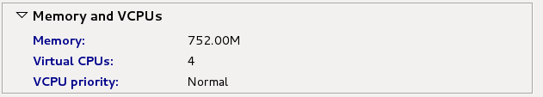
Figure 76 : Memory setting.
Sometimes you need to attach your removable storage to your VM and We will show you how you can do it. Please Plug your removable storage to your server, I suppose it is a Pen Drive. After it, SSH to your XenServer :

$ ssh root@XenServer IP
mohsen@Keep-calm-and-use-Linux:~$ ssh root@172.30.9.20
root@172.30.9.20's password:
Last login: Sat Aug 13 14:31:34 2016 from 172.30.10.18

XenServer dom0 configuration is tuned for maximum performance and reliability.

Configuration changes which are not explicitly documented or approved by Citrix
Technical Support, may not have been tested and are therefore not supported. In
addition, configuration changes may not persist after installation of a hotfix
or upgrade, and could also cause a hotfix or upgrade to fail.

Third party tools, which require modification to dom0 configuration, or
installation into dom0, may cease to function correctly after upgrade or hotfix
installation. Please consult Citrix Technical Support for advice regarding
specific tools.

Type "xsconsole" for access to the management console.
[root@xenserver ~]#

Then, Execute “dmesg” command. The output of this command is long but at the end of output you can see something about your removable storage that plugged :
[root@xenserver ~]# dmesg
[75290.601990] usb 2-1.5: new high-speed USB device number 3 using ehci-pci
[75290.853090] usb-storage 2-1.5:1.0: USB Mass Storage device detected
[75290.853174] scsi4 : usb-storage 2-1.5:1.0
[75290.853228] usbcore: registered new interface driver usb-storage
[75292.355579] scsi 4:0:0:0: Direct-Access HP v210w 1100 PQ: 0 ANSI: 0 CCS
[75292.355791] scsi 4:0:0:0: alua: supports implicit and explicit TPGS
[75292.356368] scsi 4:0:0:0: alua: No target port descriptors found
[75292.356371] scsi 4:0:0:0: alua: not attached
[75292.356473] sd 4:0:0:0: Attached scsi generic sg2 type 0
[75292.357107] sd 4:0:0:0: [sdb] 31703040 512-byte logical blocks: (16.2 GB/15.1 GiB)
[75292.357944] sd 4:0:0:0: [sdb] Write Protect is off
[75292.357946] sd 4:0:0:0: [sdb] Mode Sense: 43 00 00 00
[75292.358813] sd 4:0:0:0: [sdb] No Caching mode page found
[75292.358817] sd 4:0:0:0: [sdb] Assuming drive cache: write through
[75292.361987] sd 4:0:0:0: [sdb] No Caching mode page found
[75292.361992] sd 4:0:0:0: [sdb] Assuming drive cache: write through
[75292.363072] sdb: sdb1 sdb2
[75292.365816] sd 4:0:0:0: [sdb] No Caching mode page found
[75292.365819] sd 4:0:0:0: [sdb] Assuming drive cache: write through
[75292.365823] sd 4:0:0:0: [sdb] Attached SCSI removable disk

It this example, Our Pen Drive model is “HP v210w”. The Removable storage passtrought is so easy in XenServer and Citrix do it for your automatically and no command need. If you open “OpenXenManager” program and click on “Storage” tab in the main page then you can see that XenServer did it for you automatically :
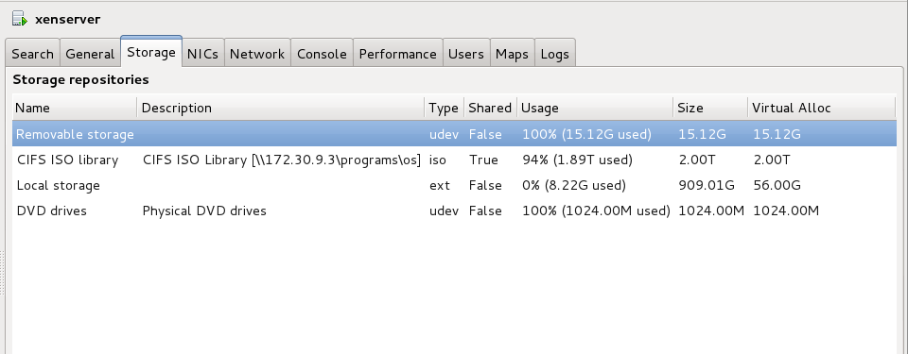
Figure 77 : Removable storage

For add it to your VM just click on your VM name on the main window then click on “Storage” tab and click on “Attach” button and select “Removable Storage” and click on “Attach” button :
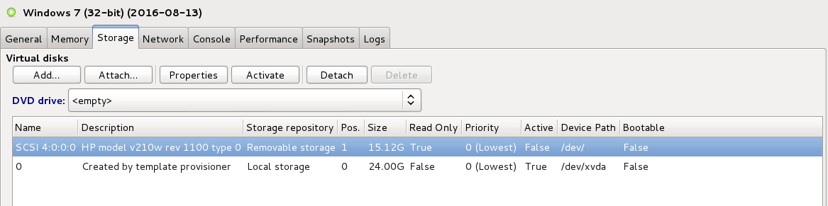
Figure 78 : USB Pass-through
After it, If you go to your VM then you can see that you Pen Drive mounted.
For unplug a Removable storage you can select it and click on “Detach” button.
You can do it by command line too. Do below steps :
1- fdisk -l
[root@xenserver ~]# fdisk -l

WARNING: GPT (GUID Partition Table) detected on '/dev/sda'! The util fdisk doesn't support GPT. Use GNU Parted.

Disk /dev/sda: 1000.2 GB, 1000204886016 bytes
256 heads, 63 sectors/track, 121126 cylinders
Units = cylinders of 16128 * 512 = 8257536 bytes

Device Boot Start End Blocks Id System
/dev/sda1 * 1 121127 976762583+ ee EFI GPT

Disk /dev/sdc: 16.2 GB, 16231956480 bytes
255 heads, 63 sectors/track, 1973 cylinders
Units = cylinders of 16065 * 512 = 8225280 bytes

Device Boot Start End Blocks Id System
/dev/sdc1 1 1974 15850496 b W95 FAT32

As you see, “/dev/sdc1” is my Pen Drive.
2- cd /dev/disk/by-id/
3- ls
[root@xenserver ~]# cd /dev/disk/by-id/
[root@xenserver by-id]# ls
scsi-SATA_ST1000DL002-9TT_W1V0RX1H scsi-SATA_ST1000DL002-9TT_W1V0RX1H-part3
scsi-SATA_ST1000DL002-9TT_W1V0RX1H-part1 usb-HP_v210w_AA00000000000238
scsi-SATA_ST1000DL002-9TT_W1V0RX1H-part2 usb-HP_v210w_AA00000000000238-part1
[root@xenserver by-id]#

4- doing below command :
xe sr-create type=lvm content-type=user device-config:device=/dev/disk/by-id/scsi-SATA_ST1000DL002-9TT_W1V0RX1H-part1 usb-HP_v210w_AA00000000000238 name-label=”Local USB Storage”

5- After it you can see that it appear in your main window of “OpenXenManager” as “ Local USB Storage”.

Snapshots
Sometimes you need test a software of update packages but it may harm your VM and you don't like to reinstall and configure your OS. The Snapshot is a good option for you and you can back to the previous state. Let me to show you that how you can do it.
In the main window on “OpenXenManager” click your VM that you like create a snapshot of it, Then click on “Snapshots” tab. After it, click on “Take Snapshot” button and you can see a window that asked you to write a name for your snapshot :

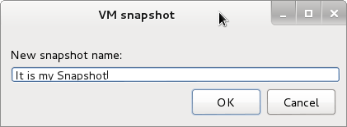
Figure 79: VM Snapshot

After it, You can see that a Snapshot is created :
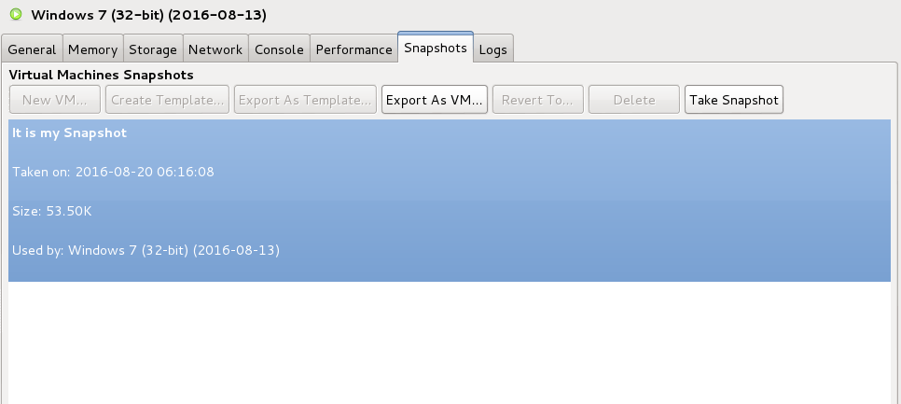
Figure 80: Snapshot created

You can see it in Citrix XenCenter too and XenCenter show it more understandable:
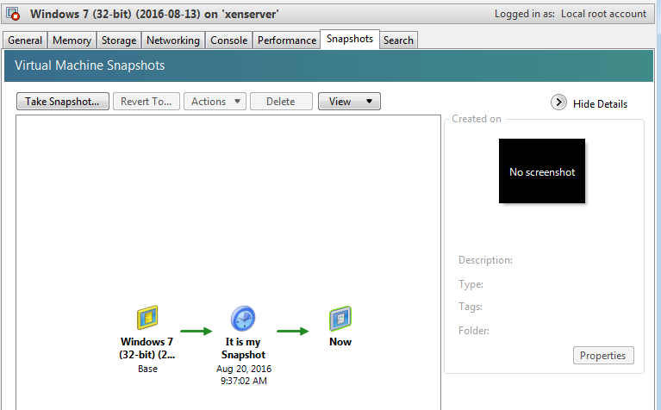
Figure 81: Snapshot Diagram

As you see, XenCenter show it in a good diagram and you can select your snapshot and right click on it and the Select “Revert To” for back to the previous state. When you select “Revert To” the XenCenter show you a message like below :

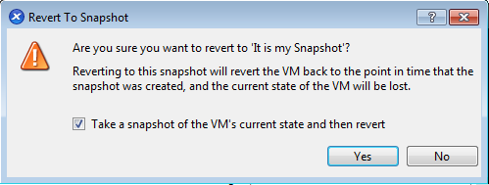
Figure 82: Warning Message

XenCenter ask you that are you sure to back to this Snapshot or not, If you are sure then click “Yes”. After it, XenCenter show you a window like below:

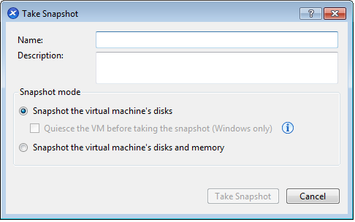
Figure 83: Take Snapshot Window
The XenCenter like to create another Snapshot and Enter a name for your Snapshot, For example, I enter “My snapshot”. After it our diagram is something like below :
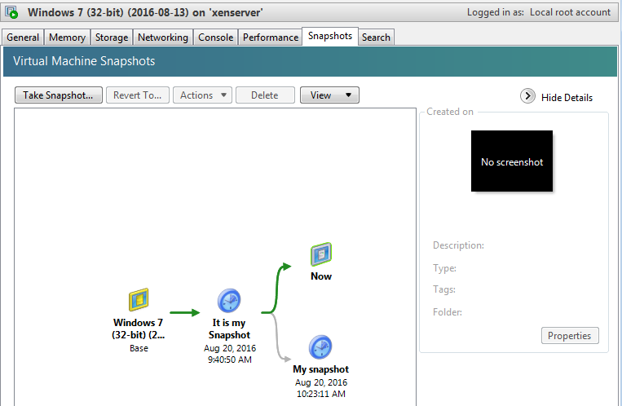
Figure 84 : XenCenter Snapshots tab

After it, My VM back to the previous state and as you can see in the diagram, the Green arrow point to the “Now”. If I right click on “My snapshot” and select “Revert To” then The XenCenter show me a same window like “Figure 82” but I deselect “Take a snapshot of...” and click yes because I don't like to create another snapshot of my current state. After it, You can see that your VM back to the state that you did change to your VM. The current Diagram is something like below :
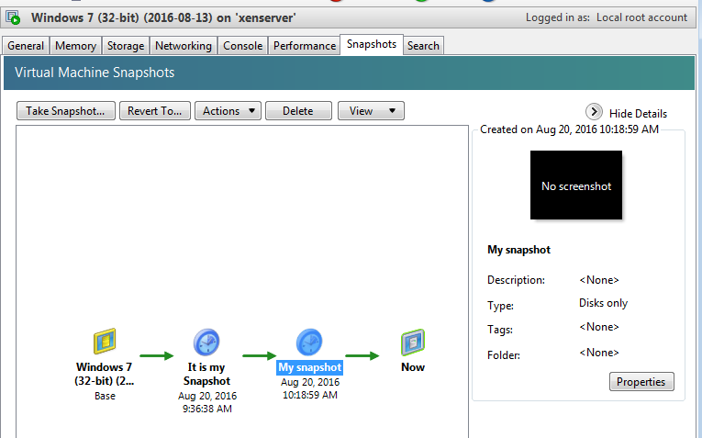
Figure 85: Back to “My snapshot”

You can do all of these via “xe” too.
SSH to your XenServer and do below steps :
xe vm-snapshot vm=Your VM name new-name-label="Your Label"
[root@xenserver ~]# xe vm-snapshot vm=Windows\ 7\ \(32-bit\)\ \(2016-08-13\) new-name-label="My Snapshot"
7f562a5f-7614-9991-5952-d8106cb10433

In “vm” parameter select the name of your VM that you want create a Snapshot from it.
After it, You can see that a Snapshot created for you and you can doing changes. For Revert to your Snapshot use below command :
xe snapshot-revert snapshot-uuid=UUID
xe snapshot-revert snapshot-uuid=7f562a5f-7614-9991-5952-d8106cb10433

After it, You can see that your VM back to the previous state. For list the snapshot you can use below command :
xe snapshot-list
[root@xenserver ~]# xe snapshot-list
uuid ( RO) : 7f562a5f-7614-9991-5952-d8106cb10433
name-label ( RW): My Snapshot
name-description ( RW):

For remove a snapshot use below command :
xe snapshot-uninstall snapshot-uuid=UUID
[root@xenserver ~]# xe snapshot-uninstall snapshot-uuid=7f562a5f-7614-9991-5952-d8106cb10433
The following items are about to be destroyed
VM : 7f562a5f-7614-9991-5952-d8106cb10433 (My Snapshot)
VDI: f0ad2781-5c8b-4202-898c-44f9cde4e9e1 (0)
Type 'yes' to continue
yes
All objects destroyed

Join your Citrix XenServer to Windows Domain
You can join your XenServer to the Windows Domain and use Active Directory accounts for work with XenServer. For do it, In the main window of “OpenXenManager” click on “Users” tab and then click on “Join Domain” button. In the Citrix XenCenter you can do it with the same steps but let us explain it via CLI.
SSH to your XenServer and execute below command :
xe pool-enable-external-auth auth-type=AD service-name=”Your Domain name” config:user=”Your Active Directory User name” config:pass=”Your Active Directory Password”
[root@xenserver ~]# xe pool-enable-external-auth auth-type=AD service-name=mydomain.com config:user=mohsen config:pass=XenServer

After it, You can see that “Join Domain” button in “Users” tab is disabled and “Leave Domain” enabled.
After it, You must give access to your AD users or Groups :
xe subject-add subject-name=”Your AD user name or group name”
[root@xenserver ~]# xe subject-add subject-name=jokar
fc21d498-1a35-b24c-9d27-c6f2153dde56

For remove a User access use below command :
xe subject-remove subject-uuid=”User UUID”
[root@xenserver ~]# xe subject-remove subject-uuid=fc21d498-1a35-b24c-9d27-c6f2153dde56

For see your current list you can use below command :
xe subject-list

[root@xenserver ~]# xe subject-list
uuid ( RO) : fc21d498-1a35-b24c-9d27-c6f2153dde56
subject-identifier ( RO): S-1-5-21-3570103376-2371597222-4282842042-1303
other-config (MRO): subject-name: MYDOMAINN\jokar; subject-upn: JOKAR@MYDOMAIN.COM; subject-uid: 128451863; subject-gid: 128451073; subject-sid: S-1-5-21-3570103376-2371597222-4282842042-1303; subject-gecos: MOHSEN JOKAR; subject-displayname: MOHSEN JOKAR; subject-is-group: false; subject-account-disabled: false; subject-account-expired: false; subject-account-locked: false; subject-password-expired: false
roles (SRO): pool-admin

But, When you add a user you can't do anything with the user in XenServer. Why? It is because you must give a role to the user. In below table, You can see the permissions for each role :

Role permissions | Pool Admin | Pool Operator | VM Power Admin | VM Admin | VM Operator | Read Only
Assign/modify roles
Log in to (physical) server consoles (through SSH and XenCenter)
Server backup/restore
Import/export OVF/OVA packages and disk images
Convert virtual machines using XenServer Conversion Manager
Log out active user connections
Create and dismiss alerts
Cancel task of any user
Pool management
Switch port locking
VM advanced operations
VM create/destroy operations
VM change CD media
View VM consoles
XenCenter view mgmt ops
Cancel own tasks
Read audit logs
Connect to pool and read all pool metadata

For give a role to a user name or group do below step :
xe subject-role-add uuid=”User name or Group UUID” role-name=
role-name is :
✔ pool-admin
✔ pool-operator
✔ vm-power-admin
✔ vm-admin
✔ vm-operator
✔ read-only

For example :
[root@xenserver ~]# xe subject-role-add uuid=fc21d498-1a35-b24c-9d27-c6f2153dde56 role-name=pool-admin

After it, Your user become a “Pool admin” and according to the above table can do anything with your XenServer.
For use the user name that you grant it access just use the user name instead of “root”.

Backup and Restore
For create a Backup from your VM in XenServer. You can use command line and Third party. We just show you CLI but if you like an automate system that Backup your VM then you can look at “http://www.acronis.com/en-us/business/backup-advanced/citrix/” , “http://www.xenserver-backup.com/” , “https://xen-orchestra.com/” and “https://www.veritas.com/support/en_US/article.TECH74309”. Some free Scripts are exist too : “https://github.com/NAUbackup/VmBackup” and “https://github.com/aviadra/Xen-pocalypse”.
OK, For create a Backup from a VM you must Shutdown your VM by default but some of third party let you to create a backup without shutdown. Let's start!
SSH to your XenServer or use “Console” tab in the main window of “OpenXenManager” or “Citrix XenCenter” :
xe vm-list
After it, You can see a list of your Vms. For example :
[root@xenserver ~]# xe vm-list
uuid ( RO) : e3ac9c9f-07be-96ca-ebb7-b5304cd45f50
name-label ( RW): My Debian
power-state ( RO): halted

uuid ( RO) : 35462d0b-938d-7658-5878-496f180b2027
name-label ( RW): Windows 7 (32-bit) (2016-08-13)
power-state ( RO): running

uuid ( RO) : 51c9e0e0-f2b0-4bec-806d-1f632437c474
name-label ( RW): Control domain on host: xenserver
power-state ( RO): running

In this example, I want create a backup from my “Windows 7” VM. First of all, I must shutdown the VM :
xe vm-shutdown uuid=”UUID of your VM”
[root@xenserver ~]# xe vm-shutdown uuid=35462d0b-938d-7658-5878-496f180b2027
[root@xenserver ~]#

Then, You should use below command with a path. Don't forget, Never use “/” of your XenServer for copy files and… Because if “/” become full then it cause your XenServer crashed.
If you like mount a directory via a remote IP the you must use “mount” command. First of all, Share the folder on remote computer and then execute below command on your XenServer :
# mkdir /home/share
# mount -t cifs //”IP Address of remote computer” -o username=”Username”,password=”Password” /home/share/
For example :
# mount -t cifs //192.168.1.1/MyDIR -o username=”Username”,password=”Password” /home/share/

Now, I can create a backup and export my VM to “/home/share/” directory :
xe vm-export uuid=”UUID of your vm” filename=”Path and file name with .xva”
xe vm-export uuid=35462d0b-938d-7658-5878-496f180b2027 filename=/home/share/myback.xva

For Restoring a backup you can use below command :
xe vm-import filename=”Path and file name with .xva”
xe vm-import filename=/home/share/myback.xva

Hotfix
It is an important part of XenServer and via Hotfixes you can solve security holes and other XenServer problems.
When a security hole or bug found in XenServer then Citrix company provide patch for solve it. We want to show you that how you can patch your XenServe.
Firs of all, Go to “http://support.citrix.com/article/CTX138115” and select your XenServer Version. After it you can find some patches that started with “CTX” words. When you click on a Hotfix then Citrix show you some information about the hotfix and tell you that which problems solved by this hotfix.
Download the Hotfix and it is a .zip file. When download completed, You must extract this .zip file and move update file to your XenServer. You can extract it on your client or move it to XenServer and extract there. When you unzip the file then you have two files. A file with .xsupdate and a file with .tar.bz2. The .xsupdate file is your update file and another file that is compressed(.tar.bz2) is the source code of the update file. Don't forget, Citrix open sourced XenServer in 2013 and must provide the source code. For more information you can read “https://www.citrix.com/blogs/2013/06/25/xenserver-6-2-is-now-fully-open-source/”. I move the file via “scp” command to my XenServer and extracted it there.
For update your XenServer you must use below command :
xe patch-upload file-name=”The file with .xsupdate”
[root@xenserver home]# xe patch-upload file-name=XS65ESP1.xsupdate
7f2e4a3a-4098-4a71-84ff-b0ba919723c7
[root@xenserver home]#

Then :
xe patch-apply uuid=<UUID of the patch> host-uuid=<UUID of the host>
[root@xenserver home]# xe patch-apply uuid=7f2e4a3a-4098-4a71-84ff-b0ba919723c7 host-uuid=638b5767-3ef5-4fed-9553-06f1c2f61f52
6972a5fc-f265-d32c-52ff-47bf96221309 is the local tools SR: scanning
Done
Preparing... ##################################################
xen-device-model ##################################################
Preparing... ##################################################
xen-hypervisor ##################################################
Preparing... ##################################################
xen-tools ##################################################
Preparing... ##################################################
xen-libs ##################################################
Preparing... ##################################################
xen-dom0-tools ##################################################
Preparing... ##################################################
xen-dom0-libs ##################################################
Preparing... ##################################################
xen-ocaml-libs ##################################################
Preparing... ##################################################
guest-templates ##################################################
Preparing... ##################################################
lvm2 ##################################################
Preparing... ##################################################
upgrade-plugin ##################################################
Preparing... ##################################################
xapi-core ##################################################
Preparing... ##################################################
xapi-xenopsd ##################################################
Preparing... ##################################################
xapi-rrdd ##################################################
Preparing... ##################################################
Stopping XCP RRDD plugin xcp-rrdd-iostat: [ OK ]
Stopping XCP RRDD plugin xcp-rrdd-squeezed: [ OK ]
Stopping XCP RRDD plugin xcp-rrdd-xenpm: [ OK ]
rrdd-plugins ##################################################
Starting XCP RRDD plugin xcp-rrdd-iostat: [ OK ]
Starting XCP RRDD plugin xcp-rrdd-squeezed: [ OK ]
Starting XCP RRDD plugin xcp-rrdd-xenpm: [ OK ]
Preparing... ##################################################
blktap ##################################################
Preparing... ##################################################
sm ##################################################
Preparing... ##################################################
tzdata ##################################################
Preparing... ##################################################
kernel ##################################################
unable to stat /sys/class/block//var/swap/swap.001: No such file or directory
Preparing... ##################################################
vgpu ##################################################
Preparing... ##################################################
linux-guest-loader-data ##################################################
Preparing... ##################################################
hwdata ##################################################
Preparing... ##################################################
xenserver-transfer-vm ##################################################
Preparing... ##################################################
openvswitch ##################################################
Preparing... ##################################################
v6d ##################################################
Preparing... ##################################################
glibc ##################################################
Preparing... ##################################################
glibc-common ##################################################
Waiting for xapi to signal init complete
Removing any existing built-in templates
Regenerating built-in templates

[root@xenserver home]#

After it, You can use “xe patch-list” for see a list of patches :
[root@xenserver home]# xe patch-list
uuid ( RO) : 5200911d-5f79-4149-abca-0556af77b14d
name-label ( RO): XS65E003
name-description ( RO): Public Availability: security fixes to glibc
size ( RO): 0
hosts (SRO): 638b5767-3ef5-4fed-9553-06f1c2f61f52
after-apply-guidance (SRO): restartHost

uuid ( RO) : 30d3992b-ac0a-45e8-9e93-d4b2e9bb235f
name-label ( RO): XS65E006
name-description ( RO): Public Availability: security fixes to Xen
size ( RO): 0
hosts (SRO): 638b5767-3ef5-4fed-9553-06f1c2f61f52
after-apply-guidance (SRO): restartHost

uuid ( RO) : 9f9d57ff-3a04-4385-9744-f961b44a1db4
name-label ( RO): XS65E001
name-description ( RO): Public Availability: XenCenter fixes for XS 6.5
size ( RO): 0
hosts (SRO): 638b5767-3ef5-4fed-9553-06f1c2f61f52
after-apply-guidance (SRO):

uuid ( RO) : 7f2e4a3a-4098-4a71-84ff-b0ba919723c7
name-label ( RO): XS65ESP1
name-description ( RO): Public Availability: XenServer 6.5 Service Pack 1 (SP1)
size ( RO): 254832812
hosts (SRO): 638b5767-3ef5-4fed-9553-06f1c2f61f52
after-apply-guidance (SRO): restartHost

uuid ( RO) : 0fedb090-7d7a-4dce-afac-34d56d4c9aff
name-label ( RO): XS65E002
name-description ( RO): Public Availability: XenTools fixes
size ( RO): 0
hosts (SRO): 638b5767-3ef5-4fed-9553-06f1c2f61f52
after-apply-guidance (SRO): restartXAPI

uuid ( RO) : 70ef547a-125c-44fc-9cc3-1b709c9b7431
name-label ( RO): XS65E007
name-description ( RO): Public Availability: Security fixes for Xen Device Model
size ( RO): 0
hosts (SRO): 638b5767-3ef5-4fed-9553-06f1c2f61f52
after-apply-guidance (SRO): restartHost

uuid ( RO) : d3c08fcb-daa0-4410-bdb2-c298109e88ad
name-label ( RO): XS65E008
name-description ( RO): Public Availability: Fix for Dom0 kernel
size ( RO): 0
hosts (SRO): 638b5767-3ef5-4fed-9553-06f1c2f61f52
after-apply-guidance (SRO): restartHost

uuid ( RO) : 492ca007-bf7b-454f-8e5c-63a991a52449
name-label ( RO): XS65E005
name-description ( RO): Storage fixes to prevent disk corruption
size ( RO): 0
hosts (SRO): 638b5767-3ef5-4fed-9553-06f1c2f61f52
after-apply-guidance (SRO):

[root@xenserver home]#

Done.
When the update completed, Don't forget to remove the Hotfix files. The “/” must not full.
You can use Citrix XenCenter for do it too. Open XenCenter and from the left side click on “Notifications” then click on “Update” and after it click on “Check for Update Now” :
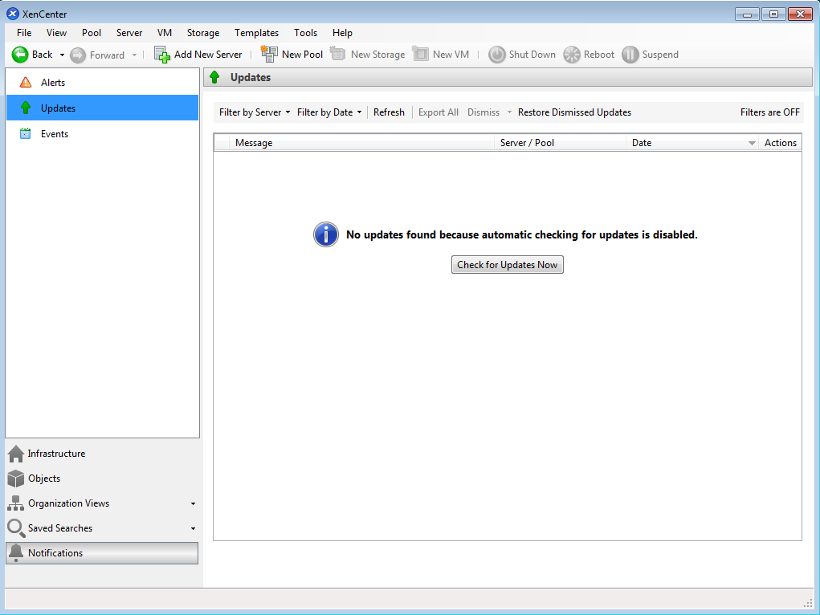
Figure 86: Update

After it, If any update exist then a list of updates show:
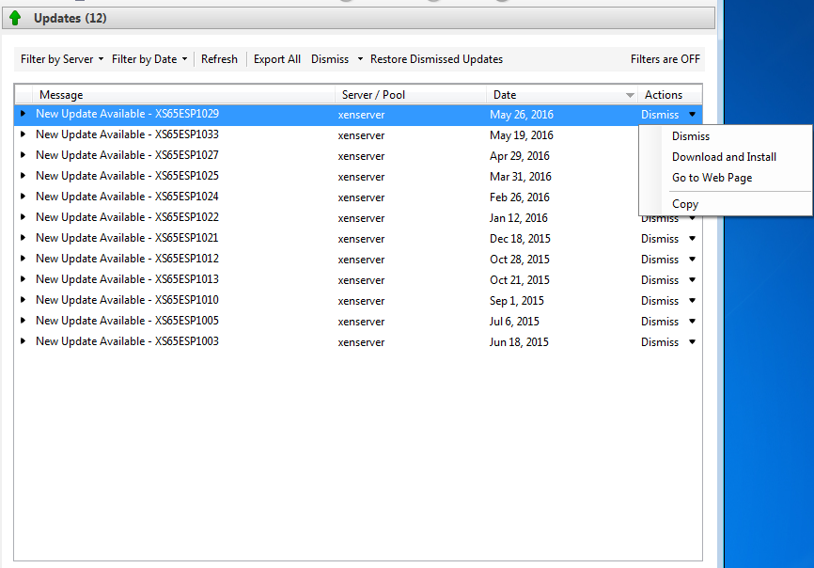
Figure 87: List of updates

Select a update and from “Actions” section click on Down arrow and then click on “Download and Install”. XenCenter Detect your XenServer(s) and when you select your XenServer Download start :
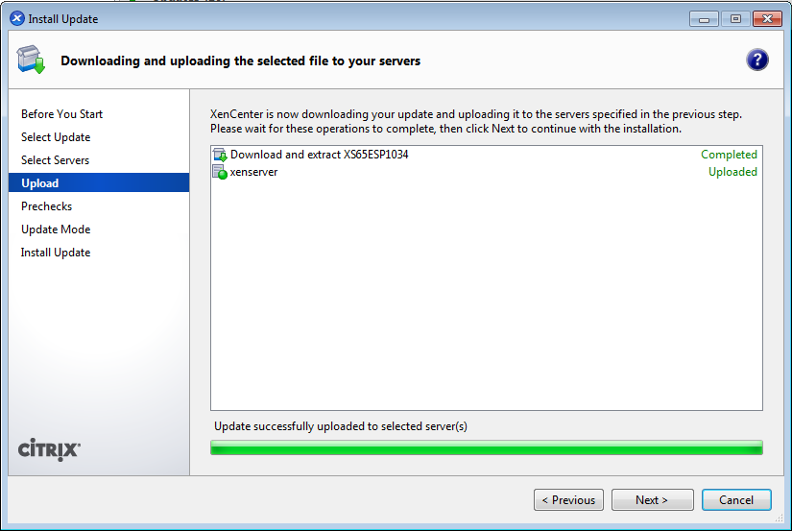
Figure 88: Download completed
When Download completed, Click on “Next” and XenServer check the server for apply update :
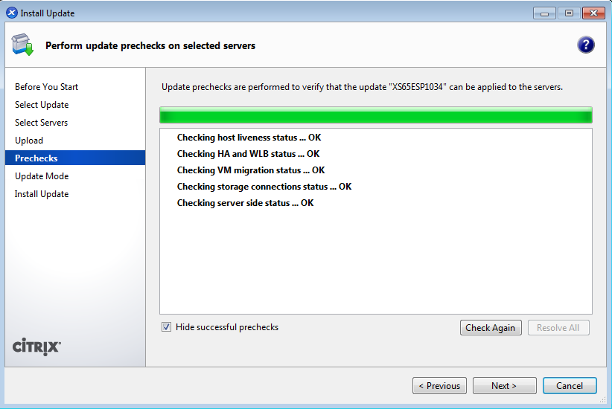
Figure 89: Checking Server
When everything is OK, Click on “Next”:
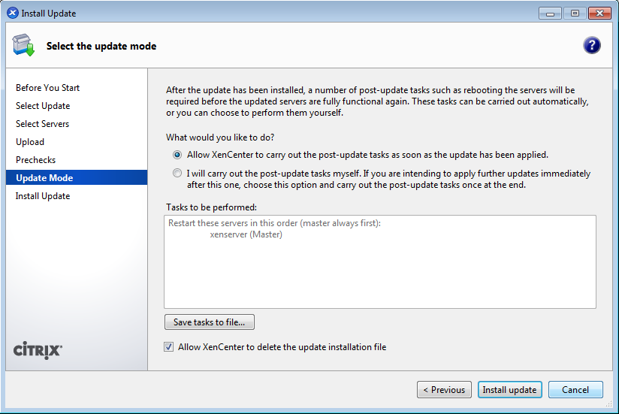
Figure 90: Ready for install the update
Click on “Install update” For start installing :
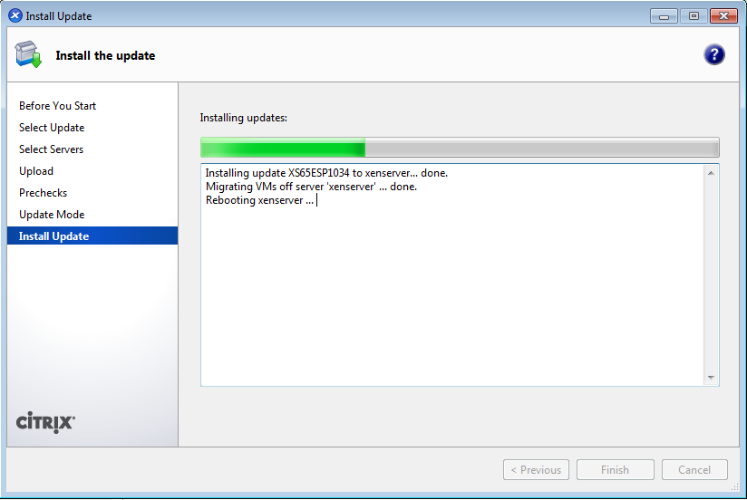
Figure 91: Installing update

When installing done then XenCenter rebooted XenServer automatically and waiting for XenServer to become ready(Go up) :
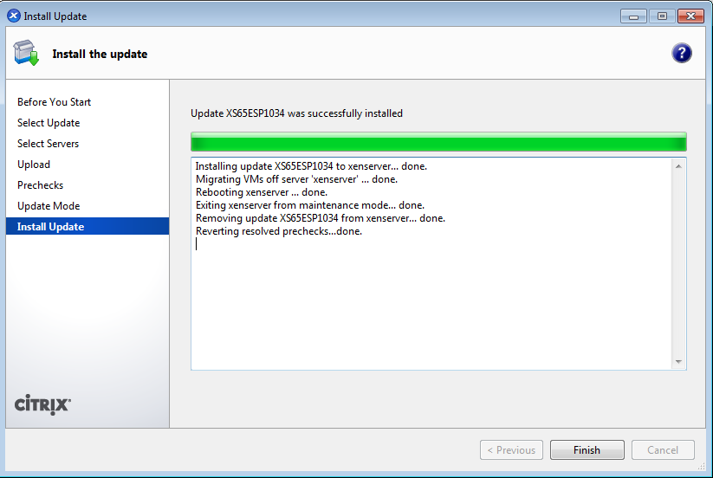
Figure 92: Update applied
Everything is OK, Click on “Finish” and do these steps for other updates too.

Citrix XenConvert
According to the Citrix website : Citrix® XenConvert™ is a physical-to-virtual (P2V) conversion tool for converting a Windows operating system, applications, and data from a physical machine to a XenServer virtual machine, Provisioning Services vDisk, virtual appliance in the Open Virtualization Format (OVF), or disk image in the Virtual Hard Disk format.
We want to show you that how you can use this tool. First of all, Download the XenConvert from “https://www.citrix.com/go/products/xenserver/xenserver-xenconvert-free.html” and install it on a Machine that you want convert it. XenConvert need .NET Framework 4. If it a VM that exist on VMWare or VirtualBox then Please remove additional tools on your VM : “Guest Additions” for VirtualBox, “Integration Services” for Microsoft Hyper-V and “VMWare Tools” for ESXi . After it, Execute XenConvert. You will see a window like below :

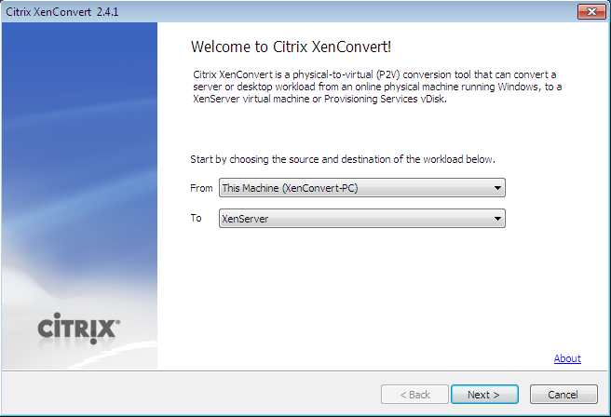
Figure 93: XenConvert

As you see, The “From” option is selected as “This Machine” and in “To” option you can select the destination of conversation. If you like your Machine moved to the XenServer directly then select “XenServer” and if you like your VM convert to a package then select OVF. The Citrix XenConvert provide other options too :

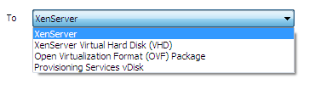
Figure 94: “To” options
For more information about “OVF” format you can read “https://en.wikipedia.org/wiki/Open_Virtualization_Format”.
After it, Click “Next”.
In the next windows, You must select the the Volume(Partition) that you want converted to the VM. We just like Drive C converted thus selected “C:” in the “Source Volume”.
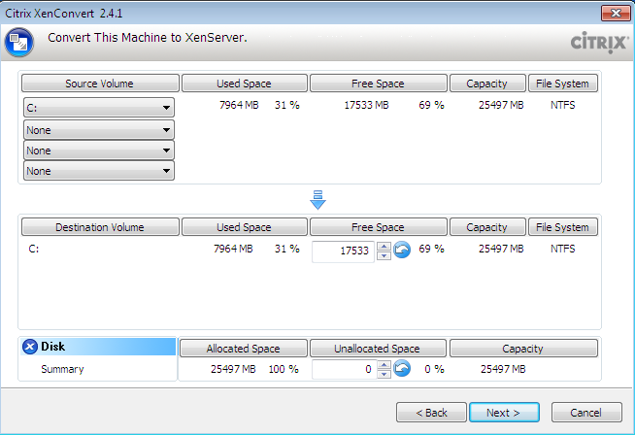
Figure 95: Select the Volume

In the next window, You must enter your XenServer information like the Citrix XenServer IP address, User name that have properly privilege(root) and Password for User name. In the “Workspace” you must specify a location that XenConvert store the OS on it and then move it to the Citrix XenServer. Click on “Browse...” button and specify a location. For example, We selected drive D.
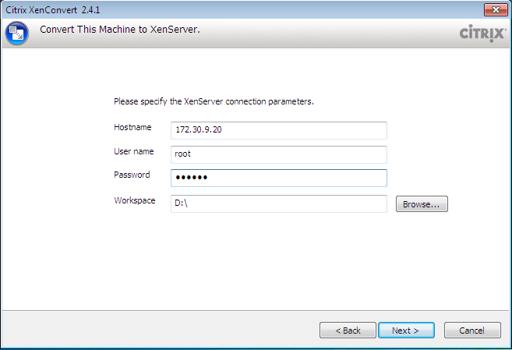
Figure 96 : provide XenServer information
After it, Click on “Next” button and XenConvert check the User name and password that you entered. If the User name and Password are correct then you see another window like below :
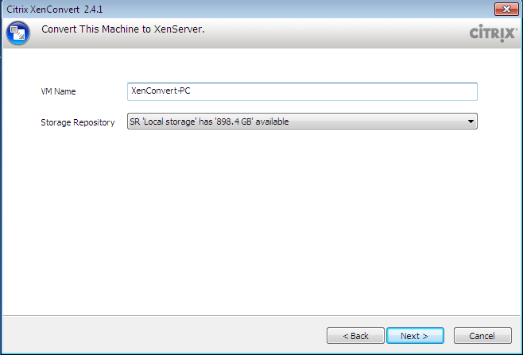
Figure 97 : Select “VM Name” and “Storage Repository”
By default, XenConvert select your Computer name as “VM Name” but you can modify it. In “Storage Repository” you can select your XenServer storage that you like the machine store on it.
Click on “Next” button. You can see a window like below :
Figure 98: Information about our job
If you like XenConvert save the result of the convert then select “Log names of...” option. Click on “Convert” button.
After a few seconds, A message like below showing and Citrix wants to create a Virtual partition and you must format this Virtual Partition :
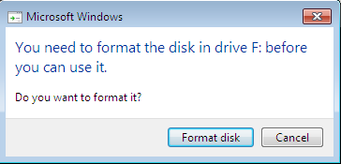
Figure 99 : Format Virtual Partition
After it, Converting started.
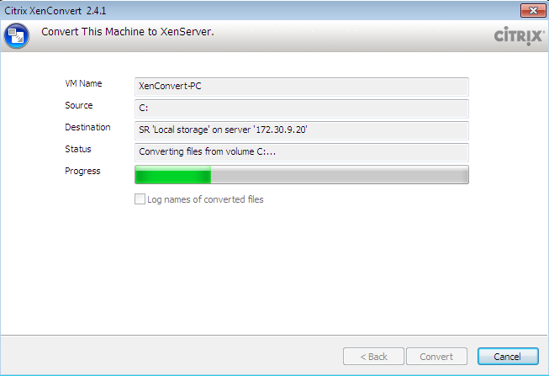
Figure 100: Converting started.
The Virtual partition that XenConvert created has the same size of partition that you selected in Figure 96 as “Workspace”.

Install other packages in XenServer
Sometimes you need to install other package on your XenServer that not exist in XenServer repository. For example, Some users like “traceroute” but if you use “yum install traceroute” then you got an error like below :
[root@xenserver ~]# yum install traceroute
Loaded plugins: fastestmirror
Determining fastest mirrors
citrix | 951 B 00:00
Setting up Install Process
No package traceroute available.
Nothing to do

How you can install other packages in XenServer? We will show you.
XenServer use Citrix yum repository by default :
[root@xenserver ~]# yum repolist enabled
Loaded plugins: fastestmirror
Loading mirror speeds from cached hostfile
repo id repo name status
citrix XenServer 6.5.0 updates 0
repolist: 0

We must disable it but you have two ways : 1- Disable it temporary 2- Disable it permanently
For disable it temporary you can use below command :
yum --enablerepo=base --disablerepo=citrix install “Your Package name”

For example :
yum --enablerepo=base --disablerepo=citrix install traceroute

For disable it permanently you can use below command :
sed -i -e "s/enabled=0/enabled=1/" /etc/yum.repos.d/CentOS-Base.repo

Then install your package :
Yum install traceroute

Don't forget, It is not a normal way and you must not install third party on your XenServer.

Clone VM
Fortunately, Clone a Xen VM is so easy and with “dd” command you can do it in one step. We use “dd” command if our VM use “LVM” and if our VM is a file (.img) then it is so easy and just copy your image to other place.
I hope you can remember our “LVM” scheme but don't worry if you can't remember it. Just use “lvdisplay” command :
[root@localhost ~]# lvdisplay
--- Logical volume ---
LV Path /dev/Xen/OpenSUSE
LV Name OpenSUSE
VG Name Xen
LV UUID dt4UiA-66k5-dd51-2AQ9-CLob-PyR3-Uvcy7u
LV Write Access read/write
LV Creation host, time localhost.localdomain, 2016-05-08 04:33:19 -0400
LV Status available
# open 0
LV Size 20.00 GiB
Current LE 5120
Segments 1
Allocation inherit
Read ahead sectors auto
- currently set to 256
Block device 253:2

--- Logical volume ---
LV Path /dev/Xen/linux
LV Name linux
VG Name Xen
LV UUID ryXghI-gXCq-S4qp-FIhF-q9Fx-GgM3-1Sfe2N
LV Write Access read/write
LV Creation host, time localhost.localdomain, 2016-05-10 09:11:19 -0400
LV Status available
# open 0
LV Size 20.00 GiB
Current LE 5120
Segments 1
Allocation inherit
Read ahead sectors auto
- currently set to 256
Block device 253:3

In this example, I like to create a clone of “/dev/Xen/linux” and as you it is about 20.00 GiB :
“dd” Syntax is : dd if=<source file name> of=<target file name> [Options]
# dd if=/dev/Xen/linux of=/home/mohsen/myclone.img bs=1K

[root@localhost ~]# dd if=/dev/Xen/linux of=/home/mohsen/myclone.img bs=1K
20971520+0 records in
20971520+0 records out
21474836480 bytes (21 GB) copied, 381.062 s, 56.4 MB/s

OK, Command finished and on other server that you like clone your VM on it you should create a “LVM” similar to current server. If you look at “Storage and Networking” part then you will find the instruction of it via “pvcreate” , “vgcreate” and “lvcreate” commands.
I assume that you copy your .img file from current server to other server via “scp” command and create your Volume Group and everything is ready for run “ lvcreate” command :
# lvcreate -L 20G -v -n linux Xen

After it, You must use “dd” command for clone it on your new Volume on your new server :
# dd if=/home/mohsen/myclone.img of=/dev/Xen/linux bs=1k
[root@localhost ~]# dd if=/home/mohsen/myclone.img of=/dev/Xen/linux bs=1k
20971520+0 records in
20971520+0 records out
21474836480 bytes (21 GB) copied, 2004.95 s, 10.7 MB/s

Everything is OK and you can config your Xen VM to use this “LVM”.

Recovery
We spoke something about cloning a VM and I guess you thinking about how you can Fix or recover a VM when it is corrupted. To be honest, The best way for it is make a backup from your VM. If your VM use .img then you can copy it to other place as a backup if your VM use LVM then you can cloning and keep it as a backup.
In Linux, You can use “testdisk” utility that it is a free and open source data recovery tool for recovery .img files or partitions. It is installed by default but if your Dom0 not have it then you can install it manually. Our Dom0 is Fedora and we use below command :
# dnf install testdisk
OK, When installing complete then you can use “testdisk” command. According to “http://www.cgsecurity.org/” the full syntax is :
# testdisk [/debug] [/log] [/logname file.log] /cmd [file.dd|file.e01|device] cmd
For example, I like to recovery my VM image and I use below command :
# testdisk /home/mohsen/Windows7.img
Work with this tool is easy. “testdisk” will show you the number of partition that your VM has and you can select your Intended partition and after it select suitable options and recovery will start :
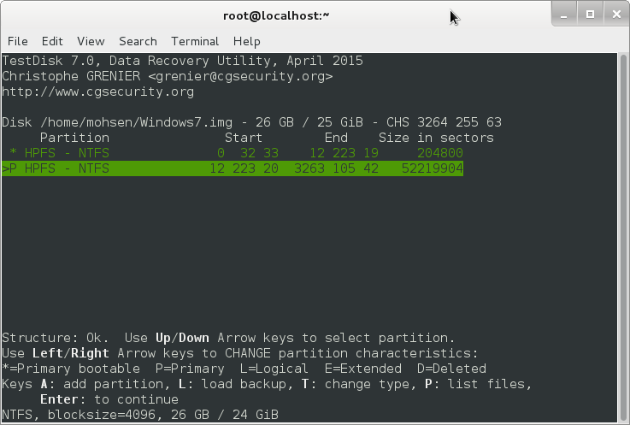
Figure 101 : TestDisk

How to auto start XEN VMs after reboot of DOM0
A good option for your Xen server is auto start. Sometimes your Server crashed or you have Power problem or for any reason your server rebooted or powered off. Suppose, You have a lot of Vms on your Dom0 and all of your Vms must be start immediately. What you should do? A system administrator answer this question with a Script that start all Xen Vms or specific Vms after each reboot but Xen Project provide a good option for your in this conditions.
It is so easy and Let me to explain it.
If you look at “/etc/xen/” directory then you will find a directory with the name “auto”. If you put a link of your VM configuration file in this photo then your VM started automatically any time that your Dom0 rebooted. We use “ln” command in Linux for create a Link :
# cd /etc/xen/auto/
# ln -s /etc/xen/windows.cfg
In this example, I created a Link of “windows.cfg” and this VM started automatically any time that my Dom0 rebooted.
OK, I rebooted Dom0 intentional and after it my DomU started automatically :
[root@localhost ~]# xl list
Name ID Mem VCPUs State Time(s)
Domain-0 0 3659 8 r----- 53.4
Windows10 2 4096 4 -b---- 48.7

As you see, My VM with the name “Windows10 “ started.

Monitoring Via Nagios
Nagios is a free and open source software that help system administrators for monitoring Systems, Networks, services and… Nagios now known as “Nagios Core”. It is true that The Xen project provide a monitoring tool by default and you can install other Linux monitoring tools too but a product like Nagios can help you in some situations.
We want to show you that how you can install Nagios from source code.
First of all, You should install some packages. We use Fedora server and Dom0 so :
# dnf install -y httpd php gcc glibc glibc-common gd gd-devel make net-snmp

After it, We should create a user with the name “nagios” and a group with the name “nagcmd” :
# useradd nagios
# groupadd nagcmd

Then :
# usermod -G nagcmd nagios
# usermod -G nagcmd apache
After it, We create a directory for download “Nagios core” source code :
# mkdir /root/nagios

Then, use “cd” command for change directory as below :
# cd /root/nagios/
After it, We use “wget” tool for download “Nagios core” and “Nagios Plugins” source code. At the time of writing this book, the Nagios version was 4.0.1 and the URL to download it was as below :
# wget http://prdownloads.sourceforge.net/sourceforge/nagios/nagios-4.0.1.tar.gz
# wget https://www.nagios-plugins.org/download/nagios-plugins-1.5.tar.gz

OK,When download finished,we use “gunzip” and “tar -xf” commands for extract the packages. When packages extracted, we use “cd” command for change to the “nagios-4.0.1” directory and issue below commands :

# ./configure –with-command-group=nagcmd
# make all
# make install
# make install-init
# make install-commandmode
# make install-config

If you like receiving email alerts then open below file via an editor like “nano” and set the “email address” with the correct email address :
# nano /usr/local/nagios/etc/objects/contacts.cfg
When everything is done the we use below command for configure web interface for nagios :
# make install-webconf

After it, we use below command for Create password for “nagiosadmin” account :
# htpasswd -s -c /usr/local/nagios/etc/htpasswd.users nagiosadmin

Now, We must start “httpd” service :
# systemctl start httpd.service

OK, “Nagios Core” installed successfully and we must install “Plugins”. I hope you extracted “nagios-plugins-1.5” package in the first step and we are ready to install it. Use “cd” command for change to “nagios-plugins-1.5” directory and issue below commands :

# ./configure --with-nagios-user=nagios --with-nagios-group=nagios
# make && make install

OK, Everything is done and we must check our configuration file :
# /usr/local/nagios/bin/nagios -v /usr/local/nagios/etc/nagios.cfg
[root@localhost nagios]# /usr/local/nagios/bin/nagios -v /usr/local/nagios/etc/nagios.cfg

Nagios Core 4.0.1
Copyright (c) 2009-present Nagios Core Development Team and Community Contributors
Copyright (c) 1999-2009 Ethan Galstad
Last Modified: 10-15-2013
License: GPL

Website: http://www.nagios.org
Reading configuration data...
Read main config file okay...
Read object config files okay...

Running pre-flight check on configuration data...

Checking objects...
Checked 9 services.
Checked 2 hosts.
Checked 1 host groups.
Checked 0 service groups.
Checked 1 contacts.
Checked 1 contact groups.
Checked 25 commands.
Checked 5 time periods.
Checked 0 host escalations.
Checked 0 service escalations.
Checking for circular paths...
Checked 2 hosts
Checked 0 service dependencies
Checked 0 host dependencies
Checked 5 timeperiods
Checking global event handlers...
Checking obsessive compulsive processor commands...
Checking misc settings...

Total Warnings: 0
Total Errors: 0

Things look okay - No serious problems were detected during the pre-flight check

As use see, “Things look okay - No serious problems were detected during the pre-flight check”, Then :
# chkconfig --add nagios
# chkconfig --level 35 nagios on
# systemctl enable httpd.service
# systemctl start httpd
# systemctl start nagios

The “Nagios Core” use port “5666” and we must open this port via “iptables” for remote control :
# iptables -A INPUT -m state --state NEW -m tcp -p tcp --dport 5666 -j ACCEPT
# iptables-save

If you remember, We spoke about “Selinux” and told you that you must not disable it, But the Selinux can cause problems and show you an error message like “Internal Server Error” when you attempt to access the Nagios CGIs. You can put Selinux in Enforcing mode :
# getenforce
But Instead of disabling SELinux or setting it to permissive mode, you can use the following command to run the CGIs under SELinux enforcing/targeted mode:
# chcon -R -t httpd_sys_content_t /usr/local/nagios/sbin/
# chcon -R -t httpd_sys_content_t /usr/local/nagios/share/
OK, All steps finished and we are ready for logging to the “Nagios”. Open a web browser and write your server IP address in URL as below :
http://172.30.9.20/nagios

In this example, Our server IP address is “172.30.9.20”.

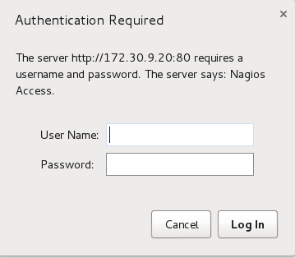
Figure 102 : Nagios logging

In “User Name” write “nagiosadmin” and in “Password” write a password that you choice. After it, We will see the “Nagios Core” page as below :
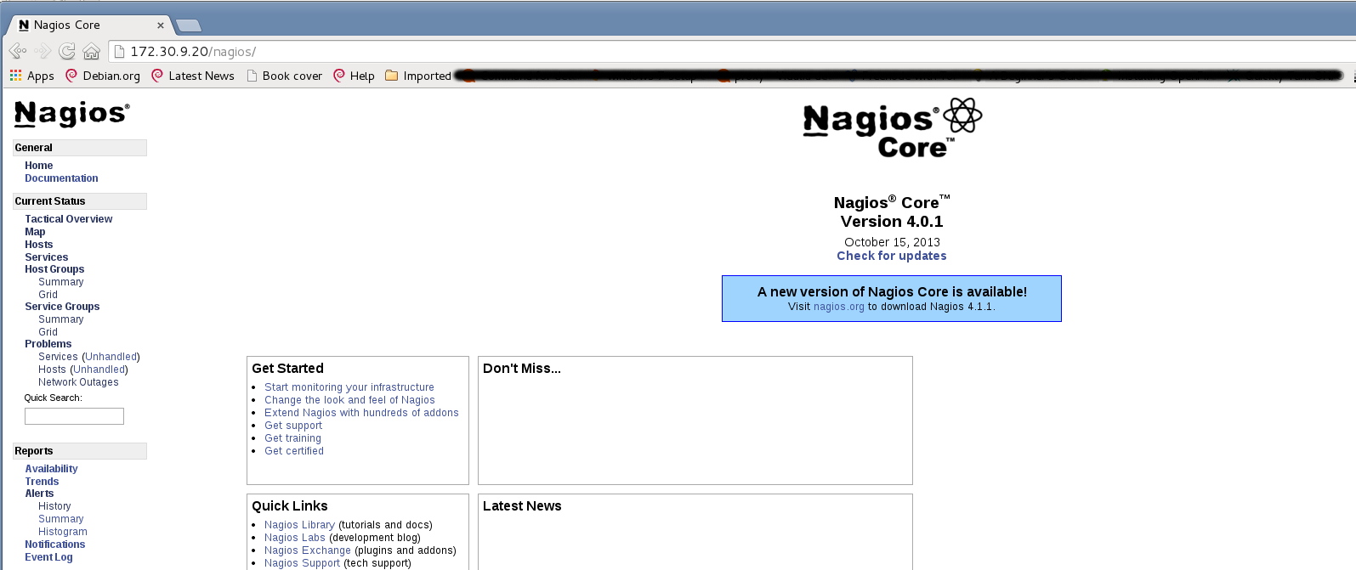
Figure 103 : Nagios

OK, If you click on “Hosts” and “Services” then you can see the current situation of your machine.
For some reasons, You don't like to install Nagios on your Xen Project machine and like to dedicate a server for it and just like to monitor your Xen Project. In this situation, You must install “Nagios Core” and “Nagios Plugin” on a server as we learned and install NRPE on your Xen Project server as below :
First of all, Install necessary packages :

# yum install -y gcc glibc glibc-common gd gd-devel make net-snmp openssl-devel perl
# yum install xinetd

Then, Create a directory as below and download necessary packages :

# mkdir /root/nagios
# wget https://www.nagios-plugins.org/download/nagios-plugins-1.5.tar.gz

Download NRPE from below URL :
https://sourceforge.net/projects/nagios/files/nrpe-2.x/

When download complete, You must create a “nagios” user :
# useradd nagios
# passwd nagios

Now, We must compile and install downloaded packages :

# tar xvfz nagios-plugins-1.4.11.tar.gz
# cd nagios-plugins-1.4.11
# ./configure --with-ssl=/usr/bin/openssl --with-ssl-lib=/usr/lib/x86_64-linux-gnu
# make
# make install

Then, Change directory permission via below commands :

# chown nagios.nagios /usr/local/nagios
# chown -R nagios.nagios /usr/local/nagios/libexec/

Nagios Plugins installed and now we must install NRPE package. Extract package and do below steps :
# cd nrpe-2.12
# ./configure --enable-command-args
# make all
# make install
# make install-config
# echo >> /etc/services
# echo '# Nagios services' >> /etc/services
# echo 'nrpe 5666/tcp' >> /etc/services
# make install-init

You can see the output of commands here :

[root@localhost nrpe-3.0]# make all
cd ./src/; make
make[1]: Entering directory `/root/nagios/nrpe-3.0/src'
gcc -g -O2 -I/usr/include/krb5 -DHAVE_CONFIG_H -I ../include -I ./../include -o nrpe ./nrpe.c ./utils.c ./acl.c -lssl -lcrypto -lnsl
gcc -g -O2 -I/usr/include/krb5 -DHAVE_CONFIG_H -I ../include -I ./../include -o check_nrpe ./check_nrpe.c ./utils.c -lssl -lcrypto -lnsl
make[1]: Leaving directory `/root/nagios/nrpe-3.0/src'

*** Compile finished ***

You can now continue with the installation or upgrade process.

Read the PDF documentation (NRPE.pdf) for information on the next
steps you should take to complete the installation or upgrade.

[root@localhost nrpe-3.0]# make install
cd ./src/; make install
make[1]: Entering directory `/root/nagios/nrpe-3.0/src'
make install-plugin
make[2]: Entering directory `/root/nagios/nrpe-3.0/src'
/usr/bin/install -c -m 755 -d /usr/local/nagios/bin
/usr/bin/install -c -m 755 ../uninstall /usr/local/nagios/bin/nrpe-uninstall
/usr/bin/install -c -m 775 -o nagios -g nagios -d /usr/local/nagios/libexec
/usr/bin/install -c -m 775 -o nagios -g nagios -d /usr/local/nagios/libexec
/usr/bin/install -c -m 775 -o nagios -g nagios check_nrpe /usr/local/nagios/libexec
make[2]: Leaving directory `/root/nagios/nrpe-3.0/src'
make install-daemon
make[2]: Entering directory `/root/nagios/nrpe-3.0/src'
/usr/bin/install -c -m 755 -d /usr/local/nagios/bin
/usr/bin/install -c -m 755 ../uninstall /usr/local/nagios/bin/nrpe-uninstall
/usr/bin/install -c -m 755 nrpe /usr/local/nagios/bin
/usr/bin/install -c -m 644 ../startup/tmpfile.conf /usr/lib/tmpfiles.d/nrpe.conf
make[2]: Leaving directory `/root/nagios/nrpe-3.0/src'
make[1]: Leaving directory `/root/nagios/nrpe-3.0/src'

[root@localhost nrpe-3.0]# make install-config
/usr/bin/install -c -m 775 -o nagios -g nagios -d /usr/local/nagios/etc
/usr/bin/install -c -m 644 -o nagios -g nagios sample-config/nrpe.cfg /usr/local/nagios/etc

After it, We must enable nrpe service :

# systemctl enable nrpe.service

I'm sure, for some security reasons you don't like to disable iptables then for this reason you must let Nagios core and NRPE Communicate with each other :

# iptables -I INPUT -p tcp --destination-port 5666 -j ACCEPT
# iptables-save

OK. The next is step is edit “nrpe.cfg” file via an editor like “nano” :
# nano /usr/local/nagios/etc/nrpe.cfg

Then , find below lines and add your nagios server IP address and change value from “0” to “1” :

allowed_hosts=127.0.0.1,NAGIOS SERVER IP ADDRESS
dont_blame_nrpe=1

Then :
# systemctl start nrpe.service

Now, It's time to do the test :

# /usr/local/nagios/libexec/check_nrpe -H 127.0.0.1

[root@localhost nrpe-3.0]# /usr/local/nagios/libexec/check_nrpe -H 127.0.0.1
NRPE vnrpe-3.0

OK, After it we must introduce our client to our Nagios server, So On Nagios server do below steps :
# touch /usr/local/nagios/etc/hosts.cfg
# touch /usr/local/nagios/etc/services.cfg
Open “hosts.cfg” file with nano editor and write below lines to it :
# nano hosts.cfg
define host{
name linux-box ; Name of this template
use generic-host ; Inherit default values
check_period 24x7
check_interval 5
retry_interval 1
max_check_attempts 10
check_command check-host-alive
notification_period 24x7
notification_interval 30
notification_options d,r
contact_groups admins
register 0 ; DONT REGISTER THIS - ITS A TEMPLATE
}
## Default
define host{
use linux-box ; Inherit default values from a template
host_name our-boy ; The name we're giving to this server
alias CentOS 7 ; A longer name for the server
address IP ADDRESS ; IP address of Remote Linux host
}

Open “services.cfg” file with nano editor and write below lines to it :
# nano services.cfg
define service{
use generic-service
host_name our-boy
service_description CPU Load
check_command check_nrpe!check_load
}
define service{
use generic-service
host_name our-boy
service_description SSH Monitoring
check_command check_nrpe!check_ssh
}
define service{
use generic-service
host_name our-boy
service_description FTP Monitoring
check_command check_nrpe!check_ftp
}

Then, Open “nagios.cfg” and add below line to it :
cfg_file=/usr/local/nagios/etc/hosts.cfg
cfg_file=/usr/local/nagios/etc/services.cfg

After it :
# nano /usr/local/nagios/etc/objects/commands.cfg
define command{
command_name check_nrpe
command_line $USER1$/check_nrpe -H $HOSTADDRESS$ -c $ARG1$
}

You can install NRPE package on your Nagios Core too and check the connection between Nagios core and your client. For example :
[root@localhost nrpe-3.0]# /root/nagios/nrpe-3.0/src/check_nrpe -H “CLIENT IP ADDRESS”
NRPE vnrpe-3.0

Now, if you restart nagios service on Nagios core server then you can see your client on “Hosts” section.

Reference :
- https://en.wikipedia.org
- http://www.dummies.com
- http://www.cyberciti.biz
- http://www.linuxjournal.com
- http://www.itworld.com
- https://www.linux.com
- http://virt.kernelnewbies.org
- http://wiki.xen.org
- http://www.pcmag.com
- https://wiki.debian.org/Xen
- https://www.suse.com
- https://www.centos.org
- http://support.citrix.com
- http://selinuxproject.org
- http://danwalsh.livejournal.com
- https://www.howtoforge.com
- http://www.datacenterknowledge.com
- http://www.datamation.com

