Step 1:
I CLICKED “CREATE VIRUAL MACHINE” IN YAST.THE FOLLOWING WIZARD APPEARED:
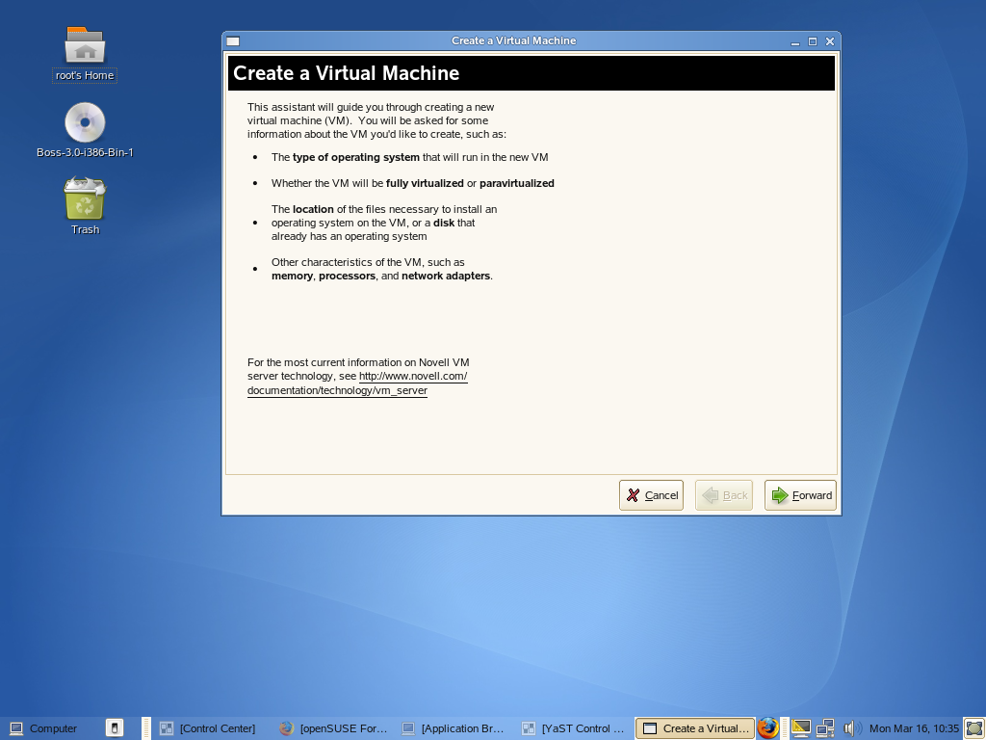

STEP 2:

AFTER CLICKING FORWARD,THE FOLLOWING WINDOW APPEARED

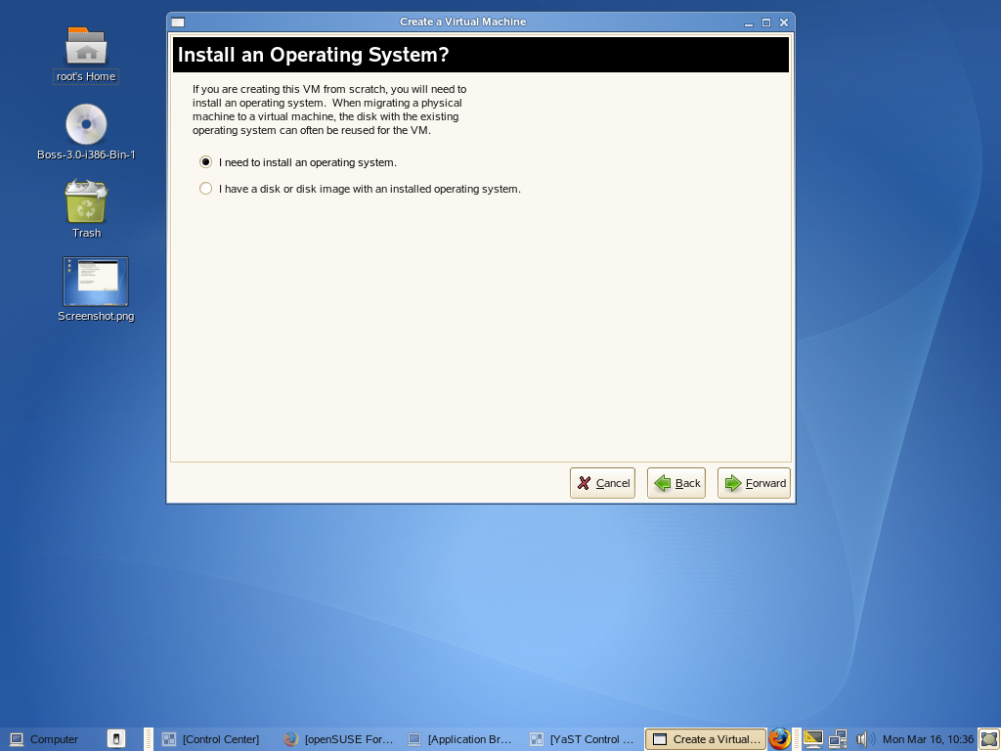

STEP 3: I CLICKED “I NEED TO INSTALL AN OPERATING SYSTEM”
THE FOLLOWING IS THE SCREEN SHOT OF THE APPEARED WINDOW

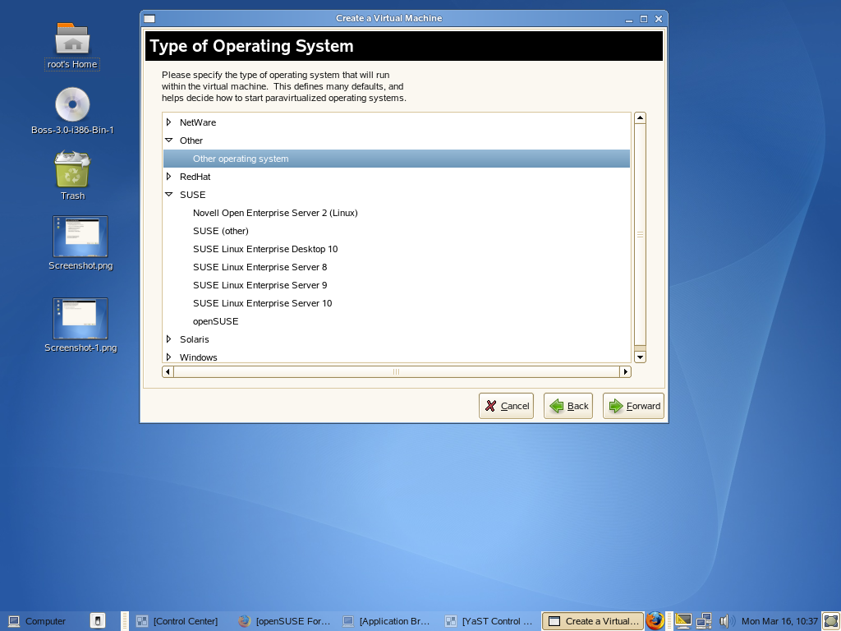
STEP 4: I SELECTED “OTHER” BECAUSE IM TRYING TO USE A LINUX DISTRIBUTION CALLED BOSS(THE INDIAN VARIATION OF THE DEBIAN) AS DOM U.

THE NEXT WINDOW IS
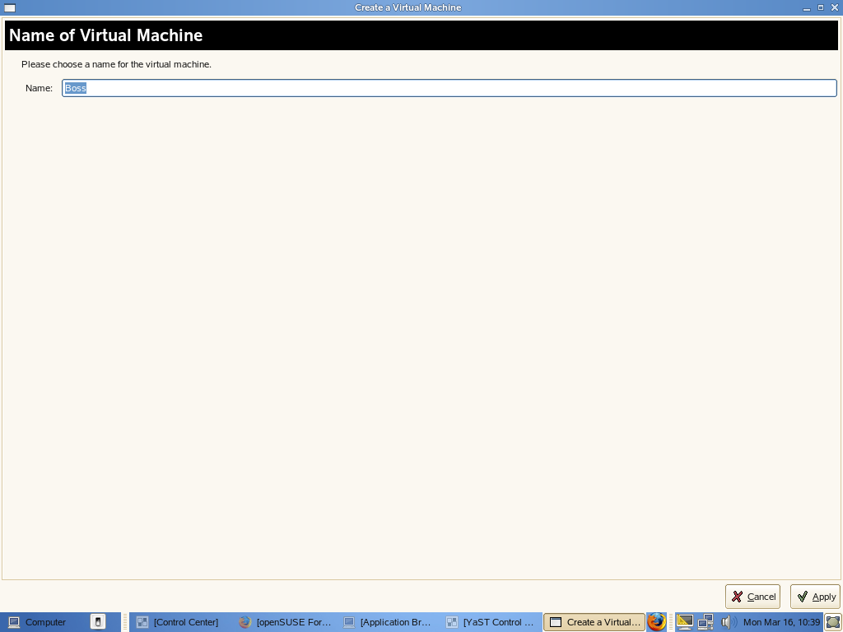
I NAMED THE VIRTUAL MACHINE AS “BOSS”.

STEP 5: NOW I TRIED TO CONFIGURE THE PROPERTIES OF BOSS ONE BY ONE
AS SHOWN BELOW:
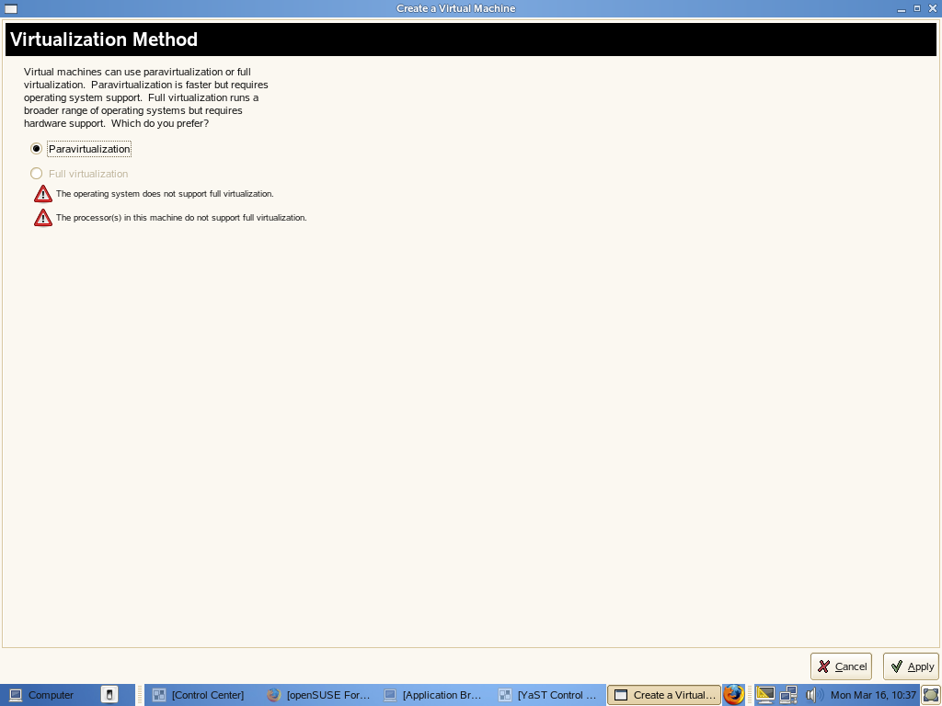

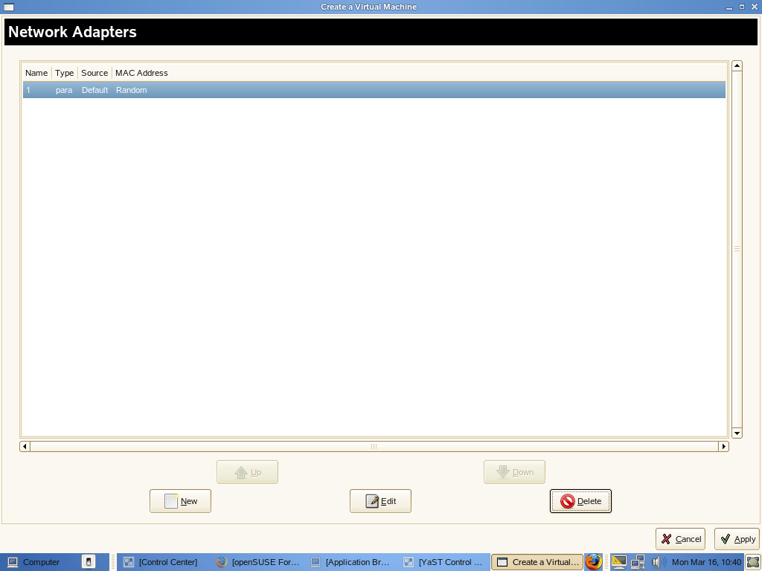

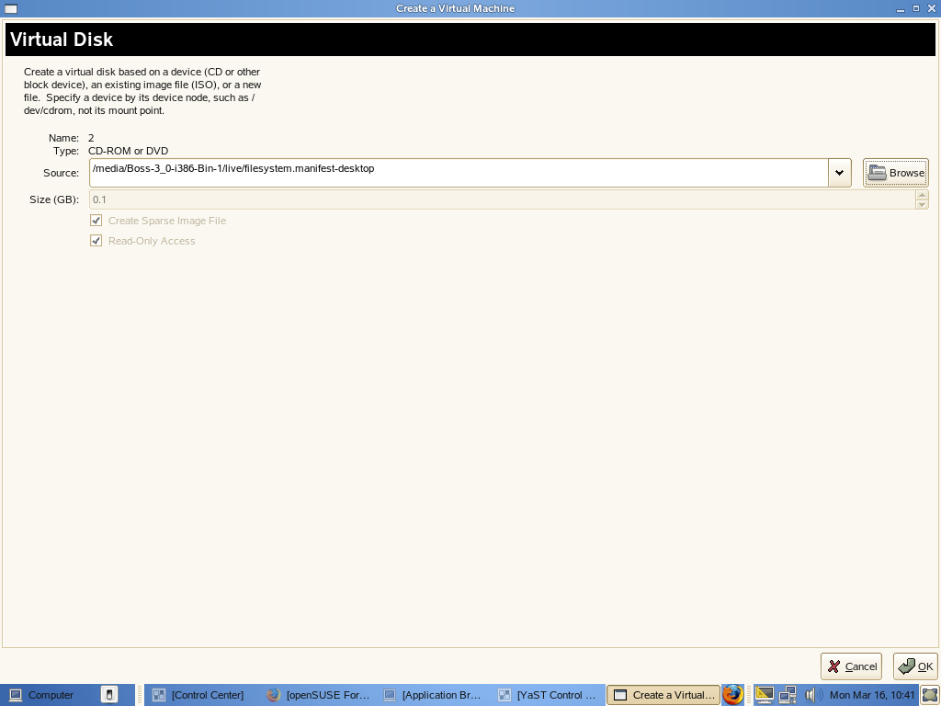

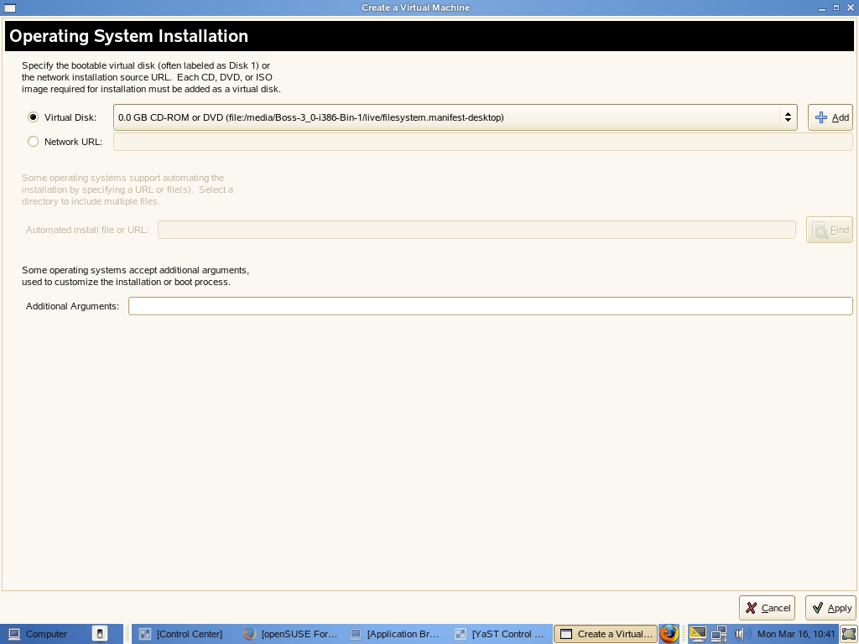

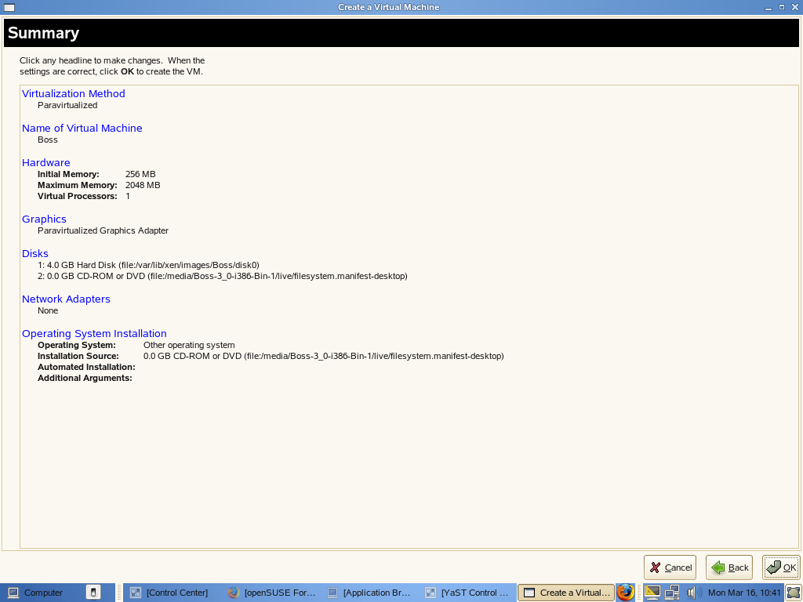

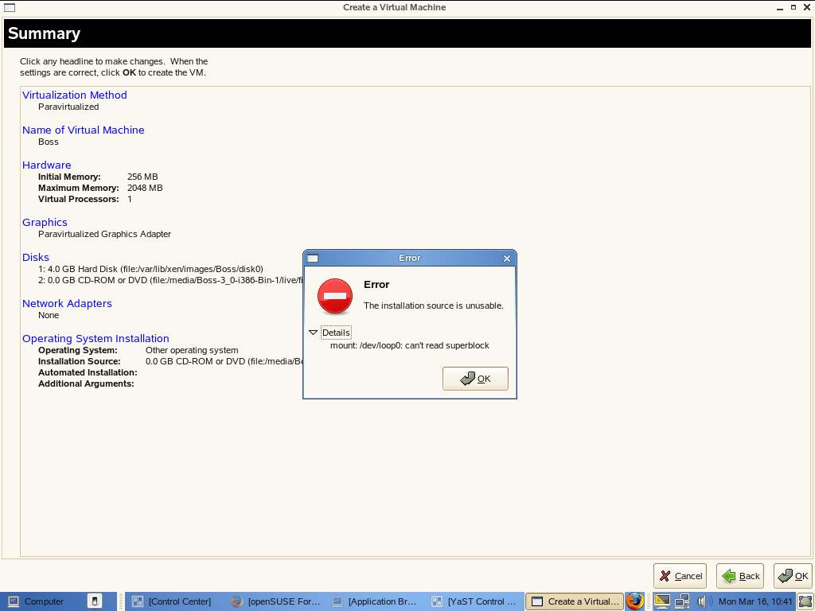

hello friends..this is the problem,i`m facing....Can any one help me to solve this...

U can contact me through cmraghavendran@rediff.com
Thanks in advance..

