Management of XEN tool
For management of XEN tool are three different systems: Xend, xm and management API.
Xend
The Xend node control daemon performs system management functions related to virtual machines. It forms a central point of control of virtualized resources, and must
be running in order to start and manage virtual machines. Xend must be run as root because it needs access to privileged system management functions.

Xend can be started on the command line as well, and supports the following set of parameters:
# xend start start xend, if not already running
# xend stop stop xend if already running
# xend restart restart xend if running, otherwise start it
# xend status indicates xend status by its return code

An HTTP interface and a Unix domain socket API are available to communicate with Xend. This allows remote users to pass commands to the daemon. By default, Xend does not start an HTTP server. It does start a Unix domain socket management server, as the low level utility xm requires it. For support of cross-machine migration, Xend can start a relocation server. This support is not enabled by default for security reasons.
Note: the example xend configuration file modifies the defaults and starts up Xend as
an HTTP server as well as a relocation server.
From the file:
#(xend-http-server no)
(xend-http-server yes)
#(xend-unix-server yes)
#(xend-relocation-server no)
(xend-relocation-server yes)
Comment or uncomment lines in that file to disable or enable features that you require.
Connections from remote hosts are disabled by default:
# Address xend should listen on for HTTP connections, if xend-http-server # set.
# Specifying 'localhost' prevents remote connections.
# Specifying the empty string '' (the default) allows all connections.
#(xend-address '')
(xend-address localhost)
It is recommended that if migration support is not needed, the xend-relocation-server
parameter value be changed to .no. or commented out.

But this interface is a very old and totally broken HTML interface and legacy, generally working SXP-based interface, on port 8000. At this time exists two more Xend interfaces but without documentation:
- xend-unix-xmlrpc-server: Legacy XML-RPC server, over HTTP/unix, the recommended way to access Xend in 3.0.4.
- xend-tcp-xmlrpc-server: Ditto, over TCP, on port 8006.

Xm

The xm tool is the primary tool for managing Xen from the console. The general
format of an xm command line is:
# xm command [switches] [arguments] [variables]

The available switches and arguments are dependent on the command chosen. The
variables may be set using declarations of the form variable=value and command
line declarations override any of the values in the con_guration _le being used,
including the standard variables described above and any custom variables (for instance, the xmdefconfig _le uses a vmid variable).

Xen-Management-API
The Xen Management API is an interface for remotely configuring and controlling virtualised guests running on a Xen-enabled host.
The API is presented here as a set of Remote Procedure Calls, with a wire format based upon XML-RPC. No specific language bindings are prescribed.
The API reference uses the terminology classes and objects. For our purposes a class is simply a hierarchical namespace; an object is an instance of a class with its fields set to specific values. Objects are persistent and exist on the server-side.
Clients may obtain opaque references to these server-side objects and then access their fields viaget/set RPCs.
For each class we specify a list of fields along with their types and qualifiers. A qualifier is one of:
- ROrun: the field is Read Only. Furthermore, its value is automatically computed at runtime. For example: current CPU load and disk IO throughput.
- ROins : the field must be manually set when a new object is created, but is then Read Only for the duration of the object’s life. For example, the maximum memory addressable by a guest is set before the guest boots.
- RW: the field is Read/Write. For example, the name of a VM.

The following classes are defined:
Name | Description
session  task  event  VM  VM metrics  VM guest metrics  host  host metrics  host cpu  network  VIF  VIF metrics  PIF  PIF metrics  SR  VDI  VBD  VBD metrics  PBD  crashdump  VTPM  console  user  debug | A session  A long-running asynchronous task  Asynchronous event registration and handling  A virtual machine (or ’guest’)  The metrics associated with a VM  The metrics reported by the guest (as opposed to inferred from outside)  A physical host  The metrics associated with a host  A physical CPU  A virtual network  A virtual network interface  The metrics associated with a virtual network device  A physical network interface (note separate VLANs are represented as several PIFs)  The metrics associated with a physical network interface  A storage repository  A virtual disk image  A virtual block device  The metrics associated with a virtual block device  The physical block devices through which hosts access SRs  A VM crashdump  A virtual TPM device  A console  A user of the system  A basic class for testing

With the following relations:
object.field | object.field | relationship
host.PBDs  SR.PBDs  VDI.VBDs  VDI.crash_dumps  VBD:VM  crashdump.VM  VIF.VM  VIF.network  PIF.host  PIF.network  SR.VDIs  VTPM.VM  console.VM  host.resident_VMs  host.host_CPUs | PBD.host  PBD.SR  VBD.VDI  crashdump.VDI  VM.VBDs  VM.crash_dumps  VM.VIFs  network.VIFs  host.PIFs  network.PIFs  VDI.SR  VM.VTPMs  VM.consoles  VM.resident_on  host_cpu.host | many-to-one  many-to-one  many-to-one  many-to-one  one-to-many  one-to-many  one-to-many  one-to-many  one-to-many  one-to-many  many-to-one  one-to-many  one-to-many  many-to-one  many-to-one
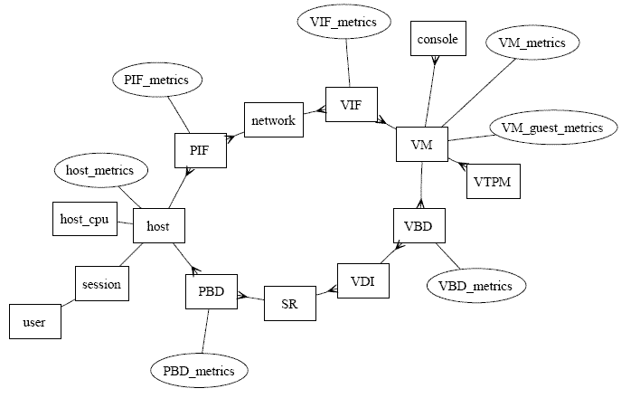

Also as an example it’s shown the different fields for the class VM:

Quals | Fields | Type | Description
ROrun | uuid | string | unique identifier/object reference
ROrun | power_state | vm_power_state | Current power state of the machine
ROrun | allowed_operations* | (vm_operations) Set | list of the operations allowed in this state. This list is advisory only and the server state may have changed by the time this field is read by a client
ROrun | current_operations* | (string -> vm_operations) Map | links each of the running task usijng this object (by reference) to a current_operation enum which describes the nature of the task
RW | name/label | string | a human-readable name
RW | name/description | string | a notes field containing human-readable description
RW | user_version | int | a user version number for this machine
RW | is_a_template | bool | true if this is a template. Template VMs can never be started, they are used only for cloning other VMs
RW | auto_power_on** | bool | tru if this VM should be started automatically after host boot
ROrun | suspend_VDI | VDI ref | The VDI that a suspend image is stored on. (Only has meaning if VM is currently suspended)
ROrun | resident_on | host ref | the host the VM is currently resident on
ROrun | scheduled_to_be_resident_on* | host ref | the host on which the VM is due to ber started/resumed/migrated. This acts as a memory reservation indicator
RW | affinity* | host ref | a host which the VM has some affinity for (or NULL). This is used as a hint to the start call when it decides where to run the VM. Implementations are free to ignore this field
RW | memory/static_max | int | Statically-set (i.e. absolute) maximum (bytes)
RW | memory/dynamic_MAX | INT | Dynamic maximum (bytes)
RW | memory/dynamic_min | int | Dynamic minimum (bytes)
RW | memory/static_min | int | tatically-set (i.e. absolute) minium (bytes)
RW | VCPUs/params | (string->string)Map | configuration parameters for the selected VCPU policy
RW | VCPUs/max | int | Max number of VCPUs
RW | VCPUs/at_startup | int | Boot number of VCPUs
RW | actions/after_shutdown | on_normal_exit | action to take after the guest has shutdown itself
RW | actions/after_reboot | on_normal_exit | action to take after the guest has rebooted itself
RW | actions/after_crash | on_crash_behaviour | action to take if the guest chrashes
ROrun | consoles | (console ref) Set | virtual console devices
ROrun | VIFs | (VIF ref) Set | virtual network interfaces
ROrun | VBDs | (VBD ref) Set | virtual block devices
ROrun | crash_dumps | (crashdump ref) Set | crash dumps associated with this VM
ROrun | VTPMs | (VTPM ref) Set | crash dumps associated with this VM
ROrun | VTPMs | (VTPM ref) Set | virtual TPMs
RW | PV/bootloader | string | name of or path to bootloader
RW | PV/kernel | string | path to the kernel
RW | PV/kernel | string | path to the kernel
RW | PV/ramdisk | string | path to the initrd
RW | PV/args | string | kernel c ommand-line arguments
RW | PV/bootloader_args | string | miscellaneous arguments for the bootloader
RW | PV/legacy_args* | string | to make Zurich guests boot
RW | HVM/boot_policy | string | HVM boot policy
RW | HVM/boot_params | (string->string) Map | HVM boot params
RW | HVM/shadow_multiplier* | float | multiplier applied to the amount of shadow that will be made available to the guest
RW | platform | (string->string) Map | platform-specific configuration
RW | PCI-bus | string | PCI bus path for pass-through devices
RW | other_config | (string->string) Map | additional configuration
ROrun | domid | int | domain ID (if available, 01 otherwise)
ROrun | domarch* | string | Domain architecture (if available, null string otherwise)
ROrun | last_boot_CPU_flags* | (string->string) Map | describes the CPU flags on which the VM was last booted
ROrun | is_control_domain | bool | true if this is a control domain (domain 0 or a drvier domain)
ROrun | metrics | VM_metrics ref | metrics associated with this VM
ROrun | guest_metrics | VM_guest_metrics ref | metrics associated with the running guest
ROrun | last_booted_record* | string | marshaled value containing VM record at time of last boot, updated dynamically to reflect the runtime state of the domain
RW | recommendations* | string | An XML specification of recommended values and ranges for properties of this VM
RW | xenstore_data* | (string->string) Map | data to be inserted into the xenstore tree (/local/domain/!domid¿/vm-data) after the VM is created
*Only enterprise edition
**Only community edition

For creation and start a virtual machine the next two RPC operations have to be called:

RPC name: create
Overview: Create a new VM instance, and return its handle.
Signature:
(VM ref) create (session_id s, VM record args)
Arguments:
type | name | description
VM record | args | All constructor arguments
Return Type: VM ref
reference to the newly created object

RPC name: start
Overview: Start the specified VM. This function can only be called with the VM is in the Halted State.
Signature:
void start (session_id s, VM ref vm, bool start_paused, bool force)
Arguments:
type | name | description
VM ref | vm | The VM to start
bool | start_paused | Instantiate VM in paused state if set to true
bool | force | Attempt to force the VM to start. If this flag is false then the VM may fail pre-boot safety checks (e.g. if the CPU the VM last booted on looks substantially different to the current one)

Return Type: void
Possible Error Codes: VM BAD POWER STATE, VM HVM REQUIRED, VM IS TEMPLATE, OTHER OPERATION IN PROGRESS, OPERATION NOT ALLOWED, BOOTLOADER FAILED, UNKNOWN BOOTLOADER, NO HOSTS AVAILABLE, LICENCE RESTRICTION

Finally a VM has the next states in the API calls:
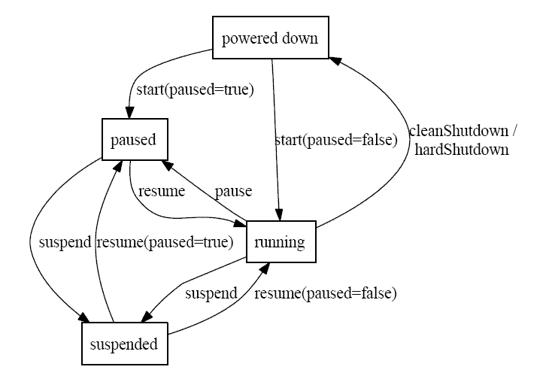

Conclusions

Summarizing:

- xm: primary tool for managing Xen from the console.

- xend-http-server: Very old and totally broken HTML interface and legacy, generally working SXP-based interface, on port 8000.

- xend-unix-server: Ditto, using a unix domain socket.

- xend-unix-xmlrpc-server: Legacy XML-RPC server, over HTTP/unix, the recommended way to access Xend in 3.0.4.

- xend-tcp-xmlrpc-server: Ditto, over TCP, on port 8006.

- xen-management-api: All new, all shiny Xen-API interface, available in preview form now, and landing for 3.0.5.

So for Federica project the three important interfaces are:
- xend-unix-xmlrpc-server: this is the recommended way to access Xend.
- xend-tcp-xmlrpc-server: another way to acces Xend by tcp port.
- xen-management-api: a new API for remote management of the Xen tool based on XML-RPC.

At that moment not too much information is on the net for the xend xmlrpc interfaces. For the management API are defined two documents, one for the enterprise edition and another one for the community edition. Anyway, all these interfaces haven’t examples on the net, only some bindings for the management API.
Also at that moment none of these interfaces is using the standard CIM. It is supposed to be included in the next versions of the XEN management API.

Bibliography

XenEnterpriseManagementInterface: http://community.citrix.com/download/attachments/17596457/xenenterpriseapi4_1.pdf?version=1

XenManagementInterface:
http://wiki.xensource.com/xenwiki/XenApi?action=AttachFile&do=get&target=xenapi-1.0.0.pdf

Xen Summmit API Slides:
http://wiki.xensource.com/xenwiki/XenApi?action=AttachFile&do=get&target=Xen+Summit+API+Slides+2007-04-18.pdf

Xen Manual:
http://bits.xensource.com/Xen/docs/user.pdf

